Ultimate Frisbee Notes

Ultimate Frisbee History
The ultimate frisbee history begins with Joel Silver, a graduate of Lafayette College, proposed a school Frisbee team on a whim in the fall of 1968. The following spring, a group of students got together to play what Silver claimed to be the "ultimate game experience," adapting the sport from a form of Frisbee football, likely learned from Jared Kass while attending a summer camp at Northfield Mount Hermon, Massachusetts where Kass was teaching. Ultimate expanded to colleges around the northeast and around the country and gained enough popularity where unofficial National Championships were held in the mid to late 70s. Eventually, the Ultimate Players Association (UPA) was formed in 1979 to govern the sport of Ultimate in the US. Since that time the UPA has grown by leaps and bounds, introducing College, Womens, Mixed, Masters, and Youth divisions, and becoming one of the fastest growing sports in the US. In late May, 2010, the organization transitioned from the Ultimate Players Association into USA Ultimate. By the end of 2012, USA Ultimate had grown to over 35,000 members. The WFDF (World Flying Disc Federation) is Ultimate’s international governing body.
10 Basic Rules of the Game

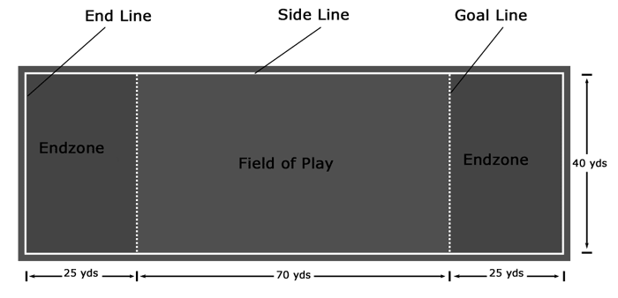
1. The Field – A rectangular shape with end zones at each end. A regulation field is 70 yards by 40 yards, with end zones 25 yards deep.

2. Initiate Play – Each point begins with both teams lining up on the front of their respective end zone. The defense throws (“pulls”) the disc to the offense. A regulation game has seven players per team.

3. Scoring – Each time the offense completes a pass in the defense’s end zone, the offense scores a point. Play is initiated after each score.

4. Movement of the Disc – The disc may be advanced in any direction by completing a pass to a teammate. Players may not run with the disc. The person with the disc (“thrower”) has ten seconds to throw it. The defender guarding the thrower (“marker”) initiates a stall count.

5. Change of Possession – When a pass is not completed (i.e., out of bounds, drop, block, interception), the defense immediately takes possession of the disc and becomes offense.

6. Substitution – Players not in the game may replace players in the game after a score and during an injury timeout.

7. Non-Contact – No physical contact is allowed between players. Picks and screens are also prohibited. A foul occurs when contact is made.

8. Fouls – When a player initiates contact on another player, a foul occurs. When a foul disrupts possession, the play resumes as if the possession was retained. If the player committing the foul disagrees with the foul call, the play is redone.

9. Self-Refereeing – Players are responsible for their own foul and line calls. Players resolve their own disputes.

10. Spirit of the Game (SOTG) – (MOST IMPORTANT RULE) Ultimate stresses sportsmanship and fair play. Competitive play is encouraged, but never at the expense of respect between players, adherence to the rules and basic joy of play.

SOTG is the underlying philosophy of Ultimate. Players are among the most courteous of athletes and always maintain a high level of sportsmanship and respect for their opponent. There are no referees in Ultimate, which means that players must govern their own conduct on the pitch. A player would never intentionally violate the rules of the game, so there are no harsh penalties to enforce these rules. If there is an infraction, it is the responsibility of the players involved to call the foul. This includes calling a foul on yourself if the person you fouled does not call the infraction. In essence, Ultimate relies on the honor system with the belief that no one would ever intentionally cheat.

BACKHAND- To throw the disc from the left side of the body for right handed players (or from the right for left handed players). The motion is similar in some respects to the backhand in tennis. (Like the 'standard' throw that non-Ultimate players may be used to).
BREAK- (side, pass or cut) the side to which the marker is trying to prevent the throw (or a pass/cut to this side).
CLEARING- To get out of the area where the thrower wants to pass the disc. It is absolutely necessary after making an unsuccessful cut or after throwing the pass. The importance of this is often underplayed to beginners.
CUT- An attempt to get free to receive the pass. It usually starts with a body fake and/or a sudden change in direction or speed.
DEFENSE- The team attempting to prevent a score.
DUMP- Player who stands behind the thrower in order to help out (must get free for an easy pass) when the offense gets in trouble.
ENDZONE- Area at the either end of the pitch within which a point is scored.
FLOW- A series of quick passes to well timed cuts - should result in an easy score.
FLYING DISC- Many people call it a "Frisbee." Ultimate players call it a disc. ("Frisbee" is the trademarked name for one particular brand of flying disc.) The disc is part of what makes Ultimate so unique. Depending on the skill of the thrower, it can be made to fly straight or in a curve, hover in mid-air or drop like a stone.
FORCE- (or mark) To make it as difficult as possible for the thrower to throw the disc in one direction (usually one side of the field) in an attempt to make (force) him/her to make a pass to the other side.
FOREHAND- (or FLICK) To throw the disc from the right side of the body for right handed players (or from the left for left handed players). The motion is similar in some respects to the forehand in tennis.
FREE- (or OPEN) To be available to receive the pass. The "free player" may be unmarked or have managed to get away from his/her defender.
HAMMER- High overhead throw in which the disc flies upside down in a parabolic type path. The grip, release etc. is similar to the forehand.
HUCK- A long pass that is often nearly the full length of the pitch and high to a tall player in the endzone.
LAYOUT- When the player dives the catch or intercept the disc. Also referred to as "going ho" (from going horizontal).
MAN-ON-MAN- The most common type of defense. Each person on defense marks an offense player and attempts to stay as close as possible with the intention of getting an interception or forcing a mistake.
OFFENSE- The team with possession of the disc.
OPEN- (side, pass or cut) the side to which the thrower is being forced (or a pass/cut to this side). It is sometimes used to describe being free to receive a pass.
PIVOT- When you plant your foot (left for right handers and right for left handers) and step to the side (allowing you the throw around the marker).
POACH- When a defender moves away from their marker to try and make an interception on a pass to another player.
POINT- (or score) When the disc is caught in the endzone by a player on the offense.
PULL- The throw at the start of each point that initiates play.
SCOOBER- (spoon pass or hiawatha) is similar to a hammer, but released away from the body from a backhand stance, instead of over the head from a forehand stance. It can be an effective short-range (10 to 20 yards/meters) throw.
STALLING- (or Stall Count) The player holding the disc has just ten seconds to pass it to a team-mate - the defender marking the player with the disc counts to ten out loud, and if the disc has not been released by the “T” in "ten" the defender takes possession. Forcing the thrower to make a less-than-ideal pass as the "stall count" nears ten is the idea behind most defensive strategies.
SWING- A lateral pass across the pitch - usually does not result in any upfield movement. This is useful to gain a better position or to reset the stall count.
TURNOVER- change of possession; when the disc has been dropped or intercepted and the offense becomes the defense.
Start of a point- each point begins with the two teams standing on opposite endzone lines. The team with the disc throws it as far down the pitch as they can, and the other team then takes possession where it lands.
After a point- after a team has scored a point, they keep hold of the disc and wait while the opposition walks back to the other end of the pitch. The team that scored then throws off to start the next point. This way, the teams change ends after every point.

