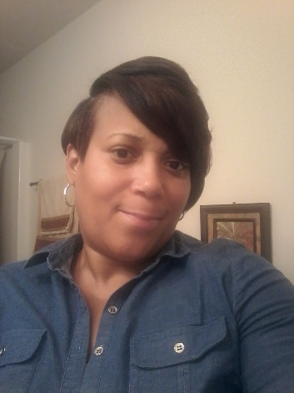

Hello,
My name is Sylvia Bell I have been working with the Richmond county School system for six years as a paraprofessional. I really enjoy working with kids! I am a mother of three boys myself, I really look forward to working with your kids this School year. 😊

