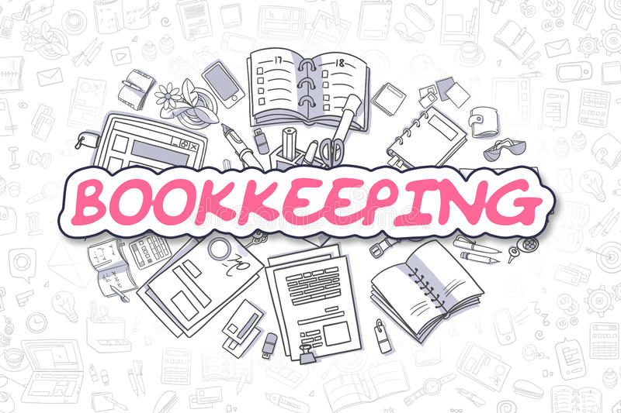

If you have any questions all my information you can find below.

Mrs. Monica Wells

706-823-6933 ext: 1874

wellsmo@boe.richmond.k12.ga.us