

Ms. Moton’s Misson, Vision, and Beliefs

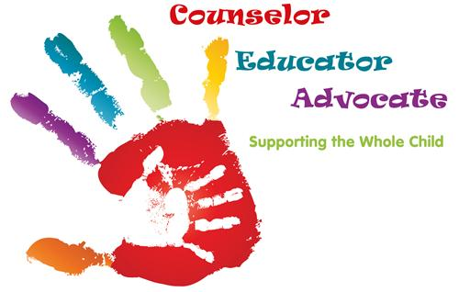

**Mission**

**The A. Dorothy Hains Elementary School Counseling Program supports the mission statement of the Richmond County Board of Education. The counseling program is designed to provide all students with an engaging competitive comprehensive curriculum. It encourages student achievement in the areas of academics, career, and social emotional learning. In partnership and collaboration with administrators, teachers, parents, and a caring community, the counseling program helps the whole child by building successful lifelong learners and problem solvers.**

**Vision**

**The A. Dorothy Hains Elementary School Counseling Program vision is to provide an atmosphere of security, warmth, and encouragement as students work to reach their fullest educational potential in the areas of academic, career, and personal development. The program will also commit to establish a solid foundation so students successfully manage their lives as healthy, responsible and productive citizens who respect themselves and others.**

**Beliefs**

* **I believe that ALL students can learn and achieve academic greatness when encouraged and nurtured in a respectful environment.**
* **I believe that nurturing ALL students social and emotional well-being will encourage academic development and future success.**
* **I believe being a proactive advocate through communication, collaboration, respect, and a shared vision can accomplish anything, ensuring student achievement, and a positive school culture and climate.**

**The school counseling program will promote the following: an understanding of and**

**respect of self and others; problem-solving and decision-making;**

**emotional-management skills; skills for learning; and the influence of**

**academic habits on career success.**