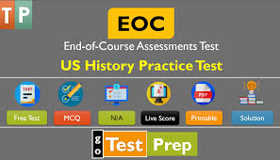

Crash Course Videos

<https://www.youtube.com/user/crashcourse>

GA Standards of Excellence

<https://www.georgiastandards.org/Georgia-Standards/Pages/Social-Studies-9-12.aspx>

United States History EOC Review

<https://slideplayer.com/slide/9311816/>

<https://www.tomrichey.net/eoc-review.html> 

Quilzet

<https://quizlet.com/202581177/cumulative-review-ga-us-history-eoc-flash-cards/>

Quizziz

<https://quizizz.com/admin/quiz/5c9e2bbb20fb24001a733c6d/georgia-us-history-eoc-review>