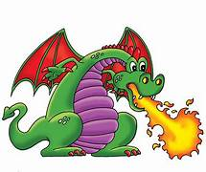**Goshen Elementary School**

**Kindergarten Supply List 2025-2026**

* Primary Composition Notebook (1)
* Composition Notebook (1)
* Blunt Tip Scissors for kids ages 4-7 (1)
* Glue Sticks (6)
* Box of Crayons (2) **Preferably Crayola if you are able**
* Markers (1)
* #2 Pencils (2 packages/boxes) **NO mechanical pencils**
* Erasers (1 pack of 3 or more)
* Tissues (2 Boxes or more)
* Disinfecting Wipes (1 or more)
* Dry Erase Markers **Fine Tip** (3 packs) **Your child will be using them for ELA and Math**
* Gallon and sandwich size ziploc bags (1)
* Over the ear headphones (1) **No earbuds**
* Backpack **No rolling backpacks**