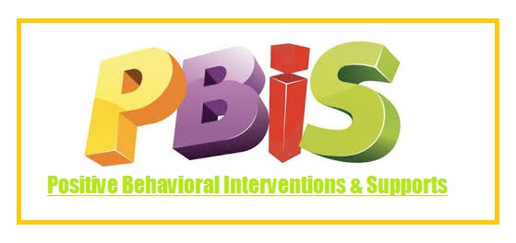

**Welcome to** **A Dorothy Hains Elementary School's Positive Behavioral Intervention and Supports (PBIS) website!  Our school-wide positive behavior interventions and supports system help students to learn the behavior expectations for various areas of our school. We hope that these clear and concise expectations will improve the school climate and help teaching and learning for all.**

**The main objective of PBIS is to decrease behaviors that interfere with student learning and create the optimum learning environment, so that students can reach social, emotional, and academic success.  When good behavior and rigorous teaching merge together, safe and productive learning environments are created where teachers can teach and all students can engage and excel in their learning.**

**In conjunction with the Richmond County School District Code of Conduct and the School-Wide Positive Behavioral Interventions and Supports (PBIS), students at A Dorothy Hains Elementary School will use the PAWS acronym to help maintain a safe environment that fosters growth and development.**

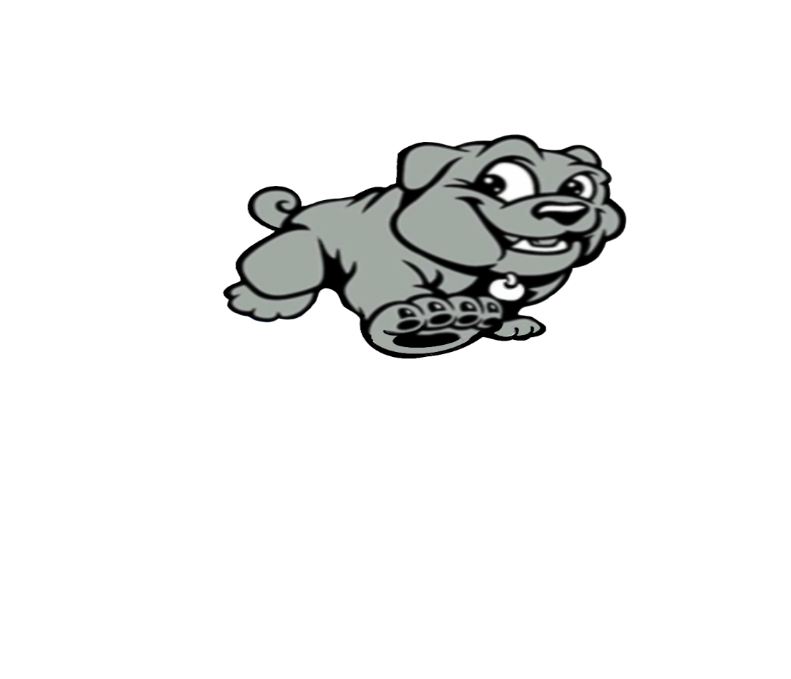

**A Dorothy Hains’ Behavioral Expectation:**

**P- BE POSITIVE**

**A-ACT RESPECTFULLY**

**W-WORK HARD**

**S-STAY SAFE**