MyOn Projects

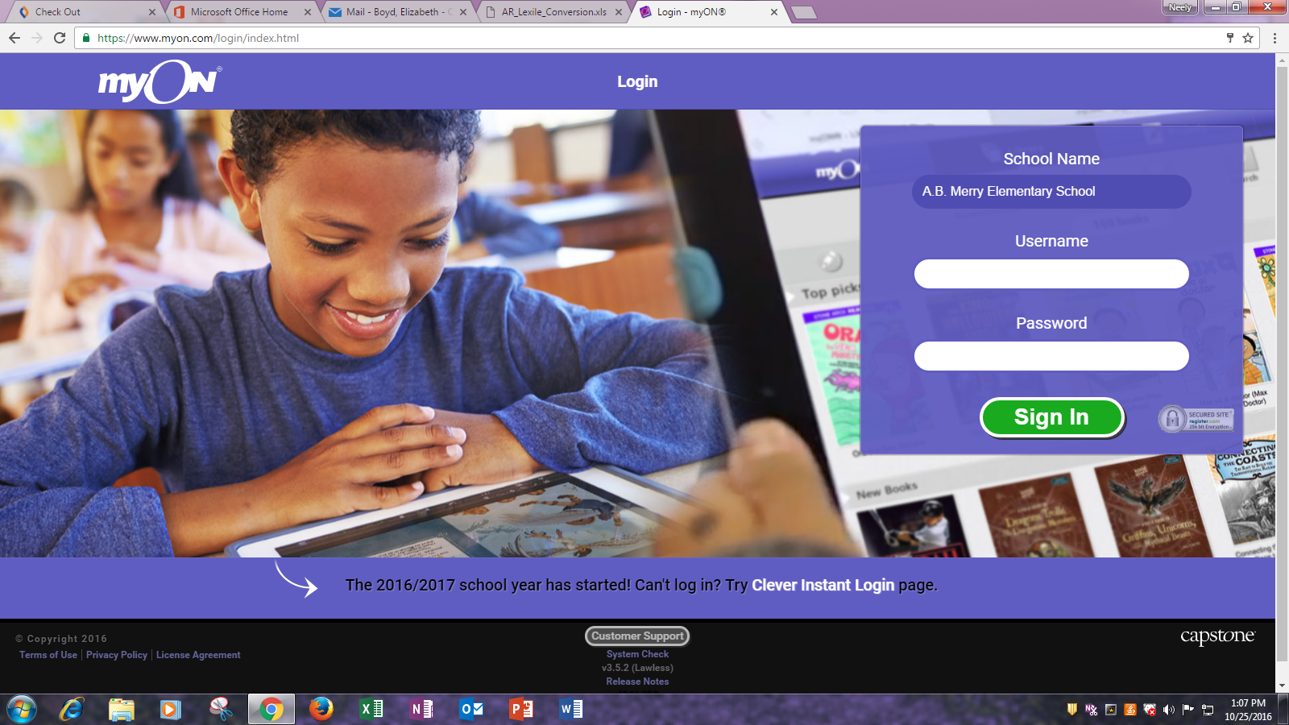

**Go to myon.com**

**Log-in INFO**

**School**

A.B. Merry Elementary School

**Teacher**

UN = email (5 and 2) ex. Boydel

PW = FIRST INITIAL@LAST INITIAL@721rcs ex. = E@B@721rcs

**Student**

Un = first initial, last name, and last 6 of their student ID (example for Tracie Livingston, tlivingston123456)

PW- first initial, last initial, and last 6 of their student ID, @ (example for Tracie Livingston, tl123456@)

The first time sts. log in they will complete a survey on the type of books they enjoy reading. After the survey the sts. will then complete a Lexile Test to see the appropriate books they can read.

**Lexile Test** – after **5 books** are finished or **3 hours’ worth** of reading is completed within a two-week time MyOn will automatically retest your sts. Lexile Levels.

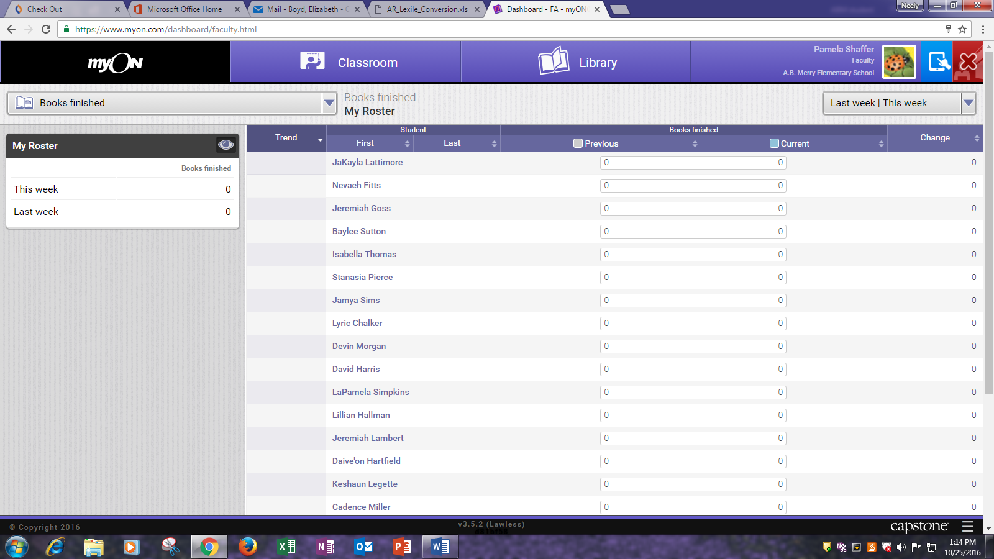

**Assigned Projects**

* Reading requirements
* Writing requirements
* Complete Graphic Organizer

Select **CLASSROOM**

Select **PROJECTS**

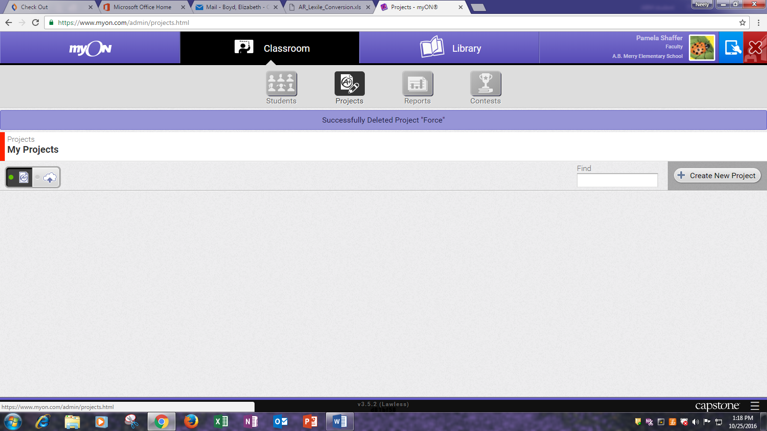



Select **CREATE NEW PROJECT**

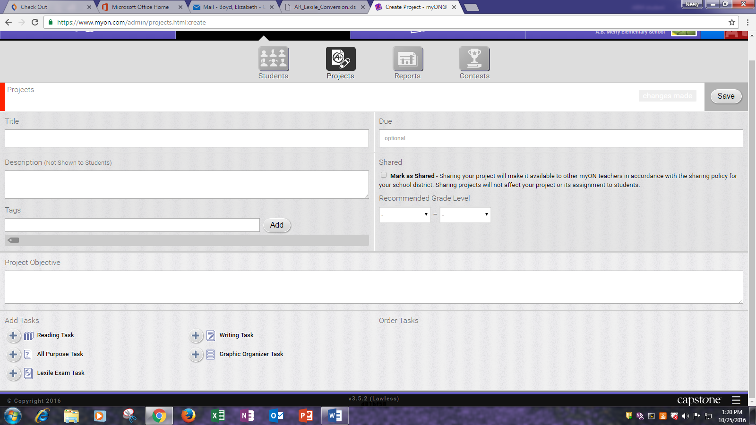

Create a **TITLE**

Create a **PROJECT OBJECTIVE**

**Select TASK** choices on bottom

**READING TASK** – select books for sts.

**ALL PURPOSE TASK** – create your own task

**LEXILE EXAM TASK** – have sts. take a Lexile test

**WRITING TASK** – the writing task can have sts. required to use a certain amount of words or be timed

**GRAPHIC ORGANIZER** – have sts. complete a selected graphic organizer

**Each of the Tasks can be combined to have sts. read a book and complete a graphic organizer, complete a writing assignment, or to complete your own assignment.**

**READING TASK**

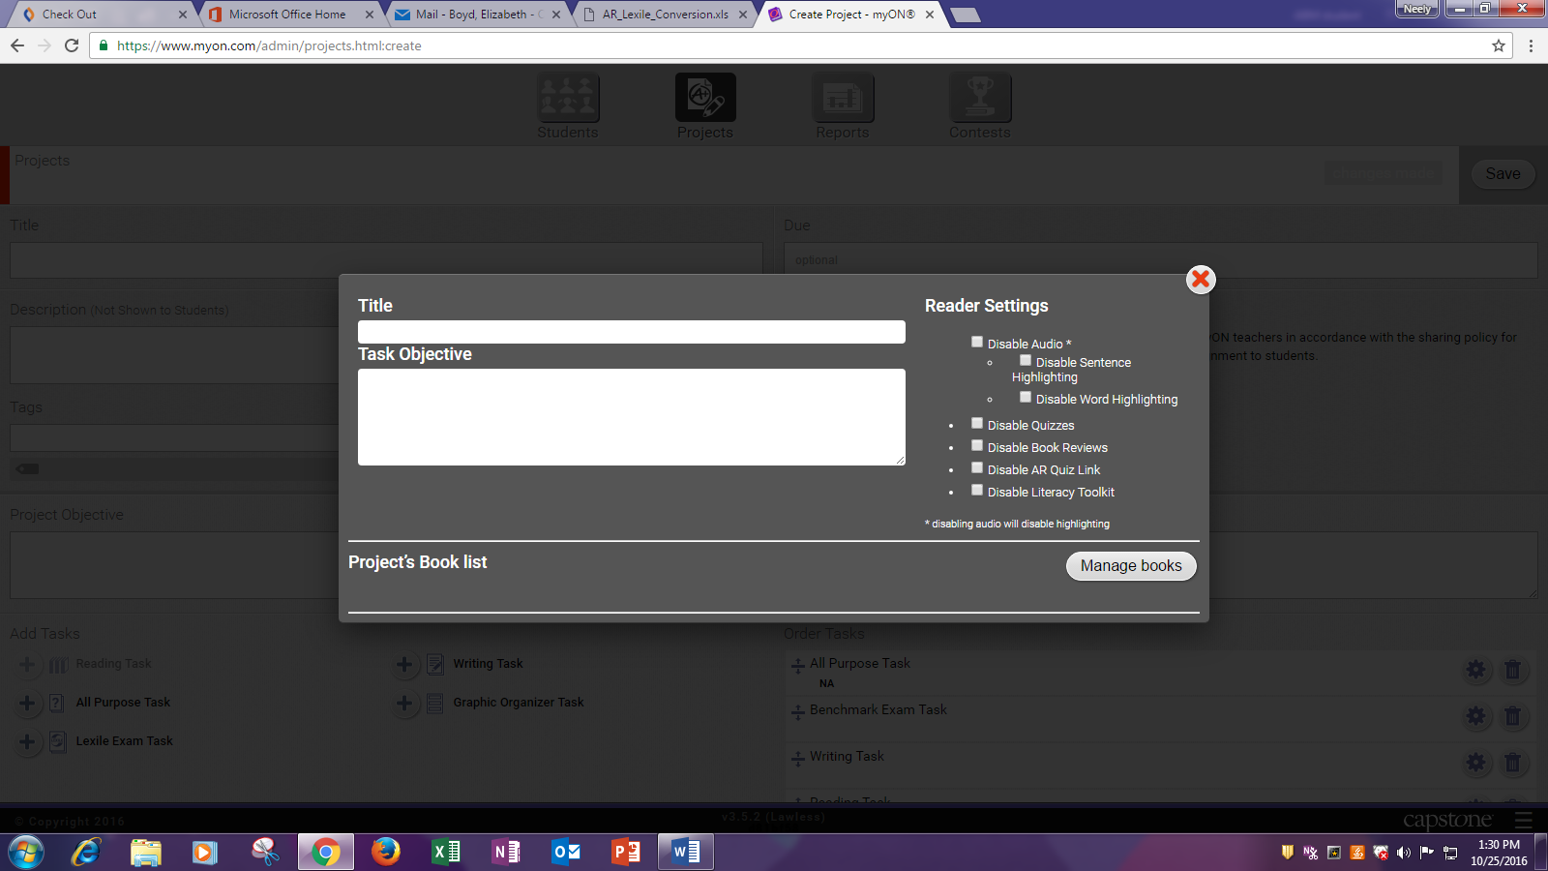

Create **TITLE**

Select **MANAGE BOOKS**

Type in the TOPIC you are searching for

I would use the Lexile “filter” to select appropriate books for your sts.

Select FIND BOOKS

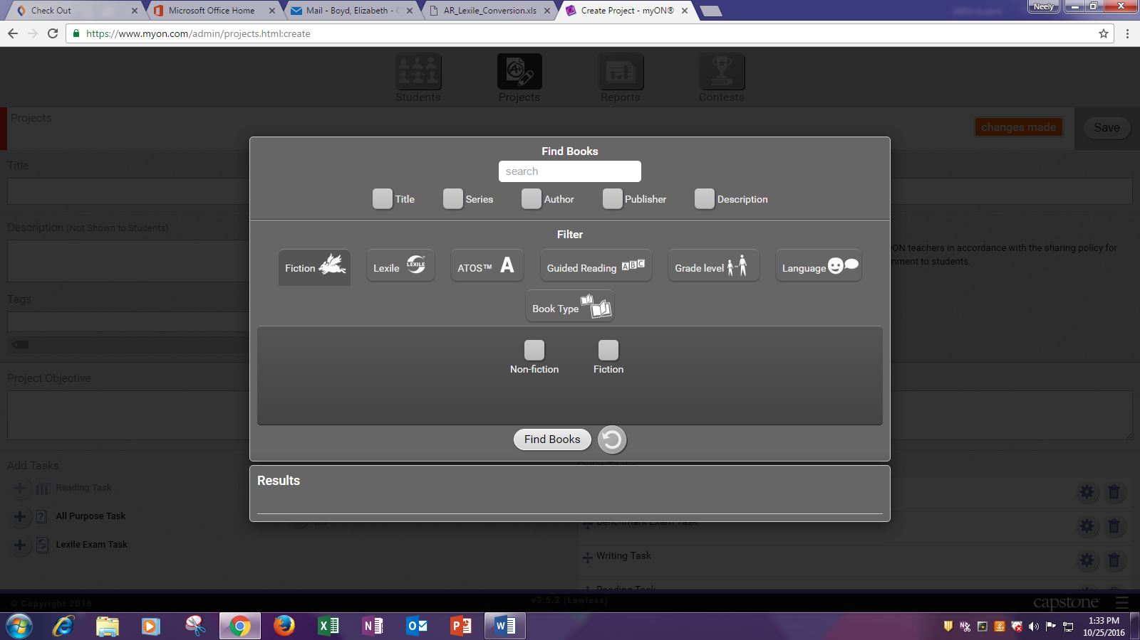

Place a check beside the books that you would like your sts. to read, and then **click outside the box**.

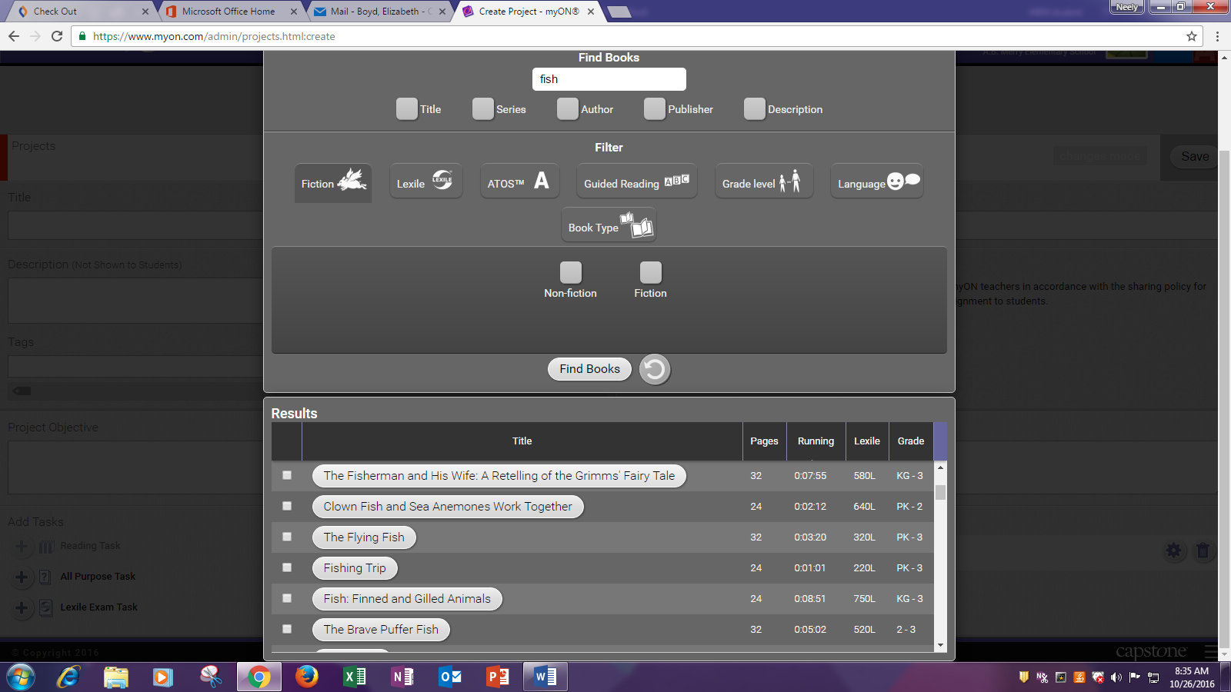

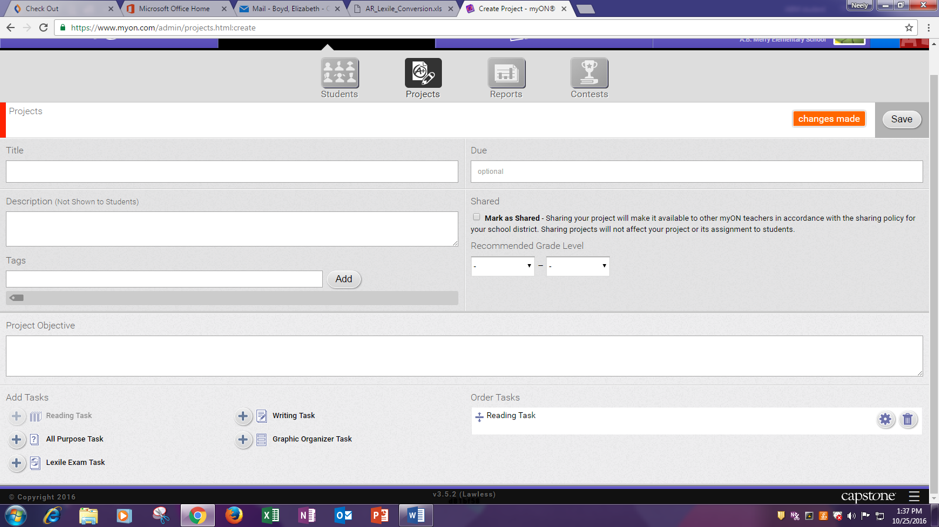

Your TASK will show up on the bottom Right side of the page

Select **SAVE** on the top right

Once it is saved then it is placed in a “holding area” called **My Projects.**

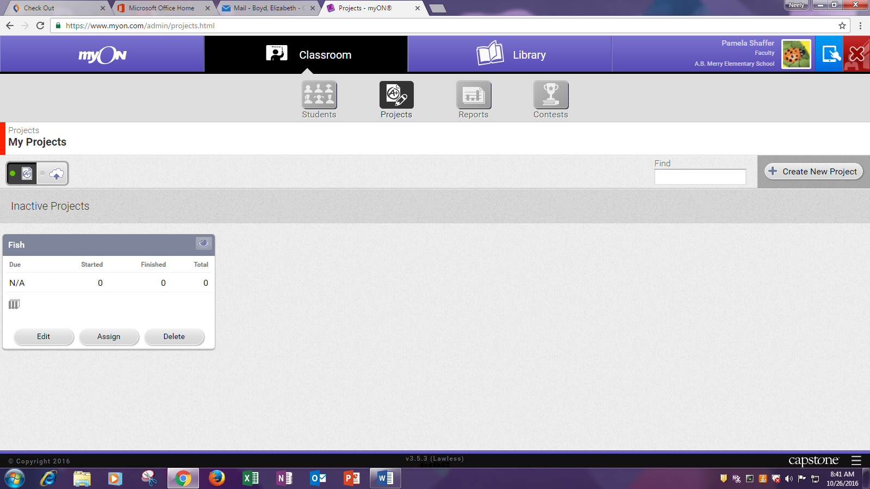

Select **Assign** Button

Select the students you want to complete the project/task.

Can select by grade or by individual sts. names.

Select **APPLY**

