1. Describe what is meant by continental drift. ______________________________________
___________________________________________________________________________

2. Describe the evidence that supports continental drift. _______________________________
______________________________________________________________________________________________________________________________________________________

3. Describe the process of seafloor spreading ______________________________________
_________________________________________________________________________________________________________________________________________________________________________________________________________________________________

4. The Theory of Plate Tectonics states ___________________________________________
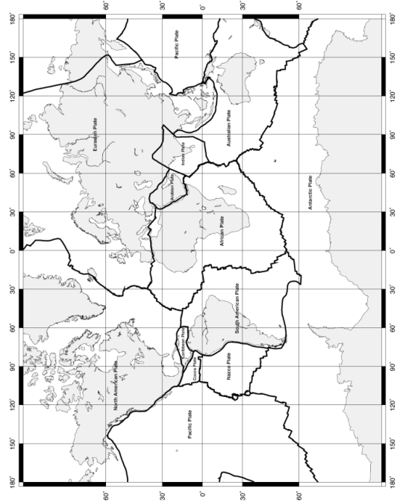
___________________________________________________________________________

5. The map to the right illustrates __________________________________________

6. __________________________________ form along ___________________________________

7. When plates move they can __________________________________________
__________________________________________
__________________________________________

8. The result of __________________________ can be seen at ________________________

*The questions below should be completed after the Boundary Chart on the next page*

9. Volcano Facts: _____________________________________________________________
___________________________________________________________________________
___________________________________________________________________________

10. Earthquake Facts: _________________________________________________________
___________________________________________________________________________
___________________________________________________________________________

11. Tsunami Facts: ___________________________________________________________
___________________________________________________________________________

Type of Boundary | Label the types of crust, arrows showing direction of movement & effects | Description | Examples
Divergent  Continent - Continent | 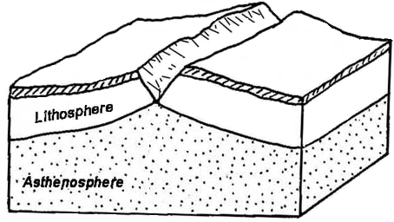
Divergent  Ocean – Ocean | 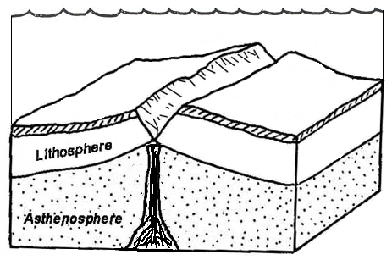
Convergent  Ocean – Continent | 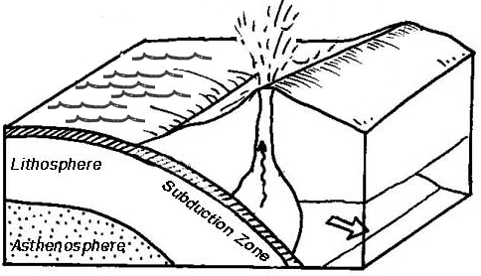
Convergent  Continent – Continent | 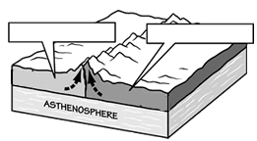
Convergent  Ocean – Ocean | 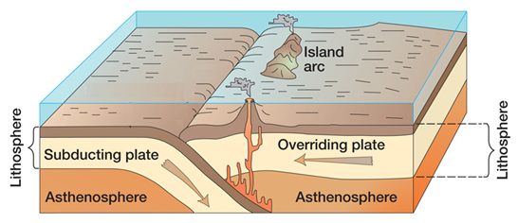
Transform | 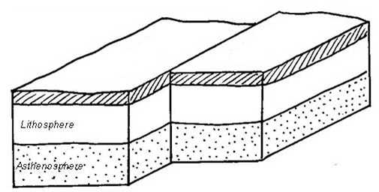

Type of Boundary | Label the types of crust, arrows showing direction of movement & effects | Description | Examples
Divergent
Continent - Continent
Divergent
Ocean – Ocean
Convergent
Ocean – Continent
Convergent
Continent – Continent
Convergent
Ocean – Ocean
Transform

