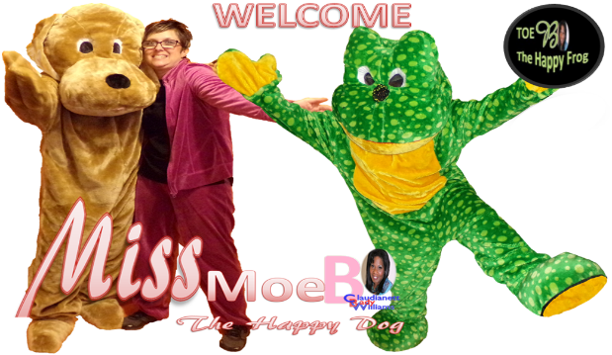
My name is Mrs. Charlotte Ginn. I am so excited to be your child’s second grade teacher for the 2024/2025 academic school year! This is my seventh year of teaching, and second year at Barton Chapel!
We, the second-grade staff, welcome students and parents with open arms, hearts, and minds. Students will learn to read advanced books, perfect math skills, become amazing authors, exceptional explorers, and super scientists! We look forward to working with parents to teach the total child to excel and have a year of great expectations and success! It is my goal to encourage students to do there very best with their school assignments. I want them to know they can achieve positive behavior and character traits daily.
We will work together to make learning fun and successful. I do encourage them to take the time and read everyday! ToeB “The Happy Frog” and Ms. MoeB “The Happy Dog”,look forward to learning with you as well! Thank you in advance for all your help and the opportunity to teach your child! As we work together as a team, I believe that not one child will be “left behind!”
In second grade, students will use individualized learning stations to master all academic content standards. In Reading/Language Arts, students will be required to master Second grade I-Ready sight words, read with fluency and accuracy while using decoding strategies. In Writing they will participate in Writer’s Workshop where they will learn the fundamentals of narrative, informational, and opinion writing compositions. In Math, students will be required to identify numbers up to 120; understand and apply base ten using place value; fluently add and subtract up to 4-digit numbers; measurement, length, and time; and identify attributes of plane and solid shapes. In Social Studies, students will learn about historical figures; Georgia: Georgia’s first people, How Georgia Became a Colony, Becoming a Georgian; Production, Distribution, Consumption, and Scarcity; and Geography. In Science, students will learn about energy and motion, seasons of the year, shadows, moon phases, and constellations, light and sound, life cycles of plants and animals, and basic needs of living things. Students will have weekly assessments in Math, Reading, Science and Social Studies. They will also be taking I-Ready. Please remember to check the school’s website for Upcoming Important dates!
Listed below are two lists, one that is required (Supply List) and the teacher’s wish list (what we need and ask for your contribution).
Supply List  - 1 backpack (no wheels)  - Pencil/Crayon Box (name on it)  - 2 packs of pencils  - 2 boxes of 24 crayons  - 1 box of 12 Color Pencils  - Glue sticks (12-16)  - 2 boxes of Tissues  - 4 composition notebooks  - 2 plastic pronged folders (2)  - 3 packs of loose leaf paper (per 9wks)  - 1 pack Expo dry-erase markers  - 1 box baby wipes  - Headphones/earbuds | Teacher Hope List  (we will go through these the entire year)  - Hand Sanitizer  - baby wipes  - ream of copy paper  - pencils  - crayons  - color pencils  - glue sticks  - paper towels  - gallon/quart Ziploc bags  - Band-Aids  - clear sheet protectors

Remember to Check the School’s Website for Upcoming Important Dates.
http://www.rcboe.org/bartonchapel
Thank you in advance for your time, support, and contribution.
Second Grade Teacher,
Mrs. Charlotte Ginn

Vision: The Richmond County School System will provide an equitable education for all students to prepare them for life beyond the classroom.
Mission Statement: Building a globally competitive school system that educates the whole child through teaching, learning, collaboration, and innovation.

