7LS Name ___________________ 2nd Period Date: ____________

Photosynthesis & Cellular Respiration Worksheet

1. What is the overall reaction (*equation*) for photosynthesis?
2. How does this compare to the overall reaction for cellular respiration?
3. Where does the energy for photosynthesis come from?
4. What plant pigments are involved in photosynthesis?
5. In what organelle of a plant cell does photosynthesis take place?
6. What is produced by photosynthesis?
7. What is the overall reaction (*equation*) for cell respiration?
8. In what organelle of a cell does cell respiration take place?
9. What is produced by cellular respiration?
10. How do photosynthesis & cellular respiration form a continuous cycle?

|  |  |  |  |
| --- | --- | --- | --- |
| phototitle  photcrosseasy | |  |  |
| **Across**  **1** A plant pigment that absorbs sunlight. (11)  **4** The links between the energy that carnivores get from eating to the energy captured by photosynthesis. (4,5)  **7** Chlorophyll absorbs every color of sunlight except this. (5)  **8** A compound needed for photosynthesis. (6,7)  **10** The product of photosynthesis. (5) | **Down**  **2** The process by which plants and some bacteria use the energy from sunlight to produce sugar. (14)  **3** Part of the plant where photosynthesis generally occurs. (6)  **5** A compound needed for photosynthesis. (5)  **6** An animal that eats plants. (9)  **9** A by-product of photosynthesis. (6)  **10** Number of molecules of oxygen produced along with one molecule of sugar. (3) | | |

7LS w/s 7C Name_________________________________

Photosynthesis Diagram

After it is labeled, the diagram below will illustrate photosynthesis. Write each of the following terms on the correct numbered line. Then answer the questions that follow.

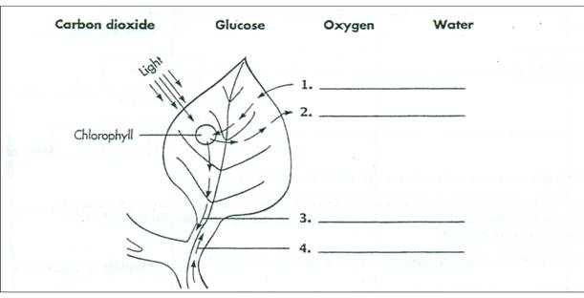

5. a. In photosynthesis, what substances come in from the outside?

b. Where does the water come from?

c. Where does the carbon dioxide come from?

6. a. In photosynthesis, what substances are produced?

b. Where does the glucose/sugar go?

c. Where does the oxygen go?

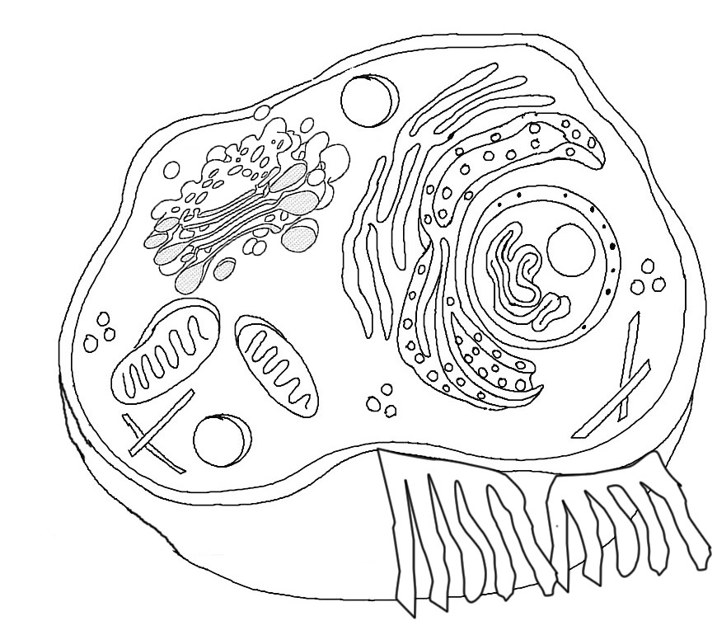This section of an animal cell shows the organelles responsible for cellular respiration. Fill in the blanks with the terms: **carbon dioxide, oxygen, food/glucose, water**

**1**

**2**

**4**

**3**

5. a. What does the mitochondria need to perform cell respiration?

b. Where does the oxygen come from?

c. Where does the glucose come from?

6. a . What is produced by cell respiration?

b. Where does the carbon dioxide go?

c. Where does the water go?

The diagram shows the photosynthesis/respiration cycle. Fill in with the following terms: cellular respiration, photosynthesis, mitochondria, chloroplast, oxygen, sugars/glucose, carbon dioxide + water, energy from sunlight, energy for cells, oxygen (yes oxygen will be used twice)

1. **__________________**
2. **__________________**
3. **__________________**
4. **__________________**
5. **__________________**
6. **__________________**
7. **__________________**
8. **__________________**
9. **__________________**
10. **__________________**

