**Cortés in Tenochtitlán**

Hernando Cortés was a Spanish explorer and conquistador who landed on the coast of Mexico in 1519. Learning of the powerful Aztec empire and its capital city of Tenochtitlán, Cortés traveled over one hundred miles inland to find the city and claim the Empire for Spain. At the time, the city of Tenochtitlán was one of the largest cities in the world. The Spanish would eventually level Tenochtitlán and build Mexico City on the site of the Aztec capital. Primary sources, such as the accounts written by Hernando Cortés and other Spanish officials, are the only surviving writings we have of this once great city.

***"This great city of Tenochtitlán is built on the salt lake, and no matter by what road you travel there are two leagues from the main body of the city to the mainland. There are four artificial causeways leading to it, and each is as wide as two cavalry lances. The city itself is as big as Seville or Córdoba. The main streets are very wide and very straight; some of these are on the land, but the rest and all the smaller ones are half on land, half canals where they paddle their canoes. All the streets have openings in places so that the water may pass from one canal to another. Over all these openings, and some of them are very wide, there are bridges. . . . There are, in all districts of this great city, many temples or houses for their idols. They are all very beautiful buildings. . . . Amongst these temples there is one, the principal one, whose great size and magnificence no human tongue could describe, for it is so large that within the precincts, which are surrounded by very high wall, a town of some five hundred inhabitants could easily be built. All round inside this wall there are very elegant quarters with very large rooms and corridors where their priests live. There are as many as forty towers, all of which are so high that in the case of the largest there are fifty steps leading up to the main part of it and the most important of these towers is higher than that of the cathedral of Seville. . . ."***

Hernando Cortés, along with around five hundred men, landed in Mexico, and prepared to attack the main power of the region, the Aztec empire. Along with a contingent of native warriors hostile to the Aztecs, Cortés entered Tenochtitlán (Mexico City) peacefully and met Emperor Montezuma II (1502-1520). More than 200,000 people lived in the Aztec capital at this time. Montezuma's civil reception of the Spanish did not last long. The Spanish abducted the emperor and attacked the Aztecs during a religious ceremony that featured human sacrifice and cannibalism. Driven out in 1520, Cortés retook Tenochtitlán in 1521, all but destroying the architectural wonders of the city in the process. The Aztecs, decimated by smallpox and Spanish weaponry, soon came under Spanish control, and Mexico became the core of New Spain, a region stretching from Panama to California.

**Aztec Hieroglyphics**

The pre-Hispanic history of Mexico is contained in the numerous pictorial codices or painted hieroglyphic books produced by the Aztecs, the Maya, the Mixtecs, and others. Unfortunately, very few pre-Conquest codices survived the Spanish Conquest and the destruction of the Aztec capital of Tenochtitlán in 1521. Of course we have the early writings of the Spanish Conquistadors themselves and innumerable published works about the Aztecs and other indigenous peoples of ancient Mexico. But we seldom hear the authentic voice of the people themselves. What did they think of their own history and how did they express it? We should then ask ourselves how do we really know what we know about the history of early Mexico? Or think we do?

We shall never know the whole story. However, we do have hundreds of pictorial and written manuscripts from the early post-Conquest period onwards. Because most of these native historical records were painted or written after the arrival of the Spaniards, there is always the possibility of external interference or foreign influence in the native accounts of their own history. The Spaniards did their best to destroy an entire civilization but did not succeed entirely. Through careful classification and comparison of all the available sources, we can at least begin to piece together something of the pre-Hispanic Aztec view of history. The more familiar name "Aztec" will be used throughout, although the people referred to themselves as the "Aztecs."

The Aztecs had a very clear conception of their past history, their rise to power, and their future destiny. Unfortunately for that vision, Aztec civilization was abruptly cut off at the height of its fluorescence. Consequently, we are left with many gaps in our knowledge. The picture is further complicated by the overlapping of surviving documentary evidence. Some manuscripts are completely pictorial, others are mixed textual and pictorial, and still others are written from the outset. Only two Aztec codices predate the Spanish Conquest and even these may be debatable. But since the Tonalamatl Aubin ("Book of Days") and the Codex Borbonicus are mainly ritual-calendrical manuscripts, they are less relevant for Aztec history.

The codices, or painted hieroglyphic books, were an essential means of communication for the Aztecs. These included religious books or lifestyle guides, historical books, and practical documents involving land claims and the like. Here we are interested mainly in the historical books, although the other categories are also relevant to the study of Mesoamerican history. Religion was such an integral part of the Aztec way of life that it cannot be considered entirely apart from the Aztec concept of history.

Unable to understand or interpret the historical codices, the Spaniards destroyed all but a few of the pre-Conquest manuscripts in an attempt to wipe out what they regarded as idolatry. However after the Conquest, the Spaniards had a vested interest in maintaining and even encouraging the native manuscript pictorial tradition as a way of obtaining information about Aztec customs and beliefs. With some notable exceptions, secular and religious Spanish chroniclers and historians were not primarily interested in preserving Aztec traditions but rather with providing information to help the Spanish authorities control subject peoples.

**Tenochtitlán – Aztec Capital City**

The impossible city - <http://www.youtube.com/watch?v=_nS6MpVbB_g>

(5 minutes)

**Aztec Weaponry**

Maquahuitl

Perhaps the best known ancient Aztec weapon is the maquahuitl (macahuitl). This is sometimes compared to the sword, and it was a powerful, close contact weapon. Like the European sword, they came in two varieties - one handed and two handed. Made from wood (usually oak), they were about 3-4" wide and 3-4' long. The two handed versions might be slightly wider and be as tall as a person. Embedded in the edges was obsidian (volcanic stone) or flint.

[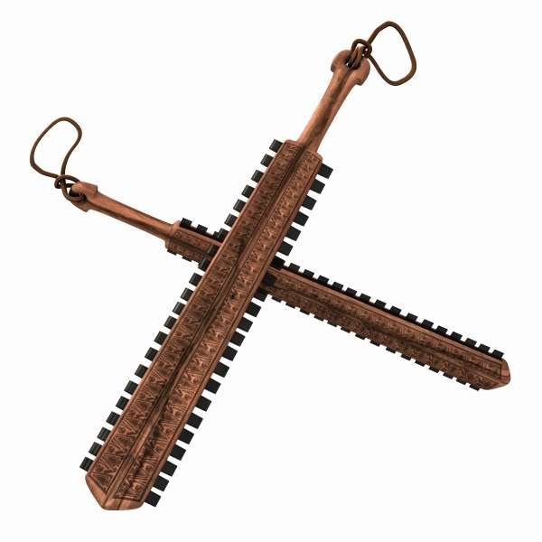](http://www.google.com/url?sa=i&rct=j&q=&esrc=s&frm=1&source=images&cd=&cad=rja&docid=1jiTyFOAY_t0iM&tbnid=QGYzCwji6HSS-M:&ved=0CAUQjRw&url=http://www.myth-weavers.com/showthread.php?p=4195940&ei=jPAbUdKaBYik4gSw6oHgAw&bvm=bv.42261806,d.bGE&psig=AFQjCNFR1ltnQ4o-F5bnSALQJFXWbxT0uw&ust=1360871894335091)

Clubs

The maquahuitl could be used as a club, but other types of clubs were used. The cuauhololli was a mace made of wood with a ball at the end. It could be used to smash and crush. Various other types of clubs were commonly used, sometimes just made of wood, other times with embedded stone as the maquahuitl.

Spears and lances

Another common ancient Aztec weapon was the spear. They were extremely sharp, and sometimes over 7 feet long. They didn't have a small point as many spears you may be familiar with, but a blade a foot wide made of smaller stone blades. Theses spears were known to pierce the Spanish armor, and were sharp enough that the warriors could use them to shave. They are called tepoztopilli. Spears were used in Mexico long before the Aztec empire.

Atlatls

The atlatl was a spear throwing device, for longer distance combat. This ancient Aztec weapon is described on The World Atlatl Association website:

An atlatl is essentially a stick with a handle on one end and a hook or socket that engages a light spear or "dart" on the other. The flipping motion of the atlatl propels a light spear much faster and farther than it could be thrown by hand alone.

As you can see, the atlatl was used in other parts of the world and is still used today. The Aztec artists often drew the gods with atlatls in their hands. Darts were used made from oak, single pointed with obsidian, flint, or even copper or bone. The propelled darts tended to be more powerful than arrows.

Bows and Arrows

Bows, known as tlahuitolli, were common as well. The bows were 5 feet long, and the arrows (yaomime) were pointed with flint, bone or obsidian, and kept in a quiver (mixiquipilli). As with all their weapons, the Aztecs were very skilled in using the bow and arrow. It is believed that the arrows could fly 450 feet or more.

Slings

Another devastating ancient Aztec weapon, the sling was made with fibers from the maguey plant (latin agave americana). The slings (tematlatl) were used to send stones flying toward the enemy. They were thrown so powerfully and accurately, that they could do significant damage to a soldier in full metal armor.

The Aztec warrior didn't just pick up stones on the battlefield - they would be prepared ahead of time, carefully shaped. It is believed that the stones could be thrown farther than the arrows could be shot - perhaps over 650 feet.

[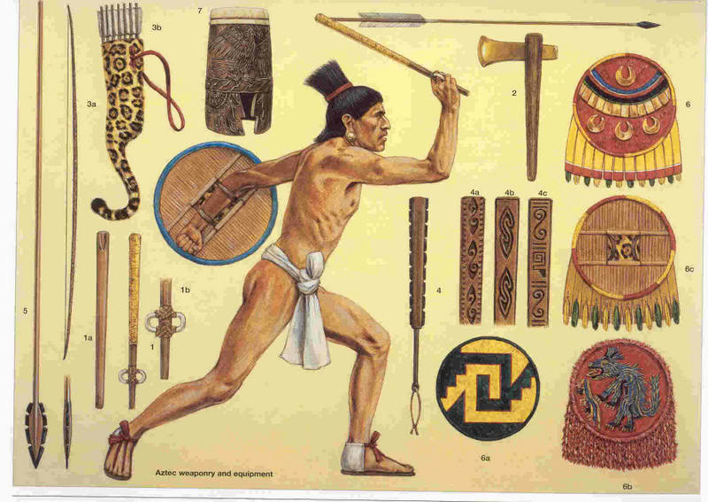](http://www.google.com/url?sa=i&source=images&cd=&cad=rja&docid=5IoeCPmRki6QPM&tbnid=KHSVbgzRrZQdXM:&ved=0CAgQjRwwAA&url=http://ant314510-mumford.wikispaces.com/Aztec+Warrior&ei=PPEbUc3zCM-DhQfj4oGIBQ&psig=AFQjCNGLcCOv2MvJgIfJGw19UO0_3WFT_Q&ust=1360872124175790)

**Aztec Rituals**

Human sacrifice was practiced extensively by the Aztecs, although the actual extent is difficult to gauge because early Spanish observers systematically exaggerated the number of sacrifices as part of their attempts to make the Aztecs seem more savage-like. The most common form of sacrifice involved cutting open the chests of victims on altars atop tall temple-pyramids.

Special sacrifice priests removed the heart and offered it to the gods, and then the body was thrown down the pyramid steps. Most victims were enemy soldiers captured in battle. They were dressed in the clothing of a god, and lived their last weeks being worshipped as that god. The actual sacrifice was a reenactment of one or more myths and the victim was seen as the god, not as a mere human. The skulls of sacrificial victims were displayed in public places on long wood racks. Beyond its manifest religious role, Aztec sacrifice also served social and political ends as a form of propaganda or even terrorism directed against the lower classes and the enemies of the city-state.

Human sacrifices were major components of a series of twenty monthly ceremonies that involved all sectors of Aztec society. Each ceremony, organized and presided over by priests, was planned in advance and lasted several days. There were public processions as sacrificial victims (dressed as gods) paraded through the streets; dances and music; offerings of many kinds; theatrical presentations and speeches, usually leading up the end with a series of sacrifices atop a town's central pyramid.

Alongside the public religion was an active program of domestic ritual that escaped the notice of most Spanish observers. Archaeological excavations of Aztec houses have turned up domestic altars, several forms of incense burners, and clay figurines probably used in curing ceremonies and other household rituals.

**Aztec Religion**

Aztec religion was polytheistic, but deities did not exist as discrete, easily identifiable individuals. The hundreds of named gods and goddesses (**over 260**) were seen more as forces or spirits, each possessing a number of distinctive attributes of clothing and regalia. Stone or clay sculptures would be dressed with a deity's clothing and thereby became its incarnation. The deities and their attributes were painted in the ritual codices, but it is not always possible to identify them because separate deities shared many attributes.

Another cause of confusion for scholars is that many deities were closely-related transformations of one another. The most prominent deities included Tezcatlipoca, a powerful creator god who was the patron of kings; Quetzalcoatl, the god of learning and patron of priests; Tlaloc, an ancient central Mexican rain god; and **Huitzilopochtli, the patron god of the Mexica people**.

Professional priests supervised many public and private rituals in honor of the gods. According to several Aztec myths, the gods had offered their own blood and some gods had sacrificed themselves in order to create the earth, the sun and moon, and humans. People therefore owed a huge debt to the gods, and offerings and sacrifices were the means of repayment. Offerings of food, incense, and other goods were commonplace. Priests engaged frequently in rituals of auto sacrifice in which they pierced various parts of their body to offer blood, which was then spattered on paper strips and burned.

**Aztec Science and Technology**

Most Aztec science served practical ends. Technological knowledge contributed to advancements in areas such as obsidian tools, agricultural methods, and building practices. The Aztec writing system was a form of pictographic representation whose use was limited to a narrow range of ritual, historical, and economic works. Astronomical observations led to fairly accurate descriptions of the heavens and the development of several calendars that could almost rival that of the Mayans.

Although Aztec concepts of health and medicine were based on religious and magical beliefs, medical practice was based upon empirical knowledge. Treatments for wounds, many diseases, and broken bones were highly effective and the early Spanish invaders quickly abandoned Spanish doctors for Aztec medical specialists who were seen as having superior methods.

Several forms of artistic expression were highly developed among the Aztecs. Stone sculpture was particularly notable. Many monumental, state-sponsored sculptures have survived, including the so--called Calendar Stone and other major works in Mexican museums. Smaller sculptures of gods, people, plants, and animals were abundant in temples, homes, and other contexts. Pictorial art in a style known as the Mixteca-Puebla style was expressed in the codices and in mural paintings. Aztec poems, speeches, and ritual chants recorded by Spanish priests include many beautiful expressive works. Music using drums, flutes, rattles, and other instruments was played at many rituals but we know little today about Aztec melody and harmony.

**Aztec Government System**

The basic Aztec political unit was the city-state, or altepetl, ruled by a king, or tlatoani. These kings were selected by a high council of nobles who chose from the male members of the city-state's royal family. Only proven military leaders were considered for kingship, and newly-selected kings had to undertake a successful campaign of conquest before they were fully invested in the office.

As previously noted, most of the Aztec city-states had their origin in the Early Aztec period, and these continued to be important through the time of the Spanish conquest. Even when conquered by stronger polities or by the Aztec empire, city-states remained important local political units. Kings were generally left in power and local government continued without much interruption. Even after the Spanish conquest, city-states retained many of their functions of local administration and the Spaniards modeled their system of territorial organization after the pre-existing Aztec city-states. The Aztec empire conquered over 500 city-states in northern and central Mesoamerica and forced their subjects to pay tribute in textiles, foodstuffs, and many other goods (described in the Codex Mendoza).

The Aztecs followed a policy of indirect rule of their provinces. So long as conquered kings acknowledged the superiority of the Aztecs emperor and paid their tribute quotas, they were left in power. In fact, the Aztecs even supported local kings who cooperated with the empire. The basic goals of Aztec imperialism were economic: the generation of tribute payments and the encouragement of commerce. The Aztecs were not able to conquer all of their enemies. Tlaxcala, a defiant Aztec (Nahuatl-speaking) region east of the Valley of Mexico completely encircled by the empire, was on the verge of being conquered when the Spaniards arrived.

**Aztec Economy**

The Aztec economy was based on agriculture. Staple crops included maize, beans, amaranth, and squash. The population explosion of the Late Aztec period brought about widespread intensification of agriculture throughout central Mexico. Stone terraces were built in hilly locations, rivers were dammed for canal irrigation, and the shallow swampy lakes of the southern Valley of Mexico were converted into highly fertile fields through the construction of raised fields (chinampas). In spite of the increasing yields of Aztec agriculture, famines and food shortages became regular events in the Late Aztec period, resulting in periods of social unrest and a general pattern of malnutrition for commoners. A variety of alternative food sources were exploited, including fish, algae, and insect larvae from the lakes.

Aztec artisans produced a variety of utilitarian and luxury goods. Cotton textiles, produced by women of all social classes, were the most important craft product, both numerically and socially. In addition to their use as clothing, textiles were the primary item of tribute payment and also served as a form of money in the marketplaces. Ceramic cookware and ritual objects were produced throughout the Aztec realm. The volcanic glass obsidian was one of the most remarkable crafts in ancient Mesoamerica. Prismatic blades of obsidian, manufactured by specialists using a difficult and sophisticated method, had the sharpest edge known to science. These tools were used for a variety of domestic and production tasks, and they were one of the most important trade goods in the Aztec economy.