Parents’ Guide to Student Success in Mathematics

First Grade

Why Are Academic Standards Important?
Academic standards are important because they help ensure that all students, no matter where they live, are prepared for success in college and the workforce. Standards provide an important first step — a clear roadmap for learning for teachers, parents, and students. Having clearly defined goals helps families and teachers work together to ensure that students succeed. They also will help your child develop critical thinking skills that will prepare him or her for college and career.

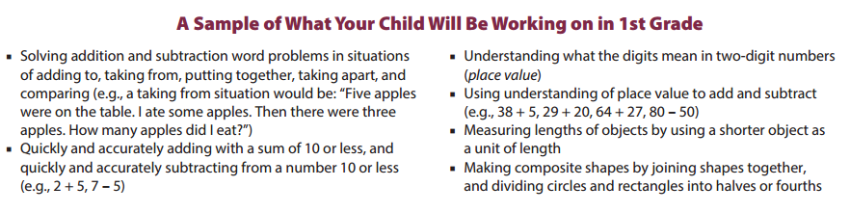

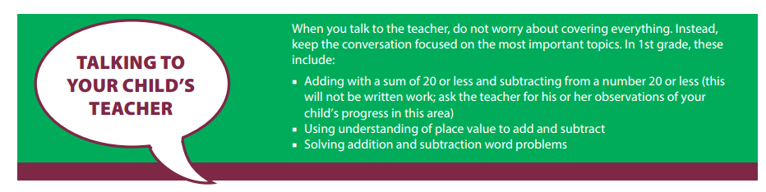

Help Your Child Learn at Home
Try to create a quiet place for your child to study, and carve out time every day when your child can concentrate. You should also try to sit down with your child at least once a week for 15 to 30 minutes while he or she works on homework. This will keep you informed about what your child is working on, and it will help you be the first to know if your child needs help with specific topics. Additionally, here are some activities you can do with your child to support learning at home:
Look for “word problems” in real life. Some 1st grade examples might include:
- If you open a new carton of a dozen eggs, and you use four eggs to cook dinner, close the carton and ask your child how many eggs are left.
- Play the “I’m thinking of a number” game. For example, “I’m thinking of a number that makes 11 when added to 8. What is my number?”

Resource: http://www.pta.org/parents/

First Grade
Nine Week Checkpoints for Parents and Students

First Nine Weeks | Second Nine Weeks
Helpful websites to help students master the first and second nine week concepts:
https://www.khanacademy.org/commoncore/grade-1-NBT
https://www.khanacademy.org/commoncore/grade-1-OA
Students should know and be able to:  - Count to 120 from any number less than 120  - Read and write any number to 120  - Write the number that matches with a group of objects up to 120  - Use ten pennies and a dime interchangeably  - Add and subtract within 20 in more than one way using a variety of strategies (i.e. adding up, compensation, doubles, removal, place value) | Students should know and be able to:  - Determine the missing numbers in addition and subtraction problems.  - Add and subtract within 20 to solve word problems  - Solve addition problems with 3 numbers  - Explain place value of a two-digit number  - Compare two-digit numbers  - Fluently add and subtract within 10 using mental math
Third Nine Weeks | Fourth Nine Weeks
Helpful websites to help students master the third and fourth nine week concepts:
https://www.khanacademy.org/commoncore/grade-1-MD
https://www.khanacademy.org/commoncore/grade-1-G
Students should know and be able to:  - Add within 100, 2-digits plus 1-digit  - Mentally find 10 more, 10 less  - Subtract multiples of 10  - Order and compare the length of two objects  - Measure objects  - Tell time to the half hour using analog and digital clocks | Students should know and be able to:  - Describe shapes  - Combine two-dimensional or three-dimensional shapes to create a new shape  - Divide shapes into equal parts using halves fourths, and quarters to describe them

