from Maus

from Maus Graphic Novel, Page 1  Transcript 1  Page 1, panel 1: In the first panel, a mouse asks an older mouse, “When did you first hear about Aushwitz?” The older mouse answers: Right away we heard.  Page 1, panel 2: The older mouse continues in the second panel: Even from there-from that other world-people came back and told us. But we didn’t believe.  Page 1, panel 3: The older mouse finishes in the third panel: Then this same news came more and more, so we believed. And later on we saw…even worse.  Page 1, panel 4: Above the fourth panel the narrative text reads: After what happened to the grandparents, it was a few months quiet. Then it came posters everywhere and speeches from the gemeinde. In the panel, a mouse in uniform speaks to a crowd: Fellow Jews: On Wednesday, August twelfth, every one of you, young and old, male and female, healthy and sick, must register at the Dienst Stadium. Members of the crowd respond: Oh no! Now what!  Page 1, panel 5: The uniformed mouse continues on the next panel: There’s no cause for alarm-it’s only a matter of inspecting your documents and stamping them. This will protect you as citizens of the region. In the crowd, a mouse responds: I’m not going. It’s a Nazi trap. The narrative text states: Everyone was worried.  Page 1, panel 6: In the last panel, three mice in the crowd are shown speaking. The first mouse says: And our Jewish Committee is helping those murderers. God knows what will happen to us at the stadium. The second mouse says: Well, they just inspected Jewish documents in some nearby towns. It was no big deal. The third mouse says: Anyway, we’ve got to go. Without our legal papers, we’re lost. In a caption, the narrative text states: To go, it was no good. But to not go, it was also no good. | 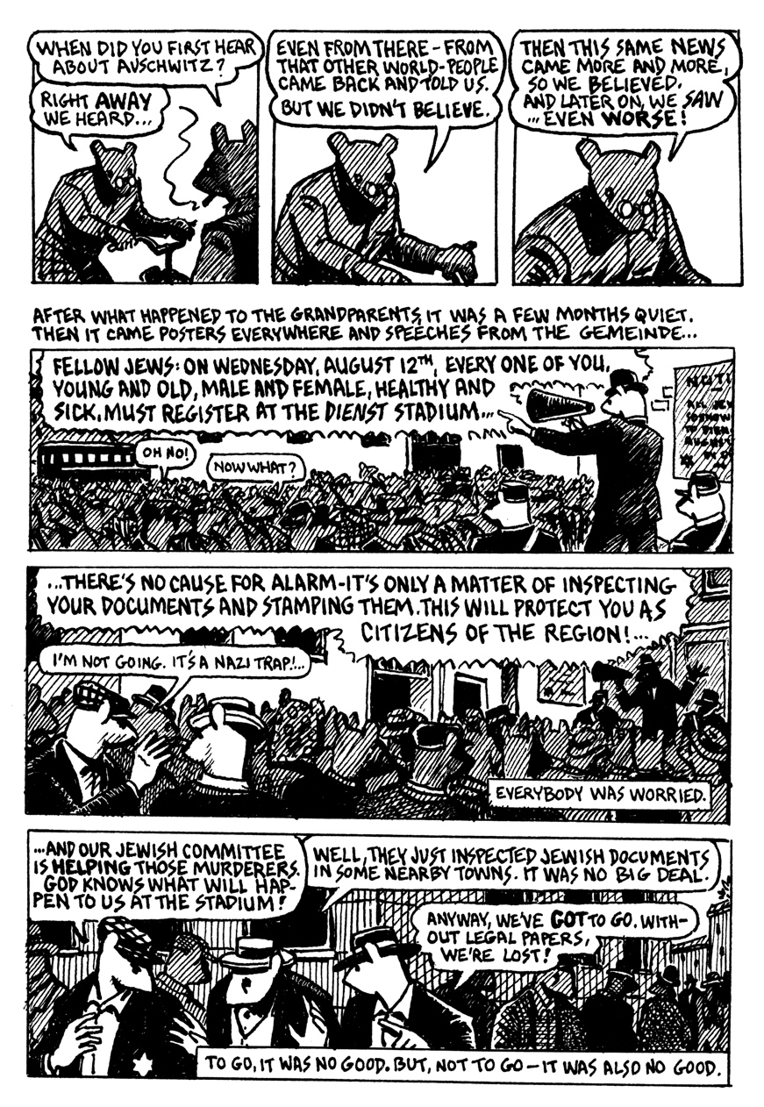

from Maus Graphic Novel, Page 2  Transcript 2  Page 2, panel 1: The narrative text continues above the first panel: My father-he had sixty-two years-came by streetcar to me from Dabrowa, the village next door from Sosnowic. In the panel, a mouse who arrives says to a boy: Here’s a cookie, Richieu. Aunt Bela baked it for you. The boy’s father says: Say thank you to grandpa.  Page 2, panel 2: The narrative text continues above the second panel: After my mother died with cancer, he lived there in the house of my sister, Fela, and her four small children. In the next panel, the grandfather says to his son: I need your advice Vladek. Should I go to the stadium on Wednesday, or hide at home?  Page 2, panel 3: In the next panel, as they sit down at the table, Vladek says: I don’t know. I’m not even sure what we’re going to do…Anja’s mother says she isn’t going. She’s sick and afraid.  Page 2, panel 4: Vladek continues in the next box: At least Anja’s father, Lolek and I all work at the German woodshop. We’re a little safer. But you don’t work. You have no papers. You don’t have anything!  Page 2, panel 5: The grandfather replies in the next panel: Well, cousin Mordecai says he’ll be at one of the inspection tables. I could bring my papers to him. As Richieu approaches the table Vladek responds: What does Fela say?  Page 2, panel 6: The grandfather answers Vladek in the next box: She’s not sure…but if Fela decides to go, of course I’ll go with her. Richieu asks for another cookie and is admonished by his father who says: Richieu! The narration continues below the panel: Really, I didn’t know how to advise him.  Page 2, panel 7: In a panel that shows mice waiting in a line, the narration reads: But finally he did go. People were afraid to not show up. So it came to the stadium almost all the Jews of Sosnowiec, and from the other villages near, maybe twenty-five or thirty thousand people. | 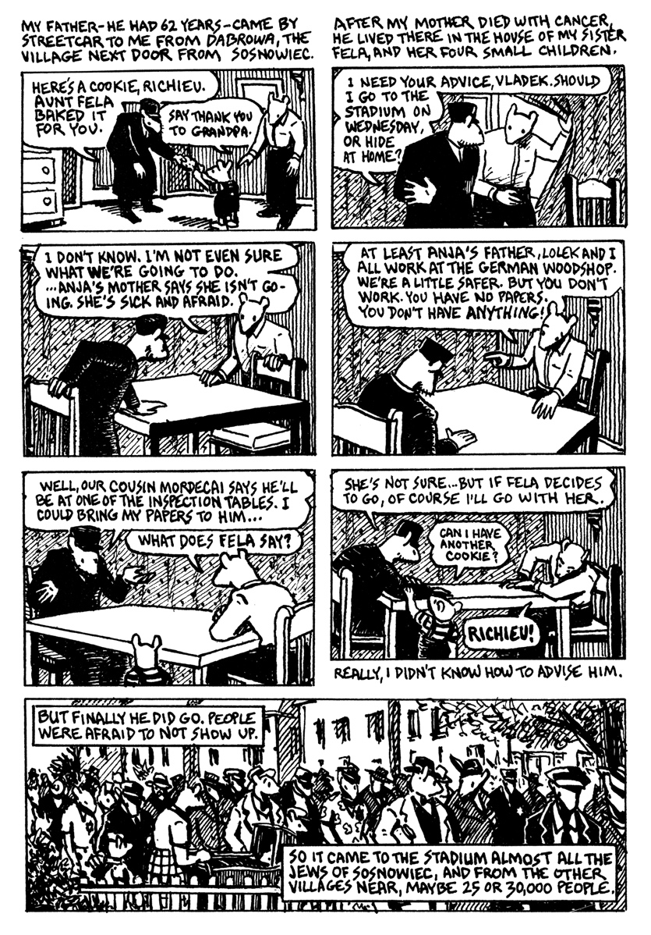
from Maus Graphic Novel, Page 3  Transcript 3  Page 3, panel 1: In a wide illustration of a large crowd viewed from overhead, the narrative text reads: Everyone came very nice dressed. They tried so that they would look young and able to work, in order to get a good stamp on their passport.  Page 3, panel 2: The narration continue above the second panel: When we were everybody inside, Gestapo with machine guns surrounded the stadium. Within the next panel shows a figure in uniform saying into a microphone: Line up at the tables by family to register! Quickly!  Page 3, panel 3: Above the next panel, the narrative text reads: Then was a selection, with people sent either to the left, either to the right. A mouse in a crowd is shown saying: Old people, families with lots of kids, and people without work cards are all going to the left! The narrative text continues: We understood this to be very bad.  Page 3, panel 4: Above another wide illustration, the narrative text reads: Me and Anja came to the table where my cousin was sitting… In the fourth panel the person at the table says: Ah, you work at the carpentry shop. Go to the right. A close up of two stamped passports is shown as the narrative text states: So we got stamped our passports and came quick to the good side of the stadium. Those they sent left, they didn’t get any stamp. | 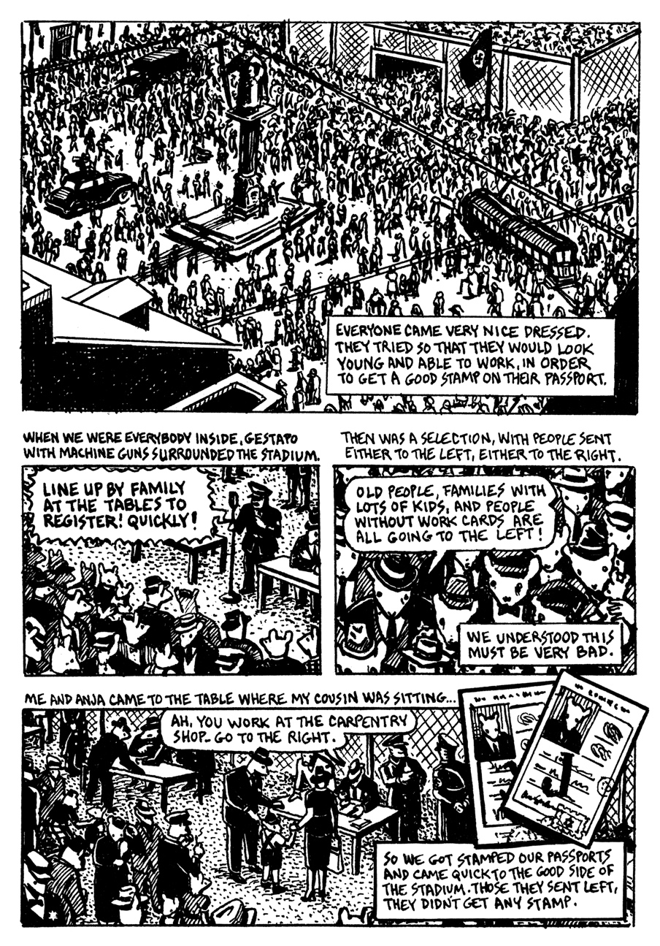
from Maus Graphic Novel, Page 4  Transcript 4  Page 4, panel 1: The narrative text above the first two panels reads: We were so happy we came through. But we worried now-were our families safe? Within the first panel, a mouse says: Look! There’s Poppa with Lolek and Lonia!  Page 4, panel 2: In the next panel, a mouse says: We saw Wolfe and Tosha. Our family seems to be okay. While Vladek responds: Did you see my father? with an emphasis on “my.” The accompanying narrative text reads: I couldn’t see anywhere my father.  Page 4, panel 3: The narrative text continues over the next panel: But later, someone who saw him told me…he came through the same cousin over to the good side. In the panel Vladek’s father is shown at a table and is told: Spiegelman…to the right.  Page 4, panel 4: The narrative text continues: Then came Fela to register. Her they sent to the left. Four children was too many. Vladek’s father, grandpa, is shown with a confused expression at the stadium in the fourth panel. He screams: Fela! The word Fela is shown in large capital letters.  Page 4, panel 5: In the next panel, Vladek’s father, grandpa, is shown saying to other assembled mice at the stadium: My daughter! How can she manage alone-with four children to take care of?  Page 4, panel 6: The narrative text over the next panel states: And what do you think? He sneaked on the bad side! Vladek’s father, grandpa, is shown climbing over a barbed wire fence with accompanying narrative text that reads: And those on the bad side never came anymore home.  Page 4, panel 7: Accompanying a panel that shows several mice walking with their heads down, the narrative text above reads: Those with a stamp were let to go home. But there were very few Jews now left in Sosnowiec…One from three they kept at the stadium…maybe ten thousand people. And with them, my father.  Page 4, panel 8: In the last panel, Vladek is shown hunched over an exercise bike and states: Well…it’s enough for today. Yes, Artie? | 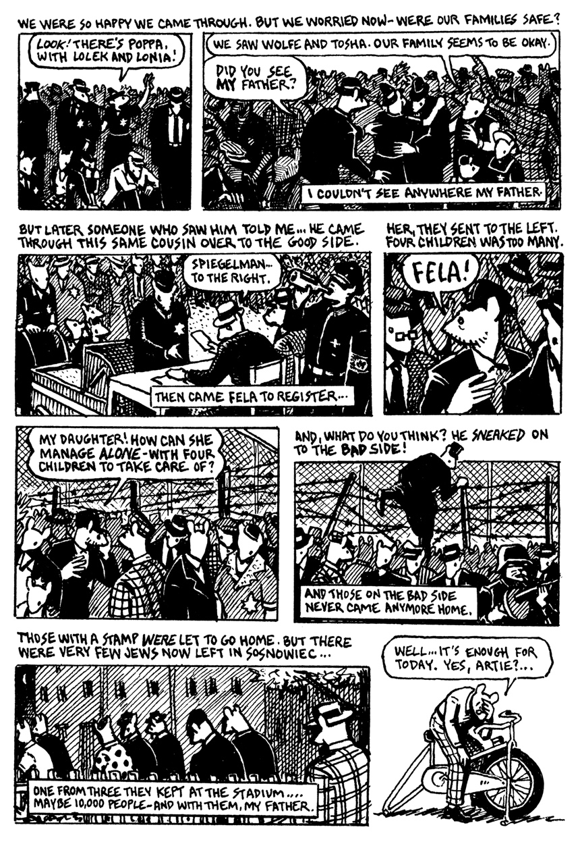
from Maus Graphic Novel, Page 5  Transcript 5  Page 5, panel 1: In the first panel Artie’s father, Vladek, gets up and says: Whoo…I overdid a little. I’m feeling dizzy. Artie responds: Maybe you should lie down a while.  Page 5, panel 2: In the second panel, a female mouse is sitting at a table and asks: Are you finished? as Artie walks into the room and says: Uh-huh. My father’s worn out. He’s taking a nap.  Page 5, panel 3: In the third panel, Artie continues: He was just telling me about the time everyone in Sosnowiec had to get his passport stamped. The other mouse replies: In the stadium? Yes…They got my mother then.  Page 5, panel 4: Across the next three panels, the mouse continues: She was taken with everybody else who was going to be deported, to the four apartment houses that were emptied to make a sort of prison…  Page 5, panel 5: They put thousands of people there….It was so crowded that some of them actually suffocated…no food…no toilets…it was terrible.  Page 5, panel 6: She fills his cup as she continues her tale in the seventh panel: People jumped out of windows to end their misery a little quicker. Artie exclaims: God.  Page 5, panel 7: In the seventh panel, Artie continues to listen as the other mouse says: But my mother SURVIVED that. Her bother was on the Jewish committee. And he hid her in a coal cellar ‘til all the transports left.  Page 5, panel 8: She finishes on the last panel: Then he got me a job scrubbing the people’s filth-Vomit! Excrement!-out of several apartments, and I managed to smuggle her out. | 