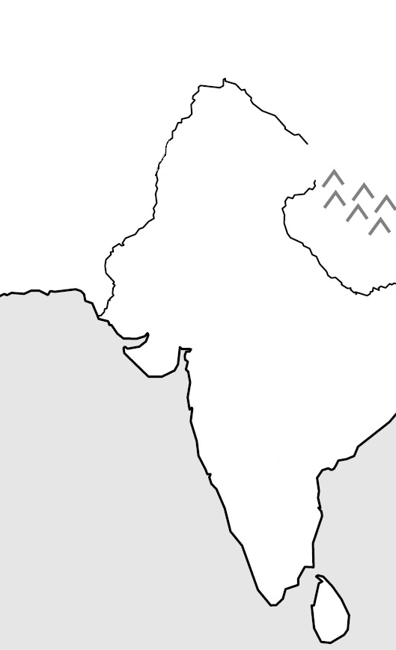
The Indus River Valley
- Unpredictable _______________ flooding
- Strong winds and _____________________
- Protected to the north by the massive _____________________ Mountains
Archeology
- ____________ and buildings discovered in 1922
- Writing discovered but still not _____________________
Major Cities
- _______________ & ___________________
- Both had a _____________________pattern
- Built with standard size __________ & with extensive _______________ systems
Economy
- Farmed ___________, barley, ____________, dates
- Used _____________________ systems and canals
- Traded cotton cloth, grain, copper, bronze pearls, & ivory in cities
Religion
- _____________________
- Included a _____________________ of creation
- Used images of sacred animals such as the _____________________
Disappearance
- Society ends around _____________________
- Theories include _____________________ (tsunami, earthquake)
- Possible invasion by _____________________

Aryans
- _____________________ people
- Migrate into India through _____________________ around 1750 BC
- Begins the _____________________ based on the Vedas
The Vedas
- Written in _____________________ beginning about 1500 BC
- The oldest _____________________ of Hinduism
- Include poems, prayers, and the Hindu _____________________
Aryan Society
- Divided by occupation:
  - _____________________ – priests
  - _____________________ – warriors
  - _____________________ – herders, farmers, artisans, merchants
  - _____________________ – Non-Aryans, laborers, servants
The Caste System
- ________________
- Establishes the basis for ________________ society

