Scene-Plotter

**Step 1:** Use index cards, a piece of paper, a blank Word doc., or below. Close your eyes and picture possible scenes of your story. Jot each different scene idea.

|  |  |  |
| --- | --- | --- |
|  |  |  |
|  |  |  |
|  |  |  |

**Step 2**: Organize the scenes into three piles: BEGINNING, MIDDLE, and END, based on where they will occur in the story.

|  |  |  |
| --- | --- | --- |
| **BEGINNING** | **MIDDLE** | **END** |
|  |  |  |

**Step 3**:

Create a timeline, plot diagram, or numbered list of your scenes in order.

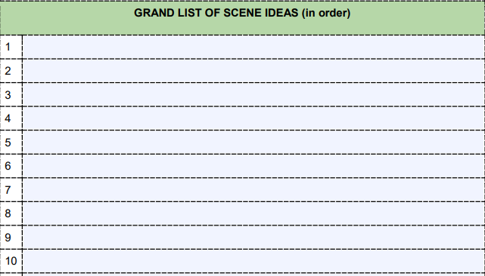

**Step 4**: GET TO WORK DRAFTING!!!