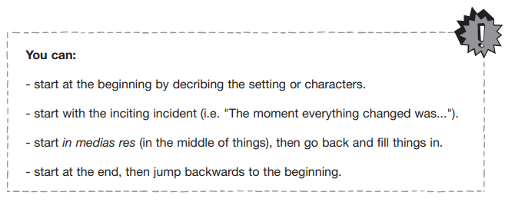

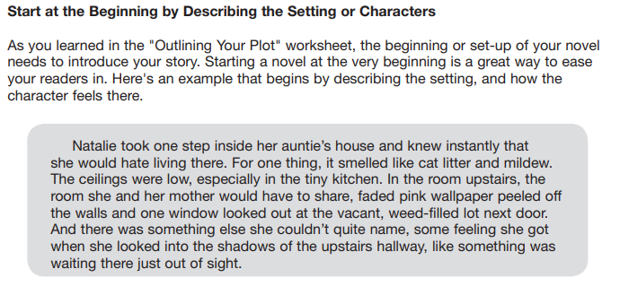

Give it a Try!

________________________________________________________________________________________________________________________________________________________________________________________________________________________________________________________________________________________________________________________________________________________________________________________________________________________________________________________________________________________________________________________________________________

__________________________________________________________________