THE



# FRAMEWORK

## FOR READING

### *Supporting the Georgia Standards of Excellence*

#### **Reading books that match your child's**



**reading level can promote growth in his or her reading ability!**

Reading standards are part of the English Language Arts (ELA) curriculum. The Georgia Standards of Excellence specify that students read and comprehend complex text at each grade level. For this reason, students in grades 3-8 and students taking high school courses in Ninth Grade Literature & Composition or American Literature & Composition receive a Lexile measure in addition to their scale score from the Georgia Milestones Assessment.

The Lexile® Framework for Reading is an educational tool that matches students with reading materials using a common measure called a Lexile®

measure. The Lexile Framework involves a scale for measuring both reading ability of an individual and the text complexity of materials he or she encounters. The Lexile scale is like a thermometer, except rather than measuring temperature, the Lexile Framework measures a text’s complexity

and a reader’s skill. When used together, Lexile reader measures and Lexile text measures help parents to select books, articles, and other materials that match their child’s reading ability.

For more information on how Lexile measures can help to improve your child’s reading ability, visit [**www.gadoe.org/lexile.aspx**](http://www.gadoe.org/lexile.aspx)

#### **About Lexile Measures**

» A Lexile measure represents both a child’s reading ability and the complexity of a text, such as a book or magazine article.

» Lexile measures provide you with valuable information about your child’s reading ability and helps to optimize reading growth.

» Using “Find a Book,” you can help your child choose books and other materials within his or her Lexile range (about 50L above to 100L below his or her Lexile measure).

» When your child reads text within his or her Lexile range, he or she is likely to comprehend enough of the text to make sense of it, while still being suﬃciently challenged to maintain interest and learning.

» Lexile measures estimate the complexity of a text based on vocabulary and sentence length. Lexile measures do not evaluate other features of a book such as

|  |  |
| --- | --- |
| **TEXT LEXILE RANGES TO GUIDE READING FOR COLLEGE AND CAREER READINESS** | |
| **GRADES** | **LEXILE TEXT RANGE** |
| 1 | 190L–530L |
| 2–3 | 420L–820L |
| 4–5 | 740L–1010L |
| 6–8 | 925L–1185L |
| 9–10 | 1050L–1335L |
| 11–12 | 1185L–1385L |

age-appropriateness, the book quality, the book's theme or other such characteristics.

» There is no direct correspondence between a speciﬁc Lexile measure and a speciﬁc grade level. However, guidelines for college and career readiness suggest that students should be reading within or beyond the Lexile ranges shown in the inset table.



» Lexile measures track reading growth over time and across content areas, no matter what grade your child is in.

THE



# FRAMEWORK

## FOR READING

### *Using the Lexile Framework at Home*

#### **Using Lexile Measures to Support Reading Growth**

The free **“Find a Book”** (Lexile.com/fab) is the

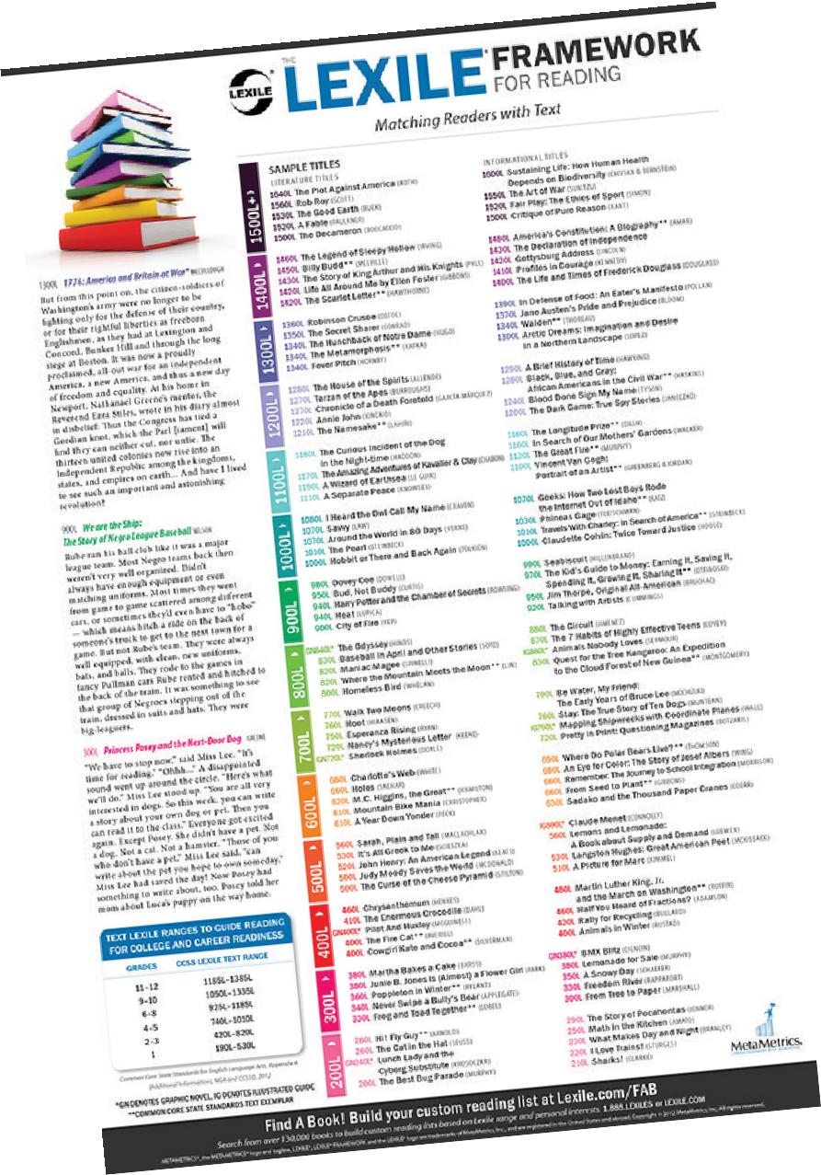

quickest and easiest way to search for ﬁction and non-ﬁction titles at your child’s Lexile level. Whether

your child is reading for school or for pleasure, this tool will help you build custom reading lists on the subjects that interest your child the most—in ﬁve simple steps.

The **Lexile "PowerV" Word Selector** provides level-appropriate vocabulary lists for over 50,000 books. Vocabulary lists can be generated for the child's Lexile reader measure and/ or the book's Lexile text measure. Parents can access the PowerV tool by visiting an individual book detail page when performing a search using "Find a Book" or the Quick Book Search tool on Lexile.com. Parents can use the tool to identify words they might want to familiarize their children with prior to reading a book to

The Georgia Department of Education worked with MetaMetrics®, developer of the Lexile Framework, to customize a **Lexile “map”** for Georgia. The map provides a graphic representation of texts and titles at

##### 02

###### **ENTER**

increase comprehension.

##### 03

###### **PICK**

your child’s interest categories

##### 04

###### **VIEW & REFINE**

your child’s search results

05

###### **PRINT**

your child’s reading list

various levels of reading ability. You can download a copy of the map at: [www.gadoe.org/lexile.aspx](http://www.gadoe.org/lexile.aspx)

your child’s Lexile measure

Find a Book! Build your custom reading list at **Lexile.com/FAB/GA**

Search from over 265,000 books to build custom reading lists based on Lexile range and personal interests. **1.888.LEXILES** or **LEXILE.COM**

METAMETRICS®, the METAMETRICS® logo and tagline, LEXILE®, LEXILE® FRAMEWORK and the LEXILE® logo are trademarks of MetaMetrics, Inc., and are registered in the United States and abroad. Copyright © 2015 MetaMetrics, Inc. All rights reserved.

##### 01

###### **GO TO**

[www.Lexile.com/fab/GA](http://www.Lexile.com/fab/GA)