**Transformations of Quadratics in Vertex form**

**Standards**

* **F.IF.4** For a function that models a relationship between two quantities, interpret key features of graphs and tables in terms of the quantities, and sketch graphs showing key features given a verbal description of the relationship. Key features include: intercepts; intervals where the function is increasing, decreasing, positive, or negative; relative maximums and minimums; symmetries; end behavior; and periodicity.
* **F.IF.8a** Use the process of factoring and completing the square in a quadratic function to show zeros, extreme values, and symmetry of the graph, and interpret these in terms of a context.

**Essential Question**: How can I identify the characteristics of a quadratic?

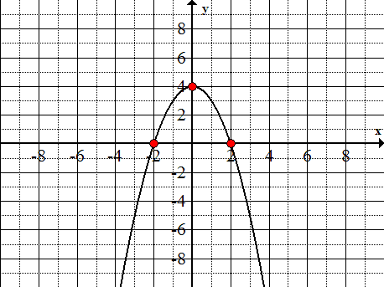A quadratic equation is an equation in which the highest power of the variable is a square. When graphed, the equation forms a “parabola.” A parabola is a curve shaped like the letter U. The points at which the parabola crosses the x-axis are called the solutions or roots.

the vertex is also called the maximum or minimum (depending on the opening of the graph.)

solution or root or zero

solution or root or zero

The solutions can be found by looking at the graph.

Parabolas have certain common characteristics.

1. Axis of symmetry: the line about which the parabola is symmetric; divides a parabola into two mirror images.
2. Vertex: the point of the parabola where the parabola and axis of symmetry intersect; the highest (or lowest) point of a parabola; the point at which the function has its maximum (or minimum) value.

The standard form of a quadratic is y = ax2 + bx + c. The vertex form of a quadratic is y = a(x – h)2 + k where a ≠ 0. The intercept form of a quadratic is y = a(x – p)(x – q), where the x-intercepts of the graph are p and q.

Use a graphing calculator to graph the following functions on the given coordinate plane. Then identify what transformation occurred from the parent graph f(x) = x2 which is already on each coordinate plane.

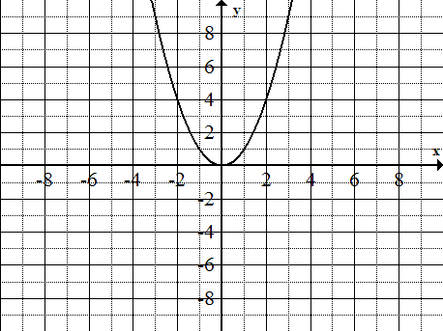1. f(x) = x2 + 2 2. f(x) = (x + 3)2 3. f(x) = x2 - 4

a = ______; h = _______; k = ______ a = ______; h = _______; k = ______ a = ______; h = _______; k = ______

Vertex______________ Vertex______________ Vertex______________

transformation: ________________ transformation: ________________ transformation: ________________

Axis of Symmetry: ______________ Axis of Symmetry: ______________ Axis of Symmetry: ______________

4. f(x) = -x2 5. f(x) = (x - 2)2 6. f(x) = 3x2

a = ______; h = _______; k = ______ a = ______; h = _______; k = ______ a = ______; h = _______; k = ______

Vertex______________ Vertex______________ Vertex______________

transformation: ________________ transformation: ________________ transformation: ________________

Axis of Symmetry: ______________ Axis of Symmetry: ______________ Axis of Symmetry: ______________

Now complete the following conjectures.

1. The graph of y = x2 + k will cause the parent graph to _______________________________.

2. The graph of y = x2 - k will cause the parent graph to _______________________________.

3. The graph of y = (x + h)2 will cause the parent graph to _______________________________.

4. The graph of y = (x - h)2 will cause the parent graph to _______________________________.

5. Multiplying the parent graph by a negative causes the parent graph to ____________________________.

Before answering questions 6 and 7, use the graphing calculator and explore what happens when you graph

y = $\frac{1}{2}x^{2}$; y = $\frac{1}{4}x^{2}$; y = $3x^{2}$ and y = in y2 and y = in y1.

6. Multiplying the parent graph by a number whose absolute value is greater than one causes the parent

graph to ______________________________________.

7. Multiplying the parent graph by a number whose absolute value is between zero and one causes the parent

graph to ______________________________________.

Describe the transformation and identify the vertex.

8. f(x) = 9. f(x) =

Use the graph of f(x) = x2 as a guide to graph transformations of quadratic functions. Horizontal and vertical translations change the vertex of f(x) = x2.

Example: g(x) = (x - 4)2 - 2.

h = _______ k = _______ --> the vertex is (h, k) or (___, ____)

The graph is shifted _____ units ___________

and _____ units ___________

Graph g(x) on the coordinate plane to the left.

|  |  |  |
| --- | --- | --- |
| Summary of the Vertex form for Quadratics  f(x) = a(x - h)2 + k | | |
| If a is NEGATIVE then the graph reflects across the x-axis | If h is POSITIVE, then the graph moves LEFT. | If k is POSITIVE, then the graph moves UP. |
| If |a| is less than 1, the graph SHRINKS. | If h is NEGATIVE, then the graph moves RIGHT. | If k is NEGATIVE, then the graph moves DOWN. |
| If |a| is greater than 1, the graph STRETCHES | Axis of Symmetry: x = h | Vertex: (h, k) |

Practice & Review on Transforming Quadratic Functions

I. Describe what the following actions cause the graph to do.

1a. A negative on the outside

1b. A number less than 1 outside

1c. Add on the inside

1d. Add on the outside

1e. Subtract on the inside

1f. Subtract on the outside

II. Describe the transformations you would perform on in order to graph the following:

1.  3. 

III. Find the vertex and axis of symmetry for each function.

1.  5. 

IV. The vertex form of a quadratic function is . Write the quadratic function in vertex form for the following:

6. the parent function f(x) = x2 is translated 2 units left and 3 units up.

7. the parent function f(x) = x2 is reflected across the x-axis, horizontally stretched by a factor of 3 and translated 2 units down.

V. Describe the difference and similarity between these two functions:

8.  and 

VI. Find the vertex and axis of symmetry of each function then graph each function on a coordinate plane.

9.  10. 

vertex:___________ vertex: __________

A.O.S. ___________ A.O.S. ____________

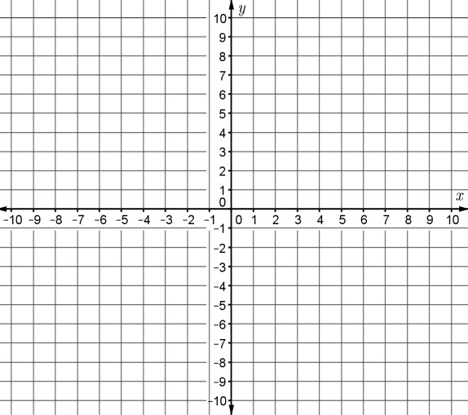

**Lesson 5: Properties of Quadratic Functions in Standard Form**

You can use the properties of a parabola to graph a quadratic function in standard form: f(x) = ax2 + bx +c, a ≠ 0.

|  |  |
| --- | --- |
| Property | Example: f(x) = -x2 – 2x + 2 |
| a > 0; opens upward  a < 0; opens downward | a = -1, b = -2, c = 2  a < 0, so parabola opens downward |
| Axis of symmetry: x =- $\frac{b}{2a}$ | Axis of symmetry: x =- $\frac{b}{2a}=-\frac{\left(-2\right)}{2\left(-1\right)}=-1$ |
| Vertex: $\left(-\frac{b}{2a}, f\left(- \frac{b}{2a}\right)\right)$ | $$f\left(- \frac{b}{2a}\right)=f\left(-1\right)=-1{\left(-1\right)}^{2}-2\left(-1\right)+2=3$$ Vertex: (-1, 3) |
| y-intercept: c | y-intercept is 2, so (0, 2) is a point on the graph |

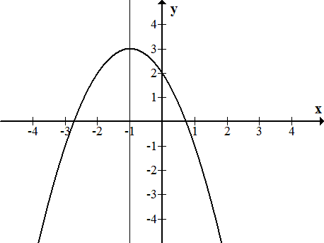

To graph f(x) = -x2 – 2x + 2:

1. Plot vertex

2. Sketch the axis of symmetry through vertex.

3. Plot y-intercept

4. Use symmetry to plot (-2, 2)

5. Sketch the graph

Practice: Use the properties of a parabola to graph f(x) = x2 – 4x + 3.

1. a = ________, b = ________, c = ________

2. The graph opens ___________________________

3. Axis of symmetry: x = - ________

4. __________

5. Vertex = ____________

6. y-intercept = ______________

The **maximum** or the **minimum** value of a parabola is the y-value of the vertex of $f\left(- \frac{b}{2a}\right).$ If the parabola opens upward, a > 0, then it is a minimum value. If the parabola opens downward, a < 0, then it is a maximum value.

|  |  |
| --- | --- |
| $$f\left(x\right)=-2x^{2}+4x-3$$ | $$f\left(x\right)=3x^{2}+12x+1$$ |
| a = -2, Find maximum.  Evaluate $- \frac{b}{2a}$ for a = -2 and b = 4. $$- \frac{b}{2a}=-\frac{4}{2\left(-2\right)}=1$$ $$f\left(- \frac{b}{2a}\right)=f\left(1\right)$$ $$=-2{\left(1\right)}^{2}+4\left(1\right)-3=-1$$ | a = 3, Find minimum.  Evaluate $- \frac{b}{2a}$ for a = 3 and b = 12. $$- \frac{b}{2a}=-\frac{12}{2\left(3\right)}=-2$$ $$f\left(- \frac{b}{2a}\right)=f\left(-2\right)$$ $$=3{\left(-2\right)}^{2}+12\left(-2\right)+1=-11$$ |
| Maximum value is -1 | Minimum value is -11 |
| Range (- $∞$, -1] | Range [-11, $∞)$ |

Find the minimum or maximum value of each function. Then state the range of each function.

7. f(x) = 2x2 – 8x + 9 minimum or maximum? ___________

range: ___________________________

8. f(x) = -3x2 + 6x – 4 minimum or maximum?

$- \frac{b}{2a}=_______$ $f\left(- \frac{b}{2a}\right)=$

___________

range: ___________________________

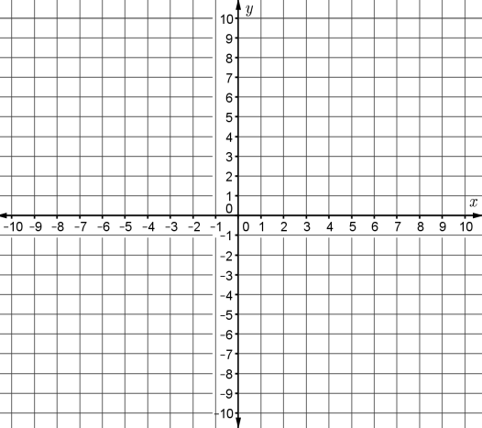For each function (a) determine whether the graph opens upward or downward, (b) find the axis of symmetry, (c) find the vertex, (d) find the y-intercept, (e) determine if the function has a minimum or maximum and (f) find the domain and range. Then graph the function.

9. f(x) = 3x2 + 2x + 1

a) upward or downward

b) axis of symmetry

c) vertex

d) y-intercept

e) minimum or maximum

f) domain:

range:

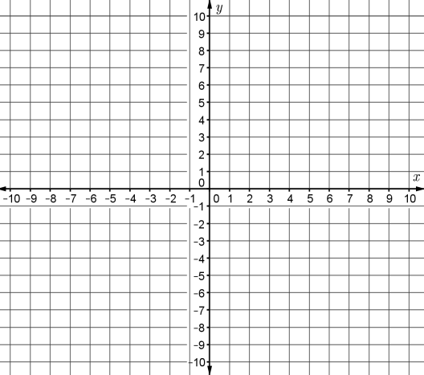10. f(x) = -2x2 – 4x – 2

a) upward or downward

b) axis of symmetry

c) vertex

d) y-intercept

e) minimum or maximum

f) domain:

range:

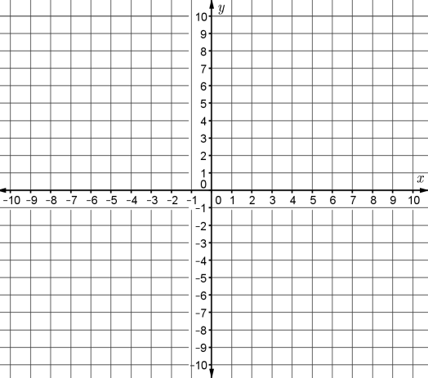11. f(x) = -x2 + 3x + 1

a) upward or downward

b) axis of symmetry

c) vertex

d) y-intercept

e) minimum or maximum

f) domain:

range:

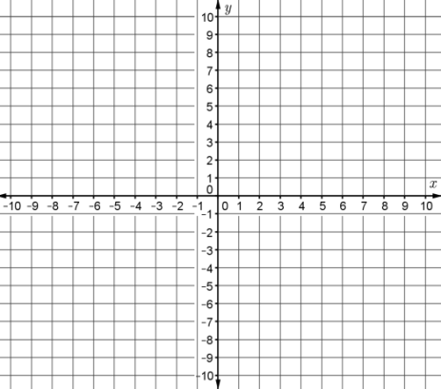**Homework**

1. y = x2 – 2x – 3

identify the zeros/roots: _________ and _________

Does it have a maximum or minimum? ___________

Axis of symmetry: __________ vertex: ___________

y-intercept: ______________________________

Domain: _____________ Range: ______________

Graph the function using at least 5 points

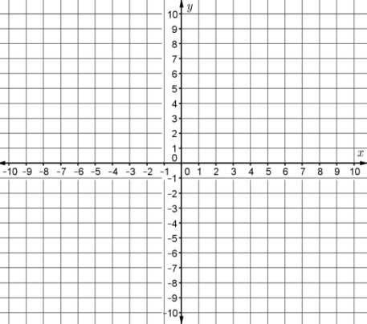

2. y = -x2 - 4x + 5

identify the zeros/roots: _________ and _________

Does it have a maximum or minimum? ___________

Axis of symmetry: __________ vertex: ___________

y-intercept: ______________________________

Domain: _____________ Range: ______________

Graph the function using at least 5 points

3. y = x2 + 4x + 7

identify the zeros/roots: _________ and _________

Does it have a maximum or minimum? ___________

Axis of symmetry: __________ vertex: ___________

y-intercept: ______________________________

Domain: _____________ Range: ______________

Graph the function using at least 5 points



4. y = -x2 - 2x + 2

identify the zeros/roots: _________ and _________

Does it have a maximum or minimum? ___________

Axis of symmetry: __________ vertex: ___________

y-intercept: ______________________________

Domain: _____________ Range: ______________

Graph the function using at least 5 points

**Essential Question(s):** What is the vertex of a parabola and where is it located? Where is the axis of symmetry of a parabola located? What information does the value of *a* in a quadratic function written in standard form give you about the parabola? What information does the value of *c* in a quadratic function written in standard form give you about the parabola? How is the *x*-value of the vertex of a parabola related to the zeros of the function? What are the other forms of quadratic equations?

The graph of a quadratic function has a **vertex** of a parabola which is the lowest (minimum) or highest (maximum) point on the curve. The **axis of symmetry** is the line that passes through the vertex and divides the parabola into two mirror images. For the parabolas we will be looking at, the axis of symmetry is a vertical line.

So far, we have mainly written our quadratic equations in standard form. Today we will also write our quadratic equations in ***factored form***: $y=a\left(x-r_{1}\right)(x-r_{2})$ and ***vertex form***: $y=a{\left(x-h\right)}^{2}+k$.

For each quadratic function, complete the table and sketch a graph. Then, determine the coordinates of the vertex, *x*-intercept(s), *y*-intercept, and the equation for the axis of symmetry. Label these key characteristics on the graph.

$y=x^{2}-4x$

|  |  |
| --- | --- |
| $$x$$ | $$y$$ |
| -2 |  |
| -1 |  |
| 0 |  |
| 1 |  |
| 2 |  |
| 3 |  |
| 4 |  |
| 5 |  |



|  |  |
| --- | --- |
| ***Vertex:*** |  |
| ***x-intercept(s):*** |  |
| ***y-intercept:*** |  |
| ***Axis of symmetry:*** |  |

|  |  |
| --- | --- |
| 1. Convert the equation to factored form | 1. Use completing the square to change the equation to vertex form. |

|  |  |
| --- | --- |
| ***Vertex:*** |  |
| ***x-intercept(s):*** |  |
| ***y-intercept:*** |  |
| ***Axis of symmetry:*** |  |

|  |  |
| --- | --- |
|  |  |
| -5 |  |
| -4 |  |
| -3 |  |
| -2 |  |
| -1 |  |
| 0 |  |
| 1 |  |
| 2 |  |



|  |  |
| --- | --- |
| 1. Convert the equation to factored form | 1. Use completing the square to change the equation to vertex form. |

1. 

|  |  |
| --- | --- |
| ***Vertex:*** |  |
| ***x-intercept(s):*** |  |
| ***y-intercept:*** |  |
| ***Axis of symmetry:*** |  |

|  |  |
| --- | --- |
|  |  |
| -1 |  |
| 0 |  |
| 1 |  |
| 2 |  |
| 3 |  |
| 4 |  |
| 5 |  |

|  |  |
| --- | --- |
| 1. Convert the equation to factored form | 1. Use completing the square to change the equation to vertex form. |

|  |  |
| --- | --- |
| ***Vertex:*** |  |
| ***x-intercept(s):*** |  |
| ***y-intercept:*** |  |
| ***Axis of symmetry:*** |  |

1. 

|  |  |
| --- | --- |
|  |  |
| -5 |  |
| -4 |  |
| -3 |  |
| -2 |  |
| -1 |  |
| 0 |  |
| 1 |  |
| 2 |  |
| 3 |  |

|  |  |
| --- | --- |
| 1. Convert the equation to factored form | 1. Use completing the square to change the equation to vertex form. |

1. The *x*-intercepts of a quadratic function are also called **zeros**. Why?
2. The standard form of the quadratic function is $y=ax^{2}+bx+c$. Use your graphs from Questions 1-4 to answer the following questions.
   1. How does the sign of *a* affect the graph of a quadratic function? Explain.
   2. What does the value of *c* determine in the graph of a quadratic function? Explain.
   3. How is the *x*-value of the vertex related to the *x*-intercepts? Explain.
3. The vertex form of the quadratic function is $y=a{\left(x-h\right)}^{2}+k$. Use your graphs from Questions 1-4 to answer the following questions.
   1. What did you notice about the vertex form and the vertex?
   2. How can you put a quadratic function in vertex form standard form without completing the square?
4. For each given axis of symmetry and point on a parabola, determine another point on the parabola.

|  |  |
| --- | --- |
| * 1. Axis of symmetry ; given point | * 1. Axis of symmetry ; given point : |
| * 1. Axis of symmetry ; given point : | * 1. Axis of symmetry $x=5$; given point $(10, 0)$: |

Just like we can algebraically find the zeros by factoring or using the Quadratic Formula, the vertex and the axis of symmetry can be found algebraically. The axis of symmetry can be found using the non-discriminant part of the Quadratic Formula:

$$x=-\frac{b}{2a}$$

Since the x-coordinate of the vertex is the same as the axis of symmetry in order to find the y-coordinate we must plug in the axis of symmetry in to the original equation and solve for y:

$$Vertex=(axis of symmetry,f\left(axis of symmetry\right))$$

1. For the following problems identify tell whether the graph opens up or down, the axis of symmetry, and the vertex. Then convert the function from standard form to factored form and vertex form.

|  |  |
| --- | --- |
| $y=-x^{2}+12x-27$ | $y=3x^{2}-8x-16$ |
| $y=-16x^{2}+12x-2$ | $y=2x^{2}+7x-15$ |

1. A soccer ball is kicked upward with an initial velocity of 48 feet per second. The acceleration due to gravity is 32 feet per second squared. The equation $s=-16 t^{2}+48t$ represents the height of the ball, *s*, after *t* seconds.

|  |  |
| --- | --- |
| * 1. What is the height of the ball after 2 seconds? | * 1. How long does it take the ball to hit the ground? |
| * 1. How long does it take the ball to reach its highest point? | * 1. How high does the ball go? |

1. An arrow is shot upward with an initial velocity of 40 meters per second. The acceleration due to gravity is approximately 10 meters per second squared. The equation $s=40t-5t^{2}$ represents the height of the arrow, *s*, after *t* seconds.

|  |  |
| --- | --- |
| * 1. What is the height of the arrow after 2 seconds? | * 1. What is the height of the arrow after 5 seconds? |
| * 1. How long does it take the arrow to hit the ground? | * 1. How long does it take the arrow to reach its maximum height? How high does it go? |

**Homework**

Sketch the graph of the function. Label the vertex, zeros (if any) and axis of symmetry.

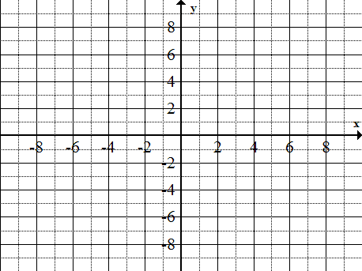1. y = x2 – 2x – 2 2. y = (x +2)(x – 2) 3. y = (x – 3)2 + 2

****Vertex ________ Zeros _____________ Vertex ________ Zeros _____________ Vertex ________ Zeros _____________

4. y = -x2 – 4x – 3 5. y = (x – 4)(x – 2) 6. y = x2 + 4x + 3



Vertex ________ Zeros _____________ Vertex ________ Zeros _____________ Vertex ________ Zeros _____________

7. Use the given graph to determine the vertex, axis of symmetry, and zeros of the parabolas.

|  |  |
| --- | --- |
|  |  |

8. For the following problems identify tell whether the graph opens up or down, the axis of symmetry, and the vertex. Then convert the function from standard form to factored form and vertex form.

|  |  |
| --- | --- |
|  |  |