Name: ________________________
Lecture Review: Chapter 12.2

The Components of DNA
For Questions 1–5, complete each statement by writing in the correct word or words.
- The building blocks of DNA are .
- Nucleotides in DNA are made of three basic components: a sugar called __________________ , a ____________________, and a nitrogenous____________________________.
- DNA contains four kinds of nitrogenous bases: __________________, __________________, __________________, and __________________.
- In DNA, __________________can be joined in any order.
- The nucleotides in DNA are joined by __________________ bonds.

Follow the directions.
1. In the diagram below, the sequence of nucleotides has the code AGCT. Color the diagram using this key:

deoxyribose: red
phosphate group: blue
adenine: yellow
cytosine: green
guanine: orange
thymine: black

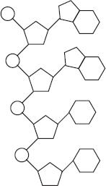
2. Circle one complete nucleotide.
Answer the questions.
3. What two parts do all nucleotides have in common? __________________________________________________________________________________________
4. Each nucleotide is connected to the next nucleotide. The connection is found between
A. sugar of one nucleotide and phosphate of another
B. base of one nucleotide and sugar of another
C. phosphate groups of two nucleotides
5. What are the parts of a DNA nucleotide?
Follow the directions.
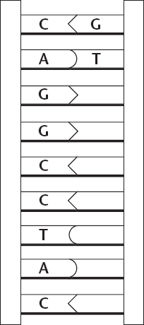
1. Write the missing letter to complete each base pair. The first two have been done for you.
Key
A = Adenine
C = Cytosine
G = Guanine
T = Thymine

Answer the questions.
2. What nucleotide is always paired with thymine?
3. What nucleotide is always paired with guanine?
4. Whose rule does base pairing prove?
5. Suppose a strand of DNA has the following code on one side.
A G T C C A G T A
What would be the matching other side of a DNA strand?

  - Complete the table by estimating the percentages of each using Chargaff’s rules.
DNA sample | Percent of adenine | Percent of thymine | Percent of guanine | Percent of cytosine
1 | 31.5
2 |  | 30 | 20
3 |  |  |  | 17

