Once you are logged into Office 365, you will access to the following apps:

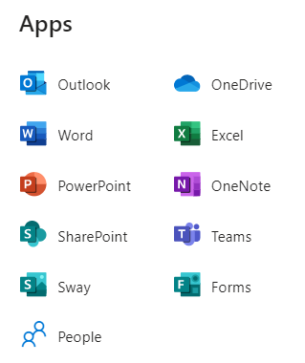

Outlook is where you can access your school email

To search for students or teachers, click on the “new message” button:



Next, type in the last name of the person you are trying to email in the section labeled **“To”.** You can locate any student or teacher at Cross Creek. Please note that you may have to put in the last name & first name for students with common last names. For example, you may have to type “Johnson, Alexis”, instead of going through all of the Johnsons in a list.

