**Welcome to Mrs. Garrett’s Guppies First Grade!**

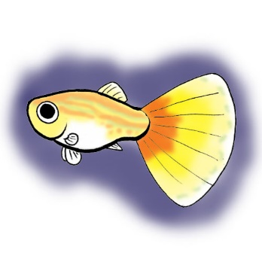

**Hello! I am excited about my first year at Freedom Park School. This is my 5th year teaching and my 2nd year teaching 1st grade. I look forward to getting to know you and your child. Please let me know if you have any questions!**