

**HS Standard 6 2017- Answer Sheet**

**1)**

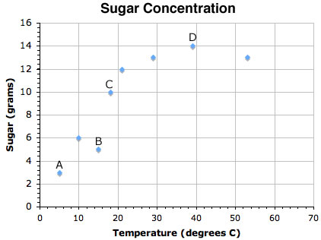

If you wanted to design an experiment to show that the solubility of sugar in tea varies according to the temperature, what variable would remain constant?

|  |  |
| --- | --- |
| **A)** | ***Volume of tea*** |

|  |  |
| --- | --- |
| B) | Concentration of tea |

|  |  |
| --- | --- |
| C) | Temperature of the tea |

|  |  |
| --- | --- |
| D) | Amount of sugar dissolved |

**Explanation:**  
The **volume of tea used** must be the same in every experiment in order for the experiments to be considered valid.

**2)** The electrical conductivity of a substance depends on the ability of the ____ in it to move.

|  |  |
| --- | --- |
| **A)** | ***electrons*** |

|  |  |
| --- | --- |
| B) | neutrons |

|  |  |
| --- | --- |
| C) | protons |

|  |  |
| --- | --- |
| D) | quarks |

**Explanation:**  
The conductivity of an object depends on the ability of the **electrons** in it to move. Protons and neutrons are not involved.

**3)**

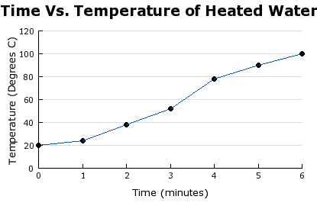

During which two minute time period is the temperature of the water changing fastest?

|  |  |
| --- | --- |
| A) | 0-2 minutes |

|  |  |
| --- | --- |
| **B)** | ***2-4 minutes*** |

|  |  |
| --- | --- |
| C) | 4-6 minutes |

|  |  |
| --- | --- |
| D) | 6-8 minutes |

**Explanation:**  
From **2-4 minutes** the temperature of the water is changing fastest.

**4)**



What is the independent variable in the graph?

|  |  |
| --- | --- |
| A) | Degrees C |

|  |  |
| --- | --- |
| B) | Amount of water |

|  |  |
| --- | --- |
| C) | Temperature of water |

|  |  |
| --- | --- |
| **D)** | ***Time of heating the water*** |

**Explanation:**  
**Time of heating the water** is the independent variable in the graph above. This is the variable that is not being tested, the temperature of the water depends on the amount of time.

**5)**

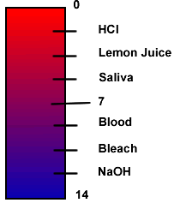

According to the scale, which of these substances is the strongest acid?

|  |  |
| --- | --- |
| A) | NaOH |

|  |  |
| --- | --- |
| B) | blood |

|  |  |
| --- | --- |
| C) | bleach |

|  |  |
| --- | --- |
| **D)** | ***lemon juice*** |

**Explanation:**  
**Lemon juice/b> is the strongest acid listed. Lemon juice contains a high concentration of citric acid and has a low pH.**

**6) Sugar is added to tea to make sweet tea. In chemical terms the sugar is the ___________ and the tea (mostly water) is the**

|  |  |
| --- | --- |
| A) | endothermic, exothermic. |

|  |  |
| --- | --- |
| B) | chemical, dissolution. |

|  |  |
| --- | --- |
| C) | reactant, product. |

|  |  |
| --- | --- |
| **D)** | ***solute, solvent.*** |

**Explanation:  
Solute, solvent is correct. In solutions, a solute is what is being dissolved and a solvent is what is doing the dissolving.**

**7) How many variables should be manipulated in a correctly performed scientific experiment?**

|  |  |
| --- | --- |
| **A)** | ***one*** |

|  |  |
| --- | --- |
| B) | three |

|  |  |
| --- | --- |
| C) | two |

|  |  |
| --- | --- |
| D) | zero |

**Explanation:  
In order to be a valid experiment only one variable should be manipulated. This ensures that the experiment will produce valuable data.**

**8) How does crushing a cube of solute increase the rate of dissolving?**

|  |  |
| --- | --- |
| A) | By increasing the amount of solvent. |

|  |  |
| --- | --- |
| B) | By decreasing the amount of solvent. |

|  |  |
| --- | --- |
| **C)** | ***By increasing the surface area of the solute.*** |

|  |  |
| --- | --- |
| D) | By decreasing the surface area of the solute. |

**Explanation:  
Crushing a solute helps to increase the rate of dissolving by increasing the surface area of the solute. If more solvent can come in contact with a greater amount of solute, the rate of dissolving increases.**

**9) Jake wants to quickly dissolve Gatorade in a pitcher. What would help Jake INCREASE the rate at which his Gatorade dissolves?**

|  |  |
| --- | --- |
| A) | adding sugar |

|  |  |
| --- | --- |
| B) | cooling the mixture |

|  |  |
| --- | --- |
| C) | adding more Gatorade |

|  |  |
| --- | --- |
| **D)** | ***stirring the mixture*** |

**Explanation:  
Stirring the mixture helps to expose more solute to solvent, thus increasing the rate of dissolving.**

**10) Which is an example of a solution?**

|  |  |
| --- | --- |
| **A)** | ***air*** |

|  |  |
| --- | --- |
| B) | oxygen |

|  |  |
| --- | --- |
| C) | salt |

|  |  |
| --- | --- |
| D) | water |

**Explanation:  
Air is a solution comprised of mostly nitrogen, oxygen, carbon dioxide and water vapor. Solutions are also called homogeneous mixtures. Water is a compound and oxygen is an element, neither of which are solutions.**

**11) In a solution, the parts of the solution are mixed**

|  |  |
| --- | --- |
| A) | chemically. |

|  |  |
| --- | --- |
| **B)** | ***physically.*** |

|  |  |
| --- | --- |
| C) | only in water. |

|  |  |
| --- | --- |
| D) | by electronic means. |

**Explanation:  
A solution is a physical combination of two or more substances. If they were chemically combined, this would be an example of a compound. Many, but not all, solutions are dissolved in water; consider air.**

**12) Adding powdered Gatorade to water makes a tasty solution. What is the solvent in this example?**

|  |  |
| --- | --- |
| **A)** | ***water*** |

|  |  |
| --- | --- |
| B) | salt and sugar |

|  |  |
| --- | --- |
| C) | Gatorade liquid |

|  |  |
| --- | --- |
| D) | Gatorade powder |

**Explanation:  
The solvent is the component that does the dissolving. In this case, water dissolves the Gatorade powder. Water is sometimes referred to as the universal solvent.**

**13) Dissolved in many gasolines are cleaning agents and anti-knock additives. These cleaning agents and additives are an example of**

|  |  |
| --- | --- |
| A) | solids. |

|  |  |
| --- | --- |
| **B)** | ***solutes.*** |

|  |  |
| --- | --- |
| C) | solutions. |

|  |  |
| --- | --- |
| D) | solvents. |

**Explanation:  
In this case, gasoline is the solvent and the parts added to it are the solutes. These are the components that are dissolved.**

**14)**

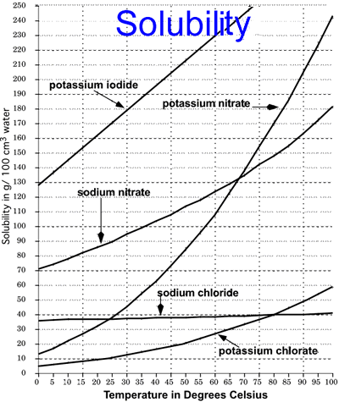

**Based on the solubility chart, which of the listed salts is the most soluble at 25 °C?**

|  |  |
| --- | --- |
| **A)** | ***sodium nitrate*** |

|  |  |
| --- | --- |
| B) | sodium chloride |

|  |  |
| --- | --- |
| C) | potassium nitrate |

|  |  |
| --- | --- |
| D) | potassium chlorate |

**Explanation:  
Sodium nitrate is the most soluble at 25 °C. Simply follow a vertical line straight up at the x-axis value of 25 until you reach the highest of the those listed in the question. Potassium iodide is much more soluble, but it is not listed as an answer choice.**

**15) Which statement is true about tomato juice?**

|  |  |
| --- | --- |
| **A)** | ***It is an acid.*** |

|  |  |
| --- | --- |
| B) | It has a pH of 7.0. |

|  |  |
| --- | --- |
| C) | It is strongly basic in nature. |

|  |  |
| --- | --- |
| D) | It is a weak hydrophobic substance. |

**Explanation:  
Tomato juice is an acid. Tomato juice gives up H+ ions in solution, so it is considered to be an acid. It has a low pH.**

**16)**

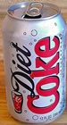

**Coca cola is similar to tomato juice because**

|  |  |
| --- | --- |
| A) | they are both bases. |

|  |  |
| --- | --- |
| **B)** | ***they are both acids.*** |

|  |  |
| --- | --- |
| C) | they are carbonated. |

|  |  |
| --- | --- |
| D) | they are high in fructose. |

**Explanation:  
Diet Coke and tomato juice are both acids because they test low on the pH scale. Solutions that have a pH below 7.0 are considered acids.**

**17) Which piece of lab equipment has specific markings for highly accurate measurements of liquid volumes?**

|  |  |
| --- | --- |
| A) | beaker |

|  |  |
| --- | --- |
| B) | test tube |

|  |  |
| --- | --- |
| C) | watch glass |

|  |  |
| --- | --- |
| **D)** | ***graduated cylinder*** |

**Explanation:  
A Graduated Cylinder. Graduated cylinders are made to measure very specific volumes of liquid.**

**18)**

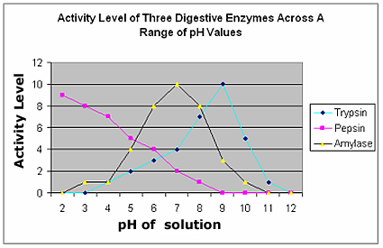

**The graph illustrates the *relative* activity levels of three common digestive enzymes, where 0 represents no activity and 12 represents the highest level of activity. Which enzyme is most active at a neutral pH of 7?**

|  |  |
| --- | --- |
| A) | pepsin |

|  |  |
| --- | --- |
| B) | trypsin |

|  |  |
| --- | --- |
| **C)** | ***amylase*** |

|  |  |
| --- | --- |
| D) | pepsin and amaylase |

**Explanation:  
Amylase. Amylase, found in saliva, is most active at a neutral pH of 7. This pH is too high for pepsin and too low for optimum trypsin activity.**

**19)**

|  |
| --- |
| Pepsi Vinegar Orange Juice |

**What property do all three of these common household substances have in common?**

|  |  |
| --- | --- |
| **A)** | ***They are all acidic.*** |

|  |  |
| --- | --- |
| B) | They all taste bitter. |

|  |  |
| --- | --- |
| C) | They all have a pH above 7. |

|  |  |
| --- | --- |
| D) | They all turn litmus paper blue. |

**Explanation:  
They are all acidic. They all turn litmus paper red, have a pH below 7 and can taste sour.**

**20)**

|  |
| --- |
| Bleach Detergent Ammonia |

**What property do all three of these common household substances have in common?**

|  |  |
| --- | --- |
| A) | They are all acidic. |

|  |  |
| --- | --- |
| B) | They all taste sour. |

|  |  |
| --- | --- |
| **C)** | ***They all have a pH above 7.*** |

|  |  |
| --- | --- |
| D) | They all turn litmus paper red. |

**Explanation:  
They all have a pH above 7. They all turn litmus paper blue, taste bitter, and are bases.**

**21)**

|  |
| --- |
| Lemon Juice Tums (antacid) Water |

**Put all of the above household items in order from lowest to highest pH.**

|  |  |
| --- | --- |
| **A)** | ***Lemon juice, water, Tums*** |

|  |  |
| --- | --- |
| B) | Water, Tums, Lemon Juice |

|  |  |
| --- | --- |
| C) | Water, Lemon Juice, Tums |

|  |  |
| --- | --- |
| D) | Tums, water, lemon juice |

**Explanation:  
Lemon juice, water, Tums is the correct order. Lemon juice is an acid with a low pH. Water has a pH of 7. And, Tums is a base with a high pH.**

**22)**



**What conclusion may be made based on this graph?**

|  |  |
| --- | --- |
| **A)** | ***Increasing temperature increases solubility.*** |

|  |  |
| --- | --- |
| B) | Decreasing temperature increases solubility. |

|  |  |
| --- | --- |
| C) | Increasing temperature decreases solubility. |

|  |  |
| --- | --- |
| D) | Increasing solubility, decreases temperature. |

**Explanation:  
Increasing temperature increases solubility. The trend for all the compounds shows a positive correlation between temperature and solubility.**

**23)**



**Which compound demonstrated the LEAST increase of solubility as a result of an increase in temperature?**

|  |  |
| --- | --- |
| A) | sodium nitrate |

|  |  |
| --- | --- |
| **B)** | ***sodium chloride*** |

|  |  |
| --- | --- |
| C) | potassium iodide |

|  |  |
| --- | --- |
| D) | potassium nitrate |

**Explanation:  
Sodium chloride demonstrated the LEAST increase of solubility as a result in increase in temperature. It only had an increase of solubility of about 3 g/100 cm3 over a temperature increase of 100 degrees Celsius.**

**24)**



**Which compound demonstrated the GREATEST increase of solubility as a result of an increase in temperature?**

|  |  |
| --- | --- |
| A) | sodium nitrate |

|  |  |
| --- | --- |
| B) | sodium chloride |

|  |  |
| --- | --- |
| **C)** | ***potassium nitrate*** |

|  |  |
| --- | --- |
| D) | potassium chlorate |

**Explanation:  
Potassium nitrate demonstrated the GREATEST increase of solubility as a result in increase in temperature. It had an increase of solubility of about 230 g/100 cm3 over a temperature increase of 100 degrees Celsius.**

**25)**

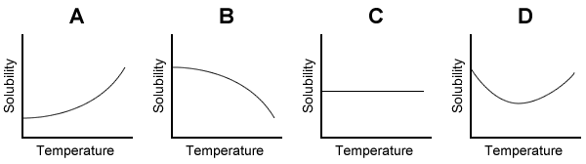

**Which solubility graph correctly depicts the increase of solubility associated with an increase of temperature of the solution?**

|  |  |
| --- | --- |
| **A)** |  |

|  |  |
| --- | --- |
| B) |  |

|  |  |
| --- | --- |
| C) |  |

|  |  |
| --- | --- |
| D) |  |

**Explanation:  
Graph A demonstrates an increase of solubility as a result of increase in temperature.**

**26) Oven cleaner is a highly caustic chemical that reacts with baked on foods. It is dangerous to the touch and has a very slippery feel.  
  
What is the likely pH of oven cleaner?**

|  |  |
| --- | --- |
| A) | below 4 |

|  |  |
| --- | --- |
| B) | around 7 |

|  |  |
| --- | --- |
| **C)** | ***above 10*** |

|  |  |
| --- | --- |
| D) | between 5 and 7 |

**Explanation:  
The likely pH of oven cleaner is above 10. Actually it can be around 13 or 14. This can be determined by the fact that it is highly caustic (corrosive) and that it feels slippery. It is a base and on the very high end of the pH scale.**

**27)**

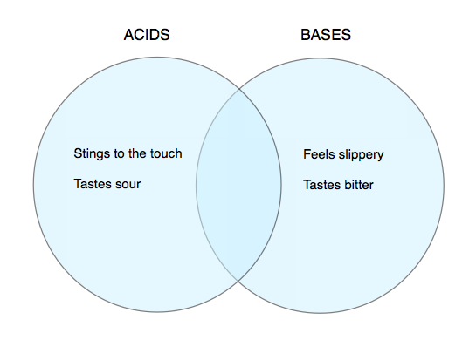

**Which phrase can accurately be placed in the middle, within both circles?**

|  |  |
| --- | --- |
| A) | has a pH of 7 |

|  |  |
| --- | --- |
| B) | dissolves metals |

|  |  |
| --- | --- |
| **C)** | ***ionizes in water*** |

|  |  |
| --- | --- |
| D) | turns red litmus paper blue |

**Explanation:  
Ionizes in water is the only statement that can be used to describe both acids and bases. Acids dissociate to form hydrogen (or hydronium) ions in water, bases form hydoxide ions.**

**28)**



**Which statement could ONLY be accurately placed within the base circle?**

|  |  |
| --- | --- |
| A) | is common in fruit juices |

|  |  |
| --- | --- |
| B) | can be found in the stomach |

|  |  |
| --- | --- |
| C) | can dissolve a copper penny |

|  |  |
| --- | --- |
| **D)** | ***includes many cleaners, like bleach*** |

**Explanation:  
Only bases include many cleaners, like bleach. Acids are found in the stomach, in fruit juices, and dissolve metals.**

**29)**

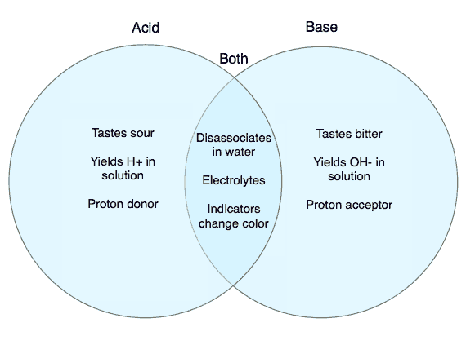

**BOTH acids and bases**

|  |  |
| --- | --- |
| A) | turn red litmus blue. |

|  |  |
| --- | --- |
| B) | are a component of soaps |

|  |  |
| --- | --- |
| C) | donate protons to solution. |

|  |  |
| --- | --- |
| **D)** | ***conduct electricity in water.*** |

**Explanation:  
Both acids and bases produce ions in solution, are electrolytes, and conduct electricity in solution. Although red litmus is an indicator, it does not change color in an acid, acids are proton donors while bases are proton acceptors. Soaps often contain bases, not acids.**

**30)**

|  |  |  |  |
| --- | --- | --- | --- |
|  | **Boiling Point** | **Electrical conductivity in aqueous solution** | **Solubility in H2O (grams of solid in 100 grams H2O)** |
| A | Low, 65o C | Poor | 3.0 |
| B | High 1600oC | Good | 36.0 |

**During chemistry class, Carl performed several lab tests on two white solids. The results of three tests are seen in the data table. Based on this data, Carl has concluded that substance B must have ____________ bonds.**

|  |  |
| --- | --- |
| A) | covalent |

|  |  |
| --- | --- |
| B) | diatomic |

|  |  |
| --- | --- |
| **C)** | ***ionic*** |

|  |  |
| --- | --- |
| D) | metallic |

**Explanation:  
Based on the data, substance B must have ionic bonds. Ionic compounds are often soluble in water. When dissolved in water, they dissociate and form ions that conduct electricity. Finally, ionic compounds have strong intermolecular forces and therefore have a very high boiling point.**

**31)**

**Data Analysis**

|  |  |
| --- | --- |
| **Aquatic Organism** | **pH Range for Life** |
| Clam | 4.5 - 5.0 |
| Snail | 5.0 - 9.0 |
| Bass | 5.5 - 9.0 |
| Crayfish | 5.5 - 8.5 |
| Mayfly | 5.5 - 9.0 |
| Salamander | 6.0 - 8.0 |
| Trout | 6.0 - 8.5 |
| Perch | 6.5 - 8.5 |
| Frog | 7.0 - 9.5 |

**To test acidity levels of water, scientists test pH. As acid rain falls, the pH level of the water in lakes and streams decreases. While certain animals can tolerate low pH levels, others are extremely sensitive to the effects of acid rain and cannot live under these conditions. Candice is working on a project to determine whether acid rain is causing a decrease in the number of bass and mayflies in a lake in her hometown. Candice takes a sample of the pH level of the lake, and she finds that the pH level is 5.4. What might Candice predict as a result of her findings?**

|  |  |
| --- | --- |
| A) | The lake's pH level of 5.4 is safe for both bass and mayflies, but not for frogs. |

|  |  |
| --- | --- |
| **B)** | ***The lake's pH level of 5.4 will cause a decrease in the amount of bass and mayflies.*** |

|  |  |
| --- | --- |
| C) | The lake's pH level of 5.4 will affect the number of bass, but probably not the mayflies. |

|  |  |
| --- | --- |
| D) | The lake's pH level of 5.4 will not affect the survival of any of the animals listed in the chart. |

**Explanation:  
This bar chart represents at the pH levels at which certain animals cannot live. The lower pH levels begin to negatively affect some animals. Bass and mayflies cannot live in a condition with a pH level below 5.5. Therefore, a pH level of 5.4 is extremely dangerous for both bass and mayflies. Candice can draw the conclusion, based on the chart, that The lake's pH level of 5.4 will cause a decrease in the amount of bass and mayflies. in her hometown.**

**32) Litmus paper is made from water-soluble dyes which are extracted from lichens. This paper is used as an acid-base indicator. Which of these common household substances would turn blue litmus paper red?**

|  |  |
| --- | --- |
| A) | bleach |

|  |  |
| --- | --- |
| B) | lye |

|  |  |
| --- | --- |
| C) | soap |

|  |  |
| --- | --- |
| **D)** | ***vinegar*** |

**Explanation:  
Blue litmus paper turn red in the presence of an acid, and vinegar is the only choice that is an acid. The rest of the choices are bases and blue litmus would stay blue when dipped in them.**

**33) Matthew was working with different concentrations of hydrochloric acid in the lab. Which of these would BEST describe the results Matthew would see if he was using a conductivity apparatus in each of the different acid concentrations?**

|  |  |
| --- | --- |
| A) | The bulb would burn the same in all concentrations. |

|  |  |
| --- | --- |
| B) | The light bulb would burn brightest in the weakest acid. |

|  |  |
| --- | --- |
| **C)** | ***The light bulb would burn brightest in the strongest acid.*** |

|  |  |
| --- | --- |
| D) | The light bulb would not burn as acids do not conduct electricity. |

**Explanation:  
The light bulb would burn brightest in the strongest acid. The stronger the acid, the more ions produced in solution, and the better conductor it is.**

**34)**

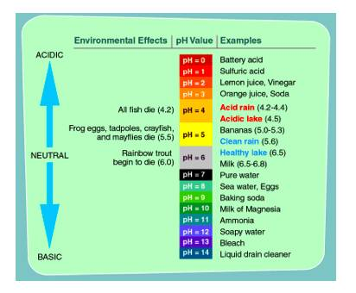

**According to this graph, a lake that has a pH level of 4**

|  |  |
| --- | --- |
| **A)** | ***has no fish.*** |

|  |  |
| --- | --- |
| B) | has many frogs. |

|  |  |
| --- | --- |
| C) | has few rainbow trout. |

|  |  |
| --- | --- |
| D) | is healthy and thriving. |

**Explanation:  
This chart shows that a healthy lake has a pH of about 7. As this acidity increases, the pH will decrease. A lake with a ph level of only 4 has no fish.**

**35)**

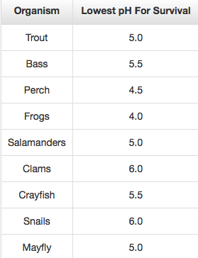

**Sulfur emissions from industry combine with water in the atmosphere and form acid rain. A new factory is built very close to the lake that Josh visits often. By examining the table that shows what pH range different species can survive, Josh decides that the aquatic life will be affected by the changes in pH that the lake. Josh correctly decides that organisms that will be the most affected are**

|  |  |
| --- | --- |
| A) | perch and frogs. |

|  |  |
| --- | --- |
| B) | mayfly and bass. |

|  |  |
| --- | --- |
| **C)** | ***snails and clams.*** |

|  |  |
| --- | --- |
| D) | frogs and salamanders. |

**Explanation:  
The answer is snails and clams. Organisms can live in narrow range of pH. The pH level of the lake will drop with the acid rain and only those organisms that can survive acidic pH environment will survive.**

**36)**

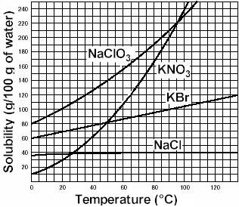

**Consider the four salts represented on the solubility curves displayed as line graphs. In all four cases the salts are which part of an aqueous solution?**

|  |  |
| --- | --- |
| A) | precipitate |

|  |  |
| --- | --- |
| **B)** | ***solute*** |

|  |  |
| --- | --- |
| C) | solvation |

|  |  |
| --- | --- |
| D) | solvent |

**Explanation:  
Each salt is a different solute dissolved in water, which would be the solvent.**