**Internal Assessment- How Temperature Affects the Rate of Enzyme Activity**

Candidate Name: Jae In Lee

Candidate Number: 2213-060

**Research Question:** What is the effect of temperature on oxygen gas production in a *Panax ginseng* catalase reaction, with substrate hydrogen peroxide, measured by a gas pressure sensor?

**Introduction**

Biological catalysts called enzymes increase the rate of reactions without themselves being chemically changed. Enzymes are globular proteins folded into a complex 3-dimensional shape that contain a special surface region called the active site where a specific substrate binds to structurally and chemically. Enzymes speed up reactions as they lower the activation energy, which is the minimum energy barrier needed to be overcome before a reaction can occur by providing an alternative reaction pathway.

In this experiment, the enzyme that will be used is catalase. This molecule is commonly found in animal and plant cells, but a substantial amount is found in a nutritious plant called ginseng or scientifically known as *Panax ginseng*. The substrate that will be catalyzed is hydrogen peroxide (H2O2) which is a poisonous waste product in the human body. Therefore, the catalase enzyme will specifically catalyze the hydrolysis reaction of H2O2 into safe, non-poisonous products of water and oxygen gas:

**2H2O2  2H2O(l) + O2(g)**

This experiment will specifically investigate the effect of temperature on the rate of reaction which can be calculated by measuring the speed of production formation. In this experiment, the production of O2 gas will determine the rate of reaction through the change in pressure as the reaction progresses. The rate at various temperatures is acquired by calculating the slope of pressure vs. time graph. Gas pressure inside the test tube will also increase depending on the amount of oxygen gas produced over a given unit of time. If the pressure change or steepness of slope is large, the rate of reaction is fast and if the change or slope is small, the rate is slow.

**Reaction = $\frac{∆ Pressure/kPa}{Time/min}$**

**Hypothesis**

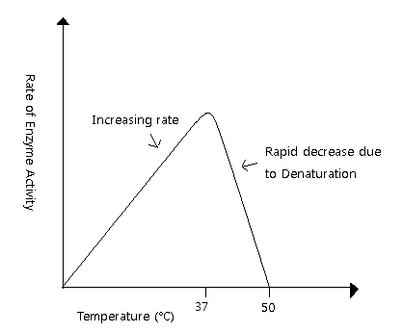

*Figure 1: Predicted Enzyme Activity Rate*

According to the Collision Theory, for a reaction to occur, particles must collide with sufficient energy to overcome the activation energy and with correct geometrical orientation. The hypothesis illustrated in Figure 1 above is that as temperature increases, so will the rate of reaction, for an increase in temperature also increases the kinetic energy of the substrate and enzyme molecules. In this case, faster movement of H2O2 and catalase molecules will increase collision frequency hence also increase the number of effective collisions. As a result, more reactions will be catalyzed and more oxygen gas will be produced in a given unit of time; therefore, enzyme activity and rate of reaction will increase.

Moreover, the Maxwell Boltzmann distribution curve shown below supports the hypothesis.

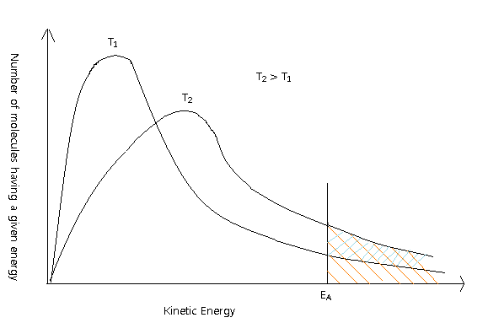

*Figure 2: Maxwell Distribution Curve*

Curves T1 and T2 show the distribution of kinetic energies for gaseous molecules at two different temperatures. Curve T2 is positively skewed because it represents a higher temperature. Hence, the peak of the graph with the most molecules is shifted towards a higher kinetic energy value and the curve broadens out. For both cases, the total area under the curve is the same; nevertheless the fraction of molecules with energy greater than the activation energy (EA) is much larger in T2 than T1. Thus, when temperature increases, more substrate particles have sufficient energy to react thus more products are formed at a given unit of time.

Furthermore, the Arrhenius equation,

k = Ae(-Ea/RT)

shows the relationship between the rate constant, k, and absolute temperature. *A* and *R* are constants; therefore it is assumed that the rate of reaction is proportional to *e(-Ea/RT)* and increases when temperature, *T*, increases.

However, since enzymes are proteins, they can be considered fragile. If the temperature becomes too high, the amino acids in the enzyme protein will vigorously vibrate to break intramolecular bonds. Then, the enzyme denatures, meaning the structure of the protein has irreversibly changed so that the substrate no longer fits into the active site, making it functionless. This denaturation point is when the temperature of the enzyme immediately exceeds the optimum temperature and starts decreasing the rate of reaction in response to increasing temperature. The hypothesis is that 37°C will be the optimum temperature where catalase activity will occur at the fastest rate because the human body also functions its best at 37°C. Once the temperature of catalase exceeds 37°C, it will denature and H2O2 molecules probably cannot fit into the active sites and start decreasing the rate of reaction as shown in Figure1. Perhaps from approximately 50°C, there may be no reaction at all, for by then, all catalase will be entirely denatured.

**Variables**

|  |  |  |
| --- | --- | --- |
|  | **Variable Measured** | **Method to control** |
| **Independent** | Temperature of catalase and hydrogen peroxide solutions (°C) | Both solutions will be poured in test tubes and cooled and heated to 10°C, 22°C (room temp), 30°C, 37°C, 45°C with use of laboratory water bath (heating through electrical energy and cooling with ice) to change the temperature and maintain it constantly throughout each trial. |
| **Dependent** | Rate of reaction  (kPa/minute) | Gas pressure sensor is used to measure gas pressure. A rubber stopper is used to ensure a closed system inside the test tube where reaction is taking place. Gradient/slope of the change of pressure for the initial 30 seconds is the rate of reaction.  3 measurements are made for each temperature to reduce random error. |
| **Controlled** | Substrate (H2O2) Concentration and Quantity | Using the same micropipette (±0.0005cm3), all trials will use exactly 1cm3 of the same H2O2 solution. |
| Amount of Enzyme (catalase) | Each trial will use 2cm3 from the same catalase solution using a micropipette (±0.0005cm3). |
| Time (min) | Each trial will collect data for 3 minutes after the H2O2 is poured into the catalase solution. An automatic timer will stop recording the gas pressure once 3 minutes have been reached. |
| Temperature THROUGHOUT each trial | Temperature must be maintained constant for 3 minutes throughout all trials. Trials will take place inside an ice water bath, hot water bath, or in room temperature where the temperatures of the solutions are equivalent to the temperature of the surroundings so to maintain a constant temperature. A temperature probe will be placed inside the water bath to ensure that the temperature remains constant and does not fluctuate. |
| Size/Volume of Test Tubes | All test tubes used in this experiment will have the same diameter, length, and size to maintain a constant volume. Variance in volume would change the pressure inside the tube for equivalent gas production amount. |
| pH | All 2cm3 catalase solutions for trials are from the same original catalase solution so all trials will have the same pH level. |
| Type of Plant (source of catalase) | Only one *Panax ginseng* will be used for all the catalase solution. Moreover, the plant will be thoroughly washed in order to wash off any dirt or impurities. |

*Table 1: List of Variables*

**Apparatus & Materials**

- one *Panax ginseng*

- at least 15cm3 of 3% H2O2 (hydrogen peroxide) solution

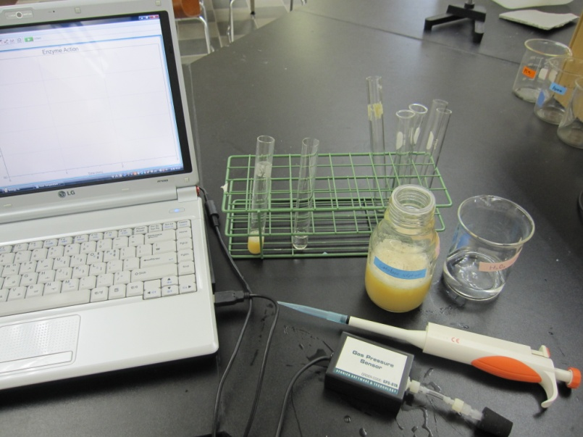- Gas pressure sensor ±0.005kPa

- Micropipette ±0.5µl (±0.0005cm3)

- 2 Temperature Probes ±0.05°C

- laboratory water bath

- mixer

- Test tubes of the same size

- micropipette tips

- Laptop with Logger Pro 3.7 software

- 3 Go Link adaptors

- at least 300cm3 of Distilled water

- solid ice

- filter paper

- funnel

- 300cm3 beaker

- scalpel

*Figure 2: Some of the few essential apparatus*

**Procedures**

***Preparation of Catalase Solution***

1. Wash the *Panax ginseng* in cold water.
2. Pulverize and mix the *Panax ginseng* with 300cm3 of distilled water using the mixer.
3. Pour the *P. ginseng* solution through a funnel with filter paper into a 300cm3 beaker. Extracted liquid should contain catalase from *P. ginseng* and should be at least 30 cm3.

***Reaction in Cold Water Bath***

1. 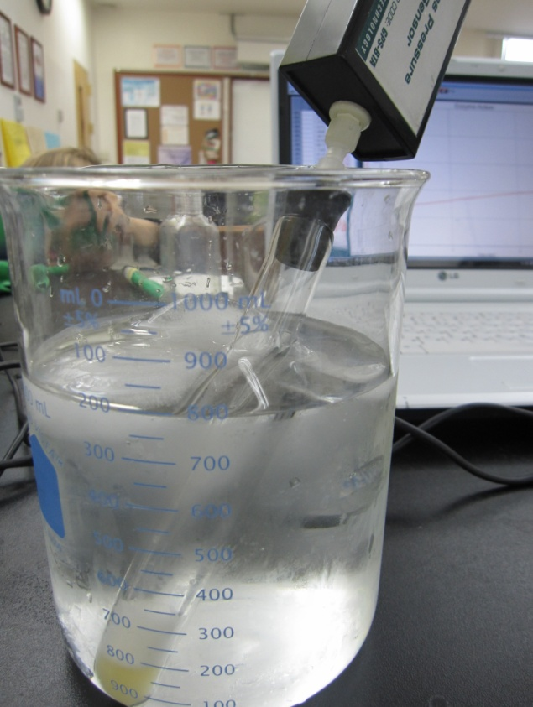Using the micropipette, transfer 2cm3 of the solution into a test tube.
2. Using micropipette, pour 1cm3 of hydrogen peroxide into another test tube.
3. Place the both test tubes inside an ice water bath of 10°C. Cool the water bath using ice. Using 2 temperature probes and Logger Pro3.7, wait until both solutions reach 10°C.
4. Remove the temperature probes and transfer 1cm3 of the H2O2 solution into the catalase solution. Make sure the hydrogen peroxide doesn’t touch the sides of the tube.
5. Immediately seal the test tube with the rubber stopper of the gas pressure sensor and collect data recording the change in gas pressure for 3 minutes. Write down qualitative observations. After recording, click “Linear Regression” for the first 0.5 minute. The gradient is the rate of catalase enzyme activity.
6. Thoroughly clean the test tubes with distilled water.
7. Repeat steps 4-9 three times to calculate the average result.

***Reaction in Room Temperature***

1. Using the micropipette, transfer 2cm3 of the *Panax ginseng* solution into 3 test tubes each and 1cm3 of hydrogen peroxide solution into 3 additional test tubes.
2. Record the room temperature using temperature probe. Place the temperature probe inside the solutions and ensure it has equivalent temperature.
3. Repeat steps 7 –9 three times in room temperature to get average result.

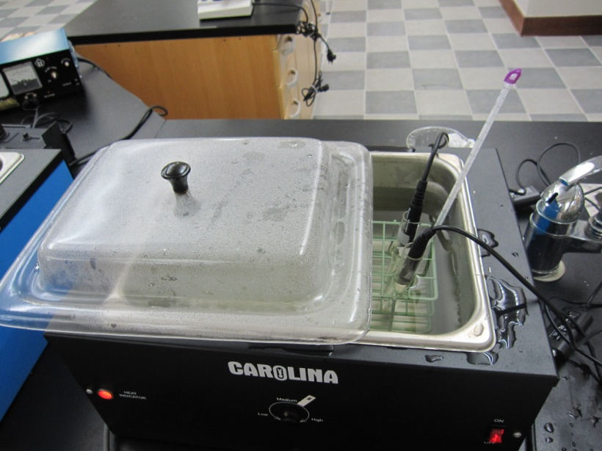***Reaction in Hot Water Baths***

1. Using the micropipette, transfer 2cm3 of the catalase solution and 1cm3 of hydrogen peroxide solution into 3 test tubes each. Result should have 6 test tubes in total.
2. Set the laboratory water bath at 30°C and place one test tube of each solution inside. Wait until their temperature is equivalent with the water bath using temperature probes to check.
3. Repeat steps 7-9 three times with the 30°C water bath. Note the pair of test tubes for each trial must be

*Figure 4: Heating the solutions in a hot water bath with temperature probes*

heated just prior to the start of reaction.

17. Repeat steps 14-16 three times at 37°C and 45°C to get average result

**Data Collection**

**Pressure/kPa against Time/s for 5 different Temperatures/°C**

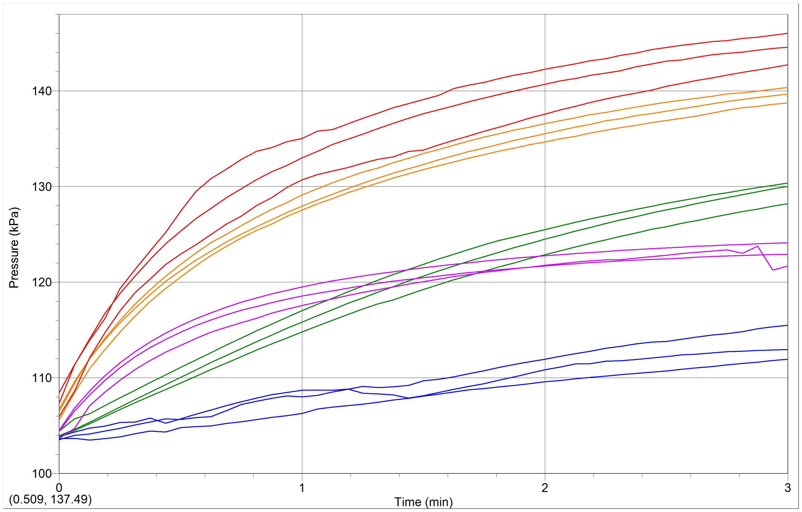

Key

**45°C**

**37°C**

**30°C**

**22°C**

**10°C**

*Figure 5: Change in gas pressure over time for 5 different temperatures signifying the amount of oxygen gas production*

**Pressure/kPa against Time/s for 5 different Temperatures/°C with Linear Regression**

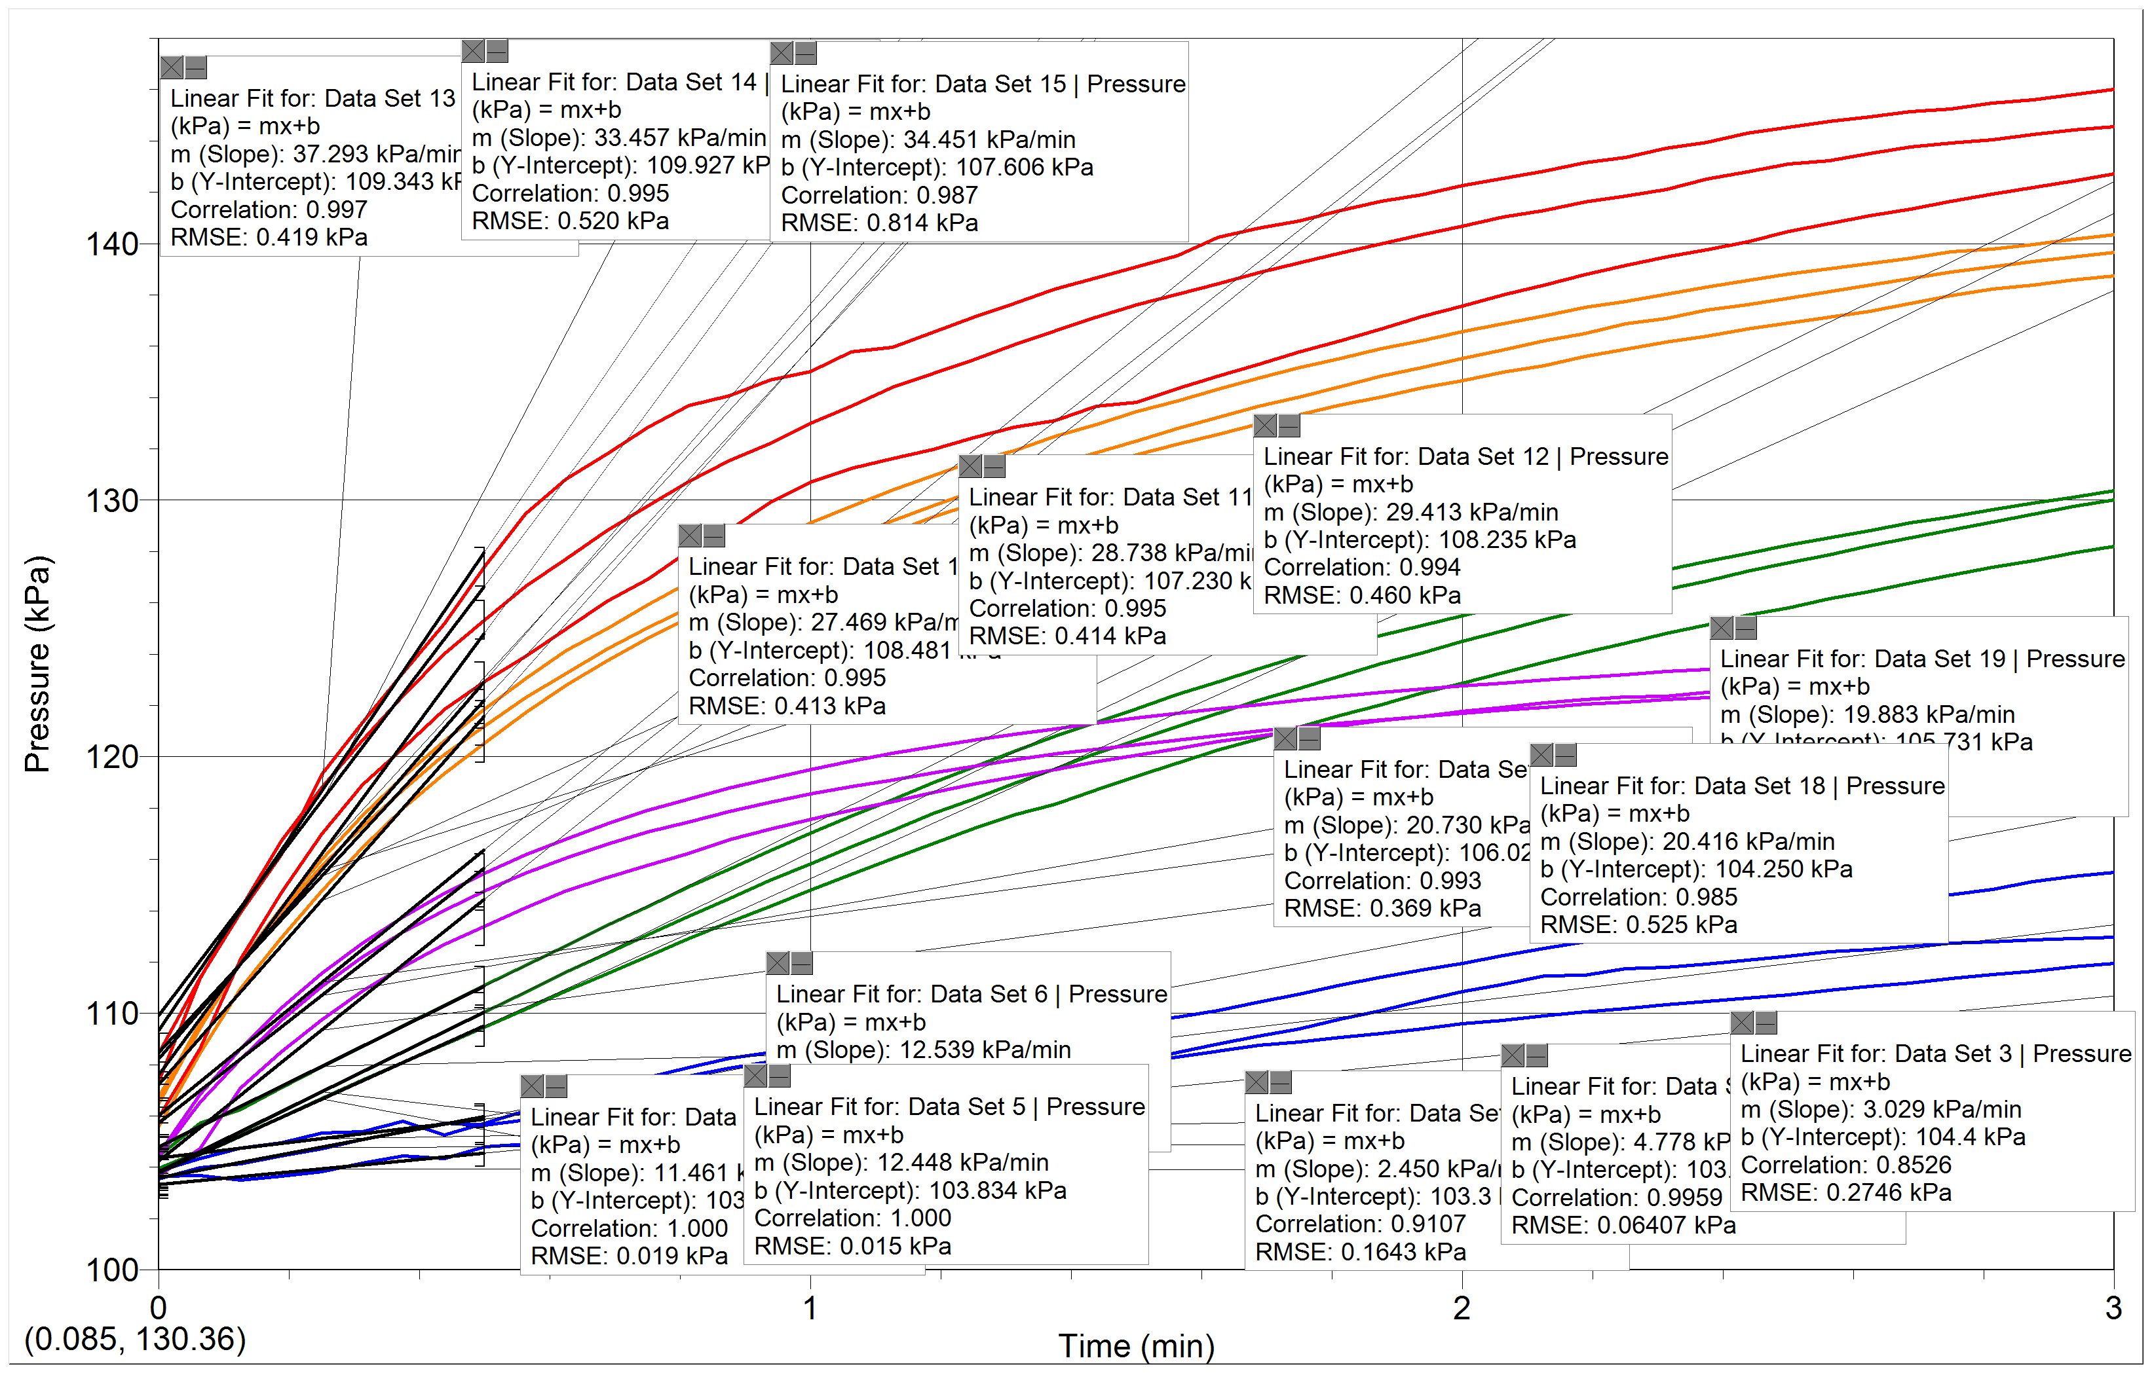

*Figure 6: Linear regression of Slope for all temperature trials to show the* ***rate of reaction***

**Quantitative Data**

|  |  |  |  |
| --- | --- | --- | --- |
| **Temperature , t/ °C**  **(±0.05°C)** | **Change in gas pressure for initial 0.5 minute/slope of linear regression**  **Rate of reaction**  **kPa/min\***  **(±0.005kPa)** | | |
| Trial 1 | Trial 2 | Trial 3 |
| 10.00 | 2.450 | 3.029 | 4.778 |
| 22.00 | 11.461 | 12.448 | 12.539 |
| 30.00 | 27.469 | 28.738 | 29.413 |
| 37.00 | 37.293 | 33.457 | 34.451 |
| 45.00 | 20.730 | 20.416 | 19.883 |

*Table 2: Rate of enzyme activity between catalase and hydrogen peroxide for all 3 trials in different temperatures*

* To determine an accurate rate of reaction, the gradient for the first 0.5minute will be found because when a reaction with such small quantities exceeds 0.5 minute, the increase in gas pressure is no longer consistent and the rate slows down because the limited amount of substrate is all used up. The rate of change in pressure over time was calculated by finding the slope of pressure vs. time graph using Logger Pro 3.7 software.s

**Qualitative Data**

* Panax ginseng catalase solution is yellow and opaque. White bubbles form on the surface when shaken or stirred. It is a thin liquid with low viscosity but contains a bitter, intense odor of ginseng. When solution sits still, soft white substances assemble at the bottom.
* Hydrogen peroxide solution is transparent and colorless. Contains odor similar to ethanol.
* During catalase-hydrogen peroxide reaction, the mixture initially becomes misty yellow. White bubbles start to form immediately on the surface. Gradually, the quantity of white bubbles increase as the gas pressure builds up. White bubbles are soft, light, and fluffy. When temperature is lower, bubble formation is not as immediate or in large quantity as in higher temperatures. In high temperatures, big transparent bubbles form on surface that pop instantly but are replaced by small white bubbles that build up.

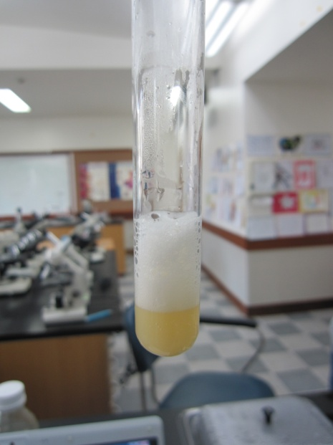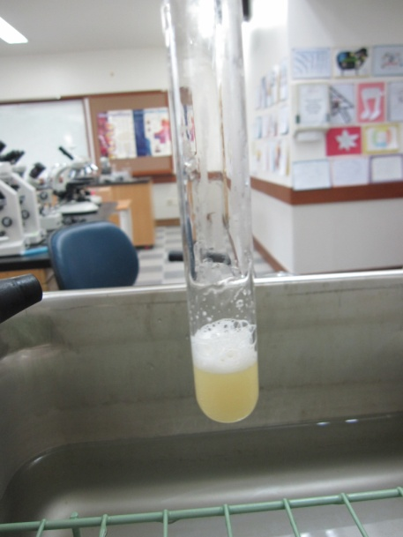

*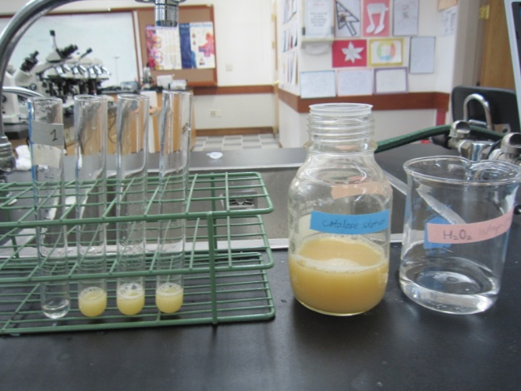Figure 7: Solution before reaction, after reaction(10°C), and after reaction (37°C) – left to right*

**Data Processing**

|  |  |
| --- | --- |
| **Temperature, t/°C**  **(±0.05°C)** | **Average rate of enzyme activity/ kPa min-1** |
| 10.00 | = 3.419 |
| 22.00 | $\frac{11.461+12.448+12.539}{3}$ $≈$ 12.149 |
| 30.00 | $\frac{27.469+28.738+29.413}{3}$ = 28.540 |
| 37.00 | $\frac{37.293+33.457+34.451}{3}$ = 35.067 |
| 45.00 | $\frac{20.730+20.416+19.883}{3}$ = 20.343 |

*Table 3: Calculation of the average rate of enzyme activity*

Uncertainty Calculations

|  |  |
| --- | --- |
| **Temperature, t/°C**  **(±0.05°C)** | **Standard Deviation** |
| 10.00 | St dev. = $\sqrt{\frac{{\left(3.419-2.450\right)}^{2}+ {\left(3.419-3.029\right)}^{2}+ {\left(3.419-4.778\right)}^{2}}{3}}$ $≈$ 0.990 |
| 22.00 | $\sqrt{\frac{\left(12.149-11.461\right)²+{\left(12.149-12.448\right)}^{2}+ (12.149-12.539)²}{3}}$ $≈$ 0.598 |
| 30.00 | $\sqrt{\frac{{\left(28.540-27.469\right)}^{2}+ {\left(28.540-28.738\right)}^{2}+ {\left(28.540-29.413\right)}^{2}}{3}}$ $≈$ 0.987 |
| 37.00 | $\sqrt{\frac{{\left(35.067-37.293\right)}^{2}+ {\left(35.067-33.457\right)}^{2}+ {\left(35.067-34.451\right)}^{2}}{3}}$ $≈$ 1.991 |
| 45.00 | $\sqrt{\frac{{\left(20.343-20.730\right)}^{2}+ {\left(20.343-20.416\right)}^{2}+ {\left(20.343-19.883\right)}^{2}}{3}}$ $≈$ 0.428 |

*Table 4: Calculation of standard deviation for each result*

|  |  |
| --- | --- |
| **Temperature, t/°C**  **(±0.0°C)** | **Average rate of enzyme activity/ kPa min-1**  **±st dev.** |
| 10.00 | 3.419 ± 0.990 |
| 22.00 | 12.149 ± 0.598 |
| 30.00 | 28.540 ± 0.987 |
| 37.00 | 35.067 ± 1.991 |
| 45.00 | 20.343 ± 0.428 |

*Table 5: Final calculated results*

Uncertainty due to Temperature probe = ±0.05°C

|  |  |
| --- | --- |
| **Temperature, t/°C**  **(±0.05°C)** | **Percent/% Uncertainty** |
| 10.00 | $\frac{0.05}{10}$ $×$ 100% = 0.50% |
| 22.00 | $\frac{0.05}{22}$ $×$ 100% = 0.23% |
| 30.00 | $\frac{0.05}{30}$ $×$ 100% = 0.17% |
| 37.00 | $\frac{0.05}{37}$ $×$ 100% = 0.14% |
| 45.00 | $\frac{0.05}{45}$ $×$ 100% = 0.11% |

*Table 6: Uncertainty due to temperature probes*

Uncertainty due to Gas Pressure sensor = ±0.005 kPa

The calculated rate of reaction can be mathematically expressed as shown below,

Rate of reaction = $\frac{∆P}{∆T}$ = $\frac{P_{2} - P_{1}}{T_{2} - T_{1}}$

P is representative of pressure and T is representative of time. Because the calculation uses 2 pressure values measured by a gas pressure sensor, the uncertainty of the rates of reaction for each trial would be

0.005 + 0.005 = **0.01 kPa**

Therefore, **0.01 kPa** is used to calculate the total uncertainty due to the gas pressure sensor as shown below.

*Table 7: Uncertainty due to gas pressure*

|  |  |  |  |  |  |
| --- | --- | --- | --- | --- | --- |
| **Temperature, t /°C**  **(±0.05°C)** | **Uncertainties** | | | **Total Percentage Uncertainty** | **Absolute Uncertainty** |
| Trial 1 | Trial 2 | Trial 3 |
| 10.00 | $\frac{0.01}{2.450}$ $×$ 100%  = 0.408% | $\frac{0.01}{3.029}$ $×$ 100%  = 0.330% | $\frac{0.01}{4.778}$ $×$ 100%  = 0.209% | 0.947% | 0.097 |
| 22.00 | $\frac{0.01}{11.461}$ $×$ 100%  = 0.087% | $\frac{0.01}{12.448}$ $×$ 100%  = 0.080% | $\frac{0.01}{12.539}$ $×$ 100%  = 0.080% | 0.247% | 0.090 |
| 30.00 | $\frac{0.01}{27.469}$ $×$ 100%  = 0.036% | $\frac{0.01}{28.738}$ $×$ 100%  = 0.035% | $\frac{0.01}{29.413}$ $×$ 100%  = 0.040% | 0.111% | 0.095 |
| 37.00 | $\frac{0.01}{37.293}$ $×$ 100%  = 0.027% | $\frac{0.01}{33.457}$ $×$ 100%  = 0.030% | $\frac{0.01}{34.451}$ $×$ 100%  = 0.029% | 0.086% | 0.090 |
| 45.00 | $\frac{0.01}{20.730}$ $×$ 100%  = 0.048% | $\frac{0.01}{20.416}$ $×$ 100%  = 0.049% | $\frac{0.01}{19.883}$ $×$ 100%  = 0.050% | 0.147% | 0.090 |

**Data Presentation**

*Figure 8: Final graph showing the affect of temperature on the rate of reaction (enzyme activity)*

**Conclusion & Evaluation**

Based on the data acquired from this experiment, the trend in the rate of enzyme activity when the temperature is manipulated can be observed in *Figure 8*, where as the temperature increases, the rate of enzyme activity also increases until a certain point where temperatures too high which decreases the rate. Therefore, my hypothesis is supported.

When comparing *Figure 1*, my hypothesized diagram, to *Figure 8*, the experimental results, the two graphs considerably resemble each other. In fact, the theory behind this experiment also suggests a similar pattern; an increasing rate until 37°C and a decline afterwards. This is only appropriate, for as temperature increases, kinetic energy increases; hence the hydrogen peroxide molecules bind frequently with catalase, increasing enzyme activity. However, as optimum temperature is surpassed, the energy is overwhelming in that it breaks intramolecular bonds and ultimately distorts the active site of catalase, which prevents enzyme activity. This pattern is demonstrated by the graph of *Figure 8* or numerical data in *Table 6*. The rate during 45°C is lower than both 37°C and 30°C. Therefore, it only makes sense when white bubble formation (the products of this enzyme reaction) was more immediate and productive during 37°C and 30°C in contrast to the inactivity during 45°C and 10°C.

There were several reliable aspects to this experiment that have contributed to the success and accuracy of the results. First of all the linear regression of only the first 0.5minute was determined. As the quantity of the substrate was limited (1cm3), the enzyme-substrate reaction can occur only for a short time. Hence, the pressure started to level out very soon (indicating no reaction), which is an inaccurate representation of the enzyme activity. Therefore, finding the gradient for the initial 0.5minute, when the reaction is fully active, is a much more accurate and reliable representation for the rate of reaction. Plus, using a micropipette with an uncertainty of only ±0.5µl allows all the solution quantities to be very precise and consistent. Moreover, 3 trials were carried out for each of the wide-ranged independent variables so that the calculated average was more accurate. Furthermore, none of the data results were anomalous because the data of the 3 trials were closely similar. The trials were very consistent in that the highest standard deviation for an independent variable was merely 1.991 while the lowest was 0.428 as shown in *Table 6 or Figure 8*. These values are considered extremely small in that they had no affect on the trend shown in *Figure 8*.

However, there were aspects that may have caused errors in this experiment

|  |  |  |
| --- | --- | --- |
| Error/Limitation | Evaluation | Improvement |
| After the hydrogen peroxide was transferred into the catalase test tube, the cork was not sealed immediately. A small quantity of the enzyme and substrate was used, 2cm3 and 1 cm3 respectively. Hence, since the reaction is very small, a considerable quantity of oxygen gas initially produced may have escaped before the tube was sealed. Therefore, the collected data may not represent the entire reaction accurately, for the initial rate of oxygen production was lost. Thus, some of the rates of enzyme activity may be inconsistent or lower than the actual rate. | This limitation is very significant. It is a direct error in that it results with the loss of initial data, which is vital for such a short reaction. Losing initial pressure data is equivalent to losing representative and important data in this experiment. | A larger quantity of enzyme and substrate solution must be used to minimize the effect of this limitation. The reaction will last longer and the initial data lost will not affect the result (rate) as much. Larger quantity is influenced less by errors. Using around 5cm3 or more of each solution would give more reliable results. Yet, using a larger test tube is required so that the cork will not pop due to over-pressure. Or using an oxygen sensor is also reasonable, for it will not pop off as easily as the gas pressure sensor cork. Moreover, to avoid the initial escape of oxygen gas, the gas pressure sensor should be placed right above the test tube by stabling it there with a retort stand and a clamp. Then when the solutions are mixed, the cork can be sealed much more immediately and oxygen will not escape as much. |
| When combining the 2 solutions together, the hydrogen peroxide solution came in contact with the sides of the test tubes. As it was transferred from one test tube into another, the hydrogen peroxide molecules may have stuck to the sides and remained there rather than reacting with the catalase solution. Moreover, only a mere 1cm3 of hydrogen peroxide was used; hence, these non-reacted molecules affect the results strongly. The amount of substrate greatly affects the rate of reaction; thus with less hydrogen peroxide, less oxygen gas produced with an inaccurate representation of the change in gas pressure. | This error is considerably significant because substrate concentration is one of the most influential factors that directly affect the rate of reaction. | Use a micropipette (low uncertainty of ±µl) to transfer the hydrogen peroxide solution directly into the catalase solution. In this case, there is less contact between the molecules and the sides of test tube. Because of the chance that the hydrogen peroxide molecules stick to the test tube side, all trials should invert the tube so that all enzymes can react with all substrate molecules. |
| Data collection stretched over several days. Although the solution was preserved in the refrigerator, time still influences enzyme activity. As enzymes in a solution lose “freshness” and become inactive as time passes, data collected during the later days may not be as accurate as the first day because of the gradual decrease in activity. Hence, data may be slightly inconsistent | This error is not as significant as the preceding ones because the solution was preserved inside a refrigerator. The cold temperature effectively prevents the solution and enzymes from losing “freshness” and activity. | All the data collection should be experimented on one day; this is even better if carried out even at one spot. In this way, the experiment can be controlled and consistent with all enzymes having the same level of activity. |
| Lastly, the equipments used in this experiment were not calibrated. Although they are precise, calibration is greatly important. Moreover, some test tubes contained water droplets inside from rinsing. These extra water molecules may have served as physical interference between the enzyme and substrate molecules, restricting enzyme activity or may have influenced the pressure build up by taking up volume or even vaporizing during high temperatures. | This error is slightly significant. Equipments are what directly measure the data while the change in gas pressure is ultimately the dependent variable of this experiment. However, the equipments were used frequently prior in other experiments hence is still considered highly accurate and reliable. Plus, the extra water droplets sum up to a tiny amount of water which hardly affects the gas pressure eventually. | All equipment and sensors such as the temperature probes, gas pressure sensor, and micropipettes must be calibrated right before the experiment. This will increase precision, accuracy, and reliability of data. Moreover, all test tubes must be dried off with no extra water droplets inside. Using either paper towels to manually dry them or a test tube rack to naturally dry them, either way is fine to ensure a controlled, consistent, and reliable data collection of the change in gas pressure. |