January 29 NHS Meeting

- Attendance
- MS Walk : Saturday, March 15th, 2025

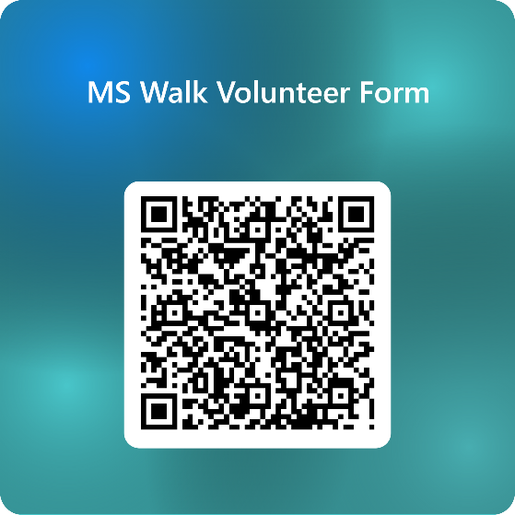
- REPORT CARDS Needed ASAP
  - Seniors: No grade verification (report card) no cords for grad!
  - Seniors: I need a nice photo of you, what college you're going to/job, Field of Study (or if military branch), any scholarship information. This is for Induction. Want to celebrate ya’ll.
  - ALL but especially SENIORS: Need your hours. No verification of community service means no cord!
- Induction: April 23 5pm All invited!

