Algebra 1 Syllabus 2019-2020
Ms. Eboni Fields, Instructor, Email: fieldeb@boe.richmond.k12.ga.us
B.S. Business Administrative Management, Francis Marion University
M.ED. Arts in Teaching, Augusta University

Instructional Philosophy: Welcome! You have been selected to participate in a collaborative classroom—a classroom where knowledge is SHARED. I believe that learning takes place more effectively when students work together, use dialogue, and discuss different strategies or perspectives to become knowledgeable independent learners.
Course Descriptions:
Algebra 1 is designed to give students a foundation for all future mathematics courses.
Major Course Goals: In Algebra I, instructional time will focus on three critical areas: (1) formulating and reasoning about equations, including modeling an association in bivariate data with a linear equation, and solving linear equations and systems of linear equations; (2) analyze exponential functions by investigating key features and creating, solving, and modeling exponential equations including recognizing geometric sequences; (3) analyze quadratic functions by investigating key features of graphs and solving quadratic equations.
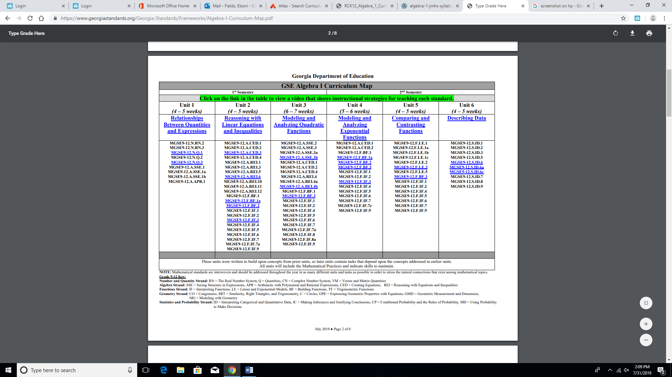

Major Course Projects & Instructional Activities: The major course projects and instructional activities will include Georgia Framework Tasks, group projects, and additional practice as evidence that you have met course standards. These assignments and projects give students ample opportunity to demonstrate what they should know and be able to do for the course. The assignments and projects ask students to apply the skills and concepts they are learning to real world problems and situations.

Projects: Projects will be an extension or enrichment of this course and concepts discussed. You will have 1 to 2 weeks to complete each project depending on the complexity of the task. Suspension, illness, etc. is not an excuse for a late project. Plan ahead!
Expectations:
The overarching expectation in this class is RESPECT: respect for yourself, respect for other students, respect for the teacher/or any individual in authority, and respect for any guests that may enter our class. Although this encompasses all other expectations, I will outline several others for the sake of clarity.
- Be IN the classroom, SEATED, and PREPARED and working on the Warm-Up Activity before the FINAL tardy bell rings.
This means getting materials, using the restroom, and socializing will be completed before the final (tardy) bell sounds. Students arriving after the tardy bell has sounded are LATE! No Exceptions!
- Bring ALL materials (books, notebooks with clean paper, completed assignments, calculators, and pencils) to class DAILY. You will not be permitted to leave to retrieve forgotten/missing items during class time.
***PLEASE BE RESPONSIBLE AND BRING YOUR OWN MATERIALS TO CLASS! ***
- Restroom PASSES will be limited to 3 per semester (Therefore, handle your business before class☺)! Time away from the classroom is time away from learning.
- Students are also expected to adhere to all policies, rules, and regulations outlined in the student handbook.
- Be on time, Be prepared, Be on task, Be successful, Be respectful, Be ready to learn and have fun!!

Consequences
- Verbal Warning, (2) Individual Counseling, (3) Parental Contact, (4)Teacher Detention, (5) Referral Guidance, (6)Parent/Teacher Conference, (7)Office Referral
*****However, some situations may result in an immediate office referral*****
School Supplies:

- Notebook 3-ring binder (AVID students do not need a separate binder)
- Paper
- Pencils
- Colored Pencils and highlighters (suggested)
- Scientific or graphing calculator
- Composition book

Notebooks: Students, you must bring your notebook to class daily. In order to be successful in this course you must maintain an organized notebook. Students should purchase 2 notebooks. One notebook (composition book) will be kept in class so that warm up activities are recorded daily and the other notebook containing notes, quizzes, homework and classwork should be brought to class daily.
ATTENTION!!!!!! Every student must BRING A NOTEBOOK to class EVERYDAY!
Remember, an organized notebook makes a great study tool.
Homework: Homework is to be completed with an honest effort. It is assigned with the purpose of reinforcing what you learned in class. The material covered in class is difficult to learn and retain without practice. I will randomly check homework and grade for effort and completion; however, you are expected to complete homework on a regular basis.
Remember, if you study to remember you forget; if you study to understand you’ll always remember.

Tests and Quizzes: Tests will ALWAYS be announced; however, quizzes may not be. Therefore, it is important to study notes and other materials covered in class for homework each night. Make-up tests and quizzes can be made up after school. See your teacher to schedule the make-up day.
Note: If you are absent the day before a test/quiz and you return to school on the day of the test/quiz, you are required to take it.
Make-up Work: I strongly advise you not to miss class. However, if you must be absent, it is your responsibility to make-up any work you may have missed and find out what work has been missed. Please check the “Week at a Glance” folders for work you may have missed. Test and quizzes missed must be made up after school.
Tutoring: TUTORING is available through appointment. Before staying after school, please be courteous and let me know that you are coming. There will be sign-in sheet available.
Nine –Week Grading Procedure:
Grade Calculations
Category | Percentage
Test | 30%
Quiz | 15%
Classwork | 45%
Homework | 10%
“Learning Today…Leading Tomorrow”
Butler High School

