2023 School Year Calendar Outline Team Sports Health

◄ July | August 2023 |  |  |  |  | September ►
Sun | Mon | Tue | Wed | Thu | Fri | Sat
 |  | 1 | 2 | 3 | 4 | 5
6 | 7 First Day of School  Expectations | 8  Syllabus | 9  Track Walk | 10  Warmup & Teams  Team Poster | 11  Expectations Quiz | 12
13 | 14 Do Now: notebook setup instructions  First Aid -16.4.  KIM vocab of terms  Do Now: Find your name & what group you are in & complete your warm up activity  You have 7 minutes.  Classwork  1.Team Assignment following the guidelines of the rubric  5 mins to pick teams  Assign roles  Team Poster  Closing:Round Table  (3rd period has to do quiz)  Do Now: Find your name & what group you are in & complete your warm up activity  You have 7 minutes.  Classwork  1.Team Assignment following the guidelines of the rubric  5 mins to pick teams  Assign roles  Team Poster  Closing:Round Table  (3rd period has to do quiz) | 15  First Aid-16.4  Equipment review & video  Coaches’ demonstrate, students practice, (I do, we do, you do)-  Do Now: Get with your team in your area &complete your warm up activity  You have 7 minutes.  (Darbee)  Classwork  1.Equipment warmup  2. Rec Games roll out from coach & practice  -ring toss  -corn hole  -ping pong  Closing: clean up  Do Now: Get with your team in your area &complete your warm up activity  You have 7 minutes.  (Darbee)  Classwork  1.Equipment warmup  2. Fitness Assessment  1. max bench press  2. squat burn out with comfortable weight  3. crunches  4. jump rope (stop more than 5 seconds & out)  Closing: cool down | 16  CPR  Do Now: close read information/steps/best  Practices  Classwork:  -Video  -teacher model, student practice in groups/pairs  (based on resources)  Do Now: Get with your team in your area &complete your warm up activity  You have 7 minutes.  (Darbee)  Classwork  1.Equipment warmup  2. Rec Games review  (Team activities  -ring toss  -corn hole  -ping pong  Closing: clean up  Do Now: Get with your team in your area &complete your warm up activity  You have 7 minutes.  (Darbee)  Classwork  Circuit 30 secs x 2  1.bicep curls  2. high knees  3. tricep kick backs  4. leg ext.  5. bar frontal lifts  6. dead lifts  Closing: cool down | 17  CPR & AED  Do Now: circle map copy & fill in together as class to review CPR & First Aid  Classwork: (I do, we do, you do)teacher model, student practice-adding AED to CPR process/steps  Closing: clean up  Do Now: Get with your team in your area &complete your warm up activity  You have 7 minutes.  (Darbee)  Classwork  Rec Games Tournament  Game 1  1 vs. 3 duty 5 OR  2 vs. 4 duty 6  1 vs. 2 duty 3 & Journal 4 & Practice 5  Game 2  3 vs. 5 duty 1  4 vs. 6 duty 2  Game 3  5 vs. 6 duty 3  1 vs. 2 duty 4  Do Now: Get with your team in your area &complete your warm up activity  You have 7 minutes.  (Darbee)  Classwork  Circuit 30 secs x 2  1.bicep curls  2. high knees  3. tricep kick backs  4. leg ext.  5. bar frontal lifts  6. dead lifts  Closing: cool down | 18  Review/Assessment  Do Now: Get your notebook from designated area & complete journal entry regarding recreational games for the week.  Classwork: Review, Assessment, Makeup  Do Now: Get your notebook from designated area & complete journal entry regarding weight training  Classwork:  Physical conditioning & weight training complete daily exercises information  & Makeup assignments | 19
20 | 21 Do Now: page 3  1.List 3 things you think of when you hear the word health  2.List 2 things people have told you about health using 2 complete sentences.  Ch.1 -role out entire assignment that will due on Friday with breakdown of which parts to be done each day  -KIM for chosen chapter terms  -mental, social, emotional health comparison chart  -factors affecting health-hands on skills activity on page 31  -teacher show example/rubric  -students complete notebook setup  -vocab  Closing: remind login | 22  Do Now:  Copy KIM chart example  Ch.1  -vocab finish  Terms:  Culture, media, geography, behavioral factors, genetic factors, risk factors, protective factors, optimal health, illness, life expectancy, life span, quality of life, health, well-being, wellness,  Closing: Round Table | 23  Ch.1  Do Now:  Picture word model  Classwork: -mental, social, emotional health comparison chart  Closing:sticky note formative | 24  Ch.1  Do Now: Do the best you can if you are not artistically blessed  1.Draw an image/emoji that comes to mind when you hear the following  1.mental health  2.social health  3.emotional health  Classwork  -factors affecting health-hands on skills activity on page 31  Outline  Closing: reminders | 25  Do Now:  Classwork:  Bring/get pics  -study guide for assessment on Canvas | 26
27 | 28 Block Schedule A  Final Draft due for health | 29 Block Schedule B  Final Draft due for health | 30  Presentations | 31  Presentations & Assessment review

Health  Week August 14-18  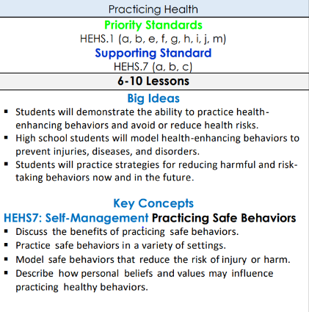 | Rec Games  PERG.4The physically educated student exhibits responsible personal and social behavior that respects self and others in physical activity settings. a. Displays the ability to design rules, procedures, and routines appropriate for the group. b. Demonstrates the ability to apply the rules and etiquette of various physical activities regardless of individual differences. c. Applies safe practices in the physical education setting. d. Describes safety protocol to avoid dehydration, overexertion, and hypo/hyperthermia during physical activity.  Learning Targets:  - Students can demonstrate the ability to work in group setting  - Students can design rules and norms necessary for the physical education setting  - Student can follow rules, procedures, routines, and expectations for PE setting  - Students can follow the safety protocol for | 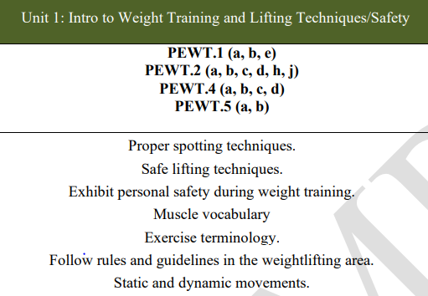
Week August 14-25
Vocabulary Terms:
Culture, media, geography, behavioral factors, genetic factors, risk factors, protective factors, optimal health, illness, life expectancy, life span, quality of life, health, well-being, wellness,

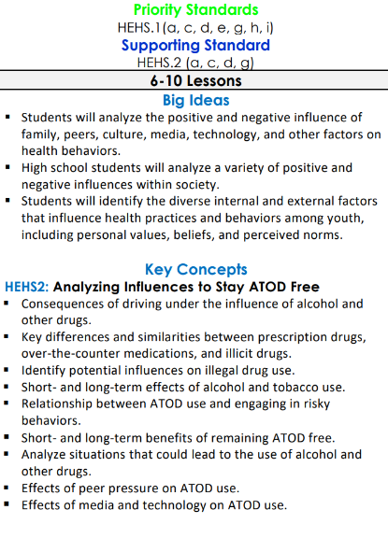

◄ August | September 2023 |  |  |  |  | October ►
Sun | Mon | Tue | Wed | Thu | Fri | Sat
 |  |  |  |  | 1  Assessment on Ch.1 | 2
3 | 4 Labor Day Holiday | 5 Asynchronous | 6 | 7 | 8 | 9
10 | 11 | 12 | 13 | 14 | 15 Progress Report | 16
17 | 18 Homecoming | 19 Homecoming | 20 Homecoming | 21 Homecoming | 22 Homecoming | 23
24 | 25 Block Schedule A | 26 Block Schedule B | 27 | 28 | 29 | 30

◄ September | October 2023 |  |  |  |  | November ►
Sun | Mon | Tue | Wed | Thu | Fri | Sat
1 | 2 ASVAB | 3 | 4 | 5 PL/Student holiday | 6 Asynchronous | 7
8 | 9 Fall Break | 10 Fall Break | 11 | 12 | 13 | 14
15 | 16 PSAT | 17 PSAT | 18 PSAT | 19 PSAT | 20 PSAT | 21
22 | 23 You Sci 10th | 24 You Sci 10th | 25 | 26 | 27 Progress Report 2 | 28
29 | 30 | 31

◄ October | November 2023 |  |  |  |  | December ►
Sun | Mon | Tue | Wed | Thu | Fri | Sat
 |  |  | 1 | 2 | 3 | 4
5 | 6 | 7 | 8 | 9 | 10 Veteran’s Day | 11
12 | 13 | 14 | 15 | 16 | 17 | 18
19 | 20 Thanksgiving | 21 Thanksgiving | 22 Thanksgiving | 23 Thanksgiving | 24 Thanksgiving | 25
26 | 27 | 28 | 29 | 30

◄ November | December 2023 |  |  |  |  | January ►
Sun | Mon | Tue | Wed | Thu | Fri | Sat
 |  |  |  |  | 1 | 2
3 | 4 Block Schedule A | 5 Block Schedule B | 6 | 7 | 8 | 9
10 | 11 | 12 | 13 | 14 Semester Exams | 15 Semester Exams | 16
17 | 18 Semester Exams | 19 Semester Exams  Early Release | 20 | 21 | 22 | 23
24 | 25 | 26 | 27 | 28 | 29 | 30
31

