Grade Level: Pre-K Dates: Feb 28-March 25
School Information  School: Copeland Elementary  School Code: 060043  Teachers: Hanley, Godbee  Buffer: | Transdisciplinary Theme: Sharing the Planet  Segment of Theme: Recycling, Be kind to animals  Over Arching Concept: Responsibility
Section 1: Overview
- Central Idea: Living things depend on each other.
- Key Concepts: Connection, Causation, Responsibility
- Guiding Related Concepts: | - Lines of Inquiry: | - Teacher Questions (Guided Questions):
Recycle/Reuse  Pick up litter  Plant trees and flowers  Care for animals and plants | - Plant growth occurs in a cycle  - People depend on plants and animals  - People are responsible for the care of plants and animals | DOK Level 3 & 4  - What do plants need to grow?  - What do humans use plants and animals for?  - How is plant and animal life being changed by things humans do?  - If we didn’t have plants and animals, how would that affect our lives?  - What is our responsibility to other people, plants, and animals on this planet?
- Prior Content Knowledge: | - Assessing the Lines of Inquiry:
Cleaning up after yourself  Nourishing your own body = feeding animals | How will you assess student’s understanding of the lines of inquiry?  As a class, develop an “I wonder board” to record questions.  Journaling/labeling parts of a plant and recycling  KWL Chart – Recycling  Recycling Collage  Caring for Pets – Drawing  As a class, generate a list of possible topics.  In a small group, choose a topic to research.
Section 2: What Are Our Target Goals?
- Concept Based Summative Assessment: | - Targeted Approaches to Learning (highlight 3): | - Targeted Learner Profile Attributes (highlight 2):
Using a four square process, teacher will scribe questions developed by students.  In small groups, they will find answers to their questions through whiteboards, books, and library.  The student will complete the four square by writing a sentence, words, or drawing (with teacher scribing). | Social Skills, Research Skills, Communication Skills. Thinking Skills, Self-Management Skills | well-balanced, caring, principled, open-minded, risk taker, knowledgeable, communicator, reflective, thinker, inquirer
Section 3: What Assessments will be provided in this unit of inquiry?
- Pre-Assessments:  What assessment will be given at the beginning of the unit to inform current understanding | - Formative Content Based Assessments:  What assessments will be given to monitor student learning of content? | - Summative Content Based Assessments:  What assessments will be given for students to show mastery of unit content?
What do we know or think we know about living things? Why are plants and animals important to us?  Class discussions | - Class discussions –accurate use of unit vocabulary, comments which show understanding of unit concepts  - Illustrations – correct terms for plants, labeling parts,  - Small Group work – productivity, cooperation, discussions using relevant details, products show understanding of task  - Journaling – accurate representation of activity, experiment (seed dissection), or sorting task | Circle chart- plastic, paper, glass  Draw a picture of three things living objects need to survive.
Section 4: How will we Facilitate Learning?
- Provocation:  How will interest into this unit be sparked? | - Learning Experiences:  What activities/experiences will help facilitate the learning? | - Evidence of Differentiation:  How will the learning experiences be adjusted to different learning styles/abilities?
The teacher will share pictures of a recycling center and trash in our community.  Students will have the opportunity to share what we could do to make our community beautiful and safe.  Nature walk around school- Identify plants, trees, litter, man made vs natural  Plant Tree- plant tree and water it everyday, watch it grown, draw it’s growth  Discussion- What people can do to help – recycling, composting, don’t litter  Discussion- Human actions harmful to animals – pollution (litter, plastics), water waste, things | Week 1:  Monday- Journaling/ Activities: draw picture of flower,  Tuesday- Label parts of plant  Wednesday- Make a list of needs of a plant  Thursday- Virtual story: Seed to Plant- https://www.youtube.com/watch?v=Rb7n_B8kzNY  Friday- Plant grass seed in a cup  Week 2:  Monday- KWL Chart on Recycling  Tuesday- Making a chart of things that can be recycled.  Wednesday- Finding things in our classroom that can recycled and placing the items in our recycling bins.  Thursday- Virtual Field trip to the Recycling Center  Friday- Adding things to our KWL chart on what we learn about recycling  Week 3  Monday- Drawing a picture of things that can recycled.  Tuesday- Virtual Read Aloud- Michael Recycle by Ellie Bethel & Illustrated by Alexandra Colombo- https://www.youtube.com/watch?v=pJweMxEhjlU  Wednesday- Make a collage out of recycle materials  Thursday- Pick up items outside on the playground that can recycled.  Friday- Add to the KWL chart  Week 4  Monday- Make a chart on how to care for animals.  Tuesday-Virtual Read Aloud- Love Your Pets https://www.youtube.com/watch?v=cF7qPKNF7co  Wednesday- Draw a picture of your favorite animal and discuss in large group how to take care of it.  Week 5  Monday- Review how we take care of animals  Wednesday- Virtual Read Aloud of Teaching Kids How to Take Care of Pets- https://www.youtube.com/watch?v=pKosbOawGSY  Week 6  Reviewing all the learning concepts of the unit.  lima bean seed coat (skin) bark rubbing, how bean seeds grow (pictures and labeling of parts as they grow, sequencing cycle) and various other plants growing in room (sweet potato, potato, organic avocado, cuttings – jade, philodendron, spider) (looking at parts and quickness/ size) Growing grass seed in paper cup, four seeds to label, plant seedlings of sunflowers and pumpkins, nasturtium  Natural Resources brought in, which plants give us what (coffee, cotton, ) | Para will be available to assist as needed – Small group and one on one assistance.  Additional time can be set aside for students who need it  Modifications to assignments as needed
- Learning Experiences in Specials:  How are Specials Courses able to connect to this unit? | - Local/National/Global Connections:  How can we connect the content to local/national/global issues? | - Student Action:  What learning experiences support potential student-initiated action?
Recycling center in the home living area.  Recycling materials in the art area. | Display local pictures of our recycling center.  Display of pictures on how to take of animals.  Discuss how recycling can help the environment.  Virtual Tours | Students create their own collages from recycling materials.  Students create a chart of how to take care of animals.  Students may choose to plant grass seeds to see how they grow..
- Student Agency and Play:  What learning experiences provide students with voice, choice and ownership? What play opportunities will be provided by Kindergarten/Pre-K? hands on/STEAM for K-5? |  | - Resources:  Which resources will you and the students use? This may include people, places, technologies, learning spaces and physical materials.
Art center- recycling materials to create self regulated collages  Recycling Center- placing recycled materials in the correct bins  Block center- different types of recycling materials to build with |  | Chart Paper  Markers  Paper  Promethium Board  Art materials (glue, stickers, form pieces, and collage materials)  Recycled Materials  Cups  Soil  Grass Seeds  Teaching Kids How to Take Care of Pets- https://www.youtube.com/watch?v=pKosbOawGSY  Michael Recycle by Ellie Bethel & Illustrated by Alexandra Colombo- https://www.youtube.com/watch?v=pJweMxEhjlU  Seed to Plant- https://www.youtube.com/watch?v=Rb7n_B8kzNY  Love Your Pets https://www.youtube.com/watch?v=cF7qPKNF7co
Section 5: Reflection (Write the year, change font color for each year)
- Reflect on learning experiences:
Godbee- As a class, the students learn how to keep the environment safe and clean by picking up trash around our school and demonstrating what items can recycle in our recycling center located in the housekeeping area. The students also made a chart on what they learn through the unit by telling the teacher one thing they liked about the unit.

Hanley- Student explained to a guest why we were picking up litter. “to keep the planet healthy”

- How were the tasks differentiated to meet different learning styles? |  | - How did the learning experiences and strategies we used throughout the unit help to develop and show students understanding of the central idea?
Godbee- Items were put out for easy access for students to make recycling colleges. Items were organize and place on tables with step by step directions on how to plant a flower.  Hanley- we use the active board to show items that are in the classroom that can recycled for our recycling center in the housekeeping area. |  | Godbee- By planting flowers, the students got a chance to learn the cycle of a flower and see how a flower needs sunlight, good soil, and water to grow.  Hanley-By going a virtual field trip to the recycling center, students got a chance to see the process of recycling and got an understanding how we need to sabe our planet. The students also use this learning experience to pretend play at our recycling center in housekeeping area.
- What learning experiences best supported students’ development and demonstration of the attributes of the learner profile and approaches to learning? |  | - How effective were the summative assessments in measuring student learning? What, if any, changes need to be made to the assessments?
Godbee- The planting of the tree taught the students about how trees save the earth and provide homes and shelters for animals. The transdisciplinary skill of responsibility taught the students how we plant a tree and what tings the tree needs so it can grow. The function of learning the parts of a tree and what it needs so it can survive helps the students learn responsibility.  Hanley- Students expressed an interest in learning how to reuse trash. Students used their art and reading skills t Hanley- Students ask daily to walk around the school and pick up litter. They point out how we can reuse our trash |  | Godbee- The circle chart on recycling was a good way to see what the students learned about what can recycled.  Hanley- The drawing pictures of three things that are needed to survive was a good way of seeing what  the students learned about plants and taking care of pets.
- What student-initiated inquiries (questions) arose from this unit of inquiry? |  | - What student action arose from this unit of inquiry?
Godbee-  - Why is recycling important to the environment?  - How do flowers help us breathe?  - How does a seed grow into a plant?  - How do take care of a pet?  Hanley-  - How does a tree grow?  - What does a flower need to grow?  - How do we treat our pets in the classroom and at home? |  | Godbee- The planting of the tree taught the students about how trees save the earth and provide homes and shelters for animals. The transdisciplinary skill of responsibility taught the students how we plant a tree and what tings the tree needs so it can grow. The function of learning the parts of a tree and what it needs so it can survive helps the students learn responsibility.  Hanley- Students expressed a interest in learning how to reuse trash. Students used their art and reading skills t Hanley- Students ask daily to walk around the school and pick up litter. They point out how we can reuse our trash
- Any additional notes or changes that need to be considered next year?
Not at this time
Section 6: Picture Evidence
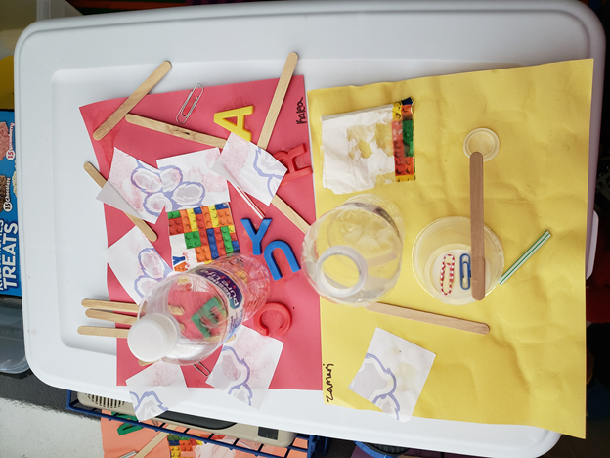
The first is a college of a letter train and the second one is a city.

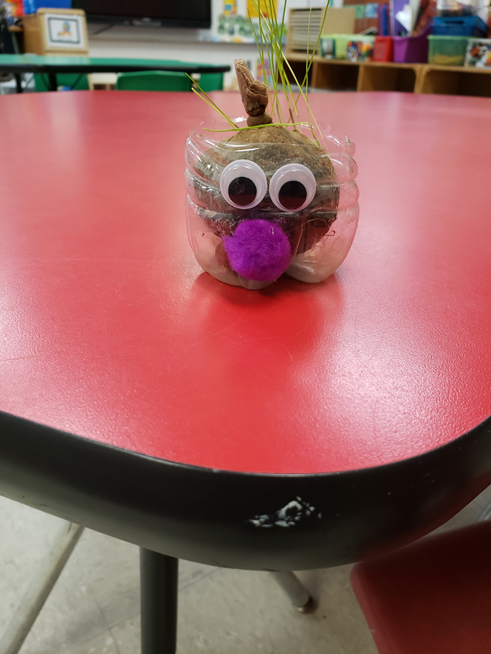

This is grass growing.
**Scroll Down for Unit Standards**

Unit Standards:

ELA:

Math:

Science: SC3.4a,SC4.4c, SC5.4a

Social Studies:

