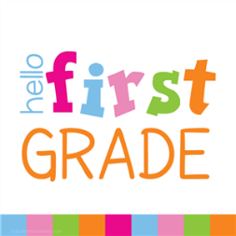

Mrs. Ward’s First Grade Supply List

* 4 composition notebooks (blue, yellow, red, green)
* 2 packs of pencils (no mechanical)
* 3 boxes of crayons (keep one at home)
* 4 plastic folders with prongs
* 6 glue sticks (keep two at home)
* 1 child scissors
* 1 plastic pencil box
* 1 pack of copy paper
* 1 over the headphones in gallon size Ziplock bag with child’s name on it (no Bluetooth or earbuds allowed)
* 1 container of Lysol wipes
* 1 bottle of hand sanitizer

\*Make sure to always have sharpened pencils and a box of crayons at home for your child to complete homework with.

\*Students must bring a personal snack and water bottle EVERY day.