Grade Level: Second Grade Dates: August 23- October 1st
School Information  School: Copeland Elementary  School Code: 060043  Teachers: Brown, Echols, Huggins and Ginn  Buffer: Sept. 29-October 1st | Transdisciplinary Theme: Who We Are  Segment of Theme: ^{Human Relationships}  Over Arching Concept: Personal Identity
Section 1: Overview
1. Central Idea: Understanding our heritage shapes our personal identity .
2. Key Concepts: Responsibility, Change and Reflection
3. Guiding Related Concepts: | 4. Lines of Inquiry: | 5. Teacher Questions (Guided Questions):
Citizenship, Values and Reflection | Cultural values shape us as individuals.  As citizens we have responsibilities.  Many people influence our history. | DOK Level 3 & 4 ( 4-6 Questions)  Q: Why is it important that rules are fair? Who decides the rules? Who decides when a rule is broken? What can a person do if they feel they have been unfairly treated? High/5  Q: What are some laws in our community that you follow? What are some rules at our school that you follow? How are they similar? How are they different? moderate high/4  Q: What are some ways you can be a good citizen in our classroom? moderate high/5  Q: What are some examples of not being a good citizen? moderate high/4  Q: How can you be a good citizen at home? moderate high/4
6. Prior Content Knowledge: | 7. Assessing the Lines of Inquiry:
I-Ready– Pre Tests  Discussion questions  SeeSaw - Activities on common and proper nouns, and adjectives. Activities on Punctation and Capitalization in sentences.  KWL Charts  Students will complete charts on Robinson, Lowe, Carter and Dr. King Jr.  I see, I think, I wonder  - Students will complete a Courage See-Think-Wonder - Three-part organizer used to observe a stimulus, usually an image, and tell what you see in it, what it makes you think, and what you still wonder about it. Ask students how they feel about the images depicting segregation.  Think Pair Share  Students will complete this based on the character traits and famous Georgians.  Bubble Maps (Thinking Maps) :  Students will watch Brainpop Jr. Rights and Responsibilities and create a Bubble Map.  Learner Profile  (Student Interest Reading Inventory) | How will you assess student’s understanding of the lines of inquiry?  Students will interview a family member about their traditions, culture, family history and create a poster or visual to share.  Students will create a personal poster “All About Me” and share  Students will create essential agreements as a class to follow.  Students will review and follow rituals and routines and practice often.  Discussion on responsibilities at home verses responsibilities in our class/school and community.  Gallery walk on famous/influential people from current culture  Gallery walk of historians studied throughout the unit.
Section 2: What Are Our Target Goals?
- Concept Based Summative Assessment: | - Targeted Approaches to Learning (highlight 3): | - Targeted Learner Profile Attributes (highlight 2):
Personal Identity Project Compared with Famous Georgian  Students will choose a famous Georgian– Martin Luther King, Jackie Robinson, Juliet Gordon Lowe, Jimmy Carter  Students will compare their personal characteristics to the characteristics of the chosen Georgian.  Students will identify similar Learner Profile Traits, Why is the Georgian important and how do you compare to the famous Georgian.  Ex: Jackie Robinson showed courage.  Illustrate a time in your life when you showed courage.  Students will create either a Poster or write a narrative related to their personal identity using a rubric. | Social Skills, Research Skills, Communication Skills. Thinking Skills, Self-Management Skills | well-balanced, caring, principled, open-minded, risk taker, knowledgeable, communicator, reflective, thinker, inquirer
Section 3: What Assessments will be provided in this unit of inquiry?
- Pre-Assessments:  What assessment will be given at the beginning of the unit to inform current understanding | - Formative Content Based Assessments:  What assessments will be given to monitor student learning of content? | - Summative Content Based Assessments:  What assessments will be given for students to show mastery of unit content?
Pre Test I-Ready- Reading, Math  Pre (Writing)- SeeSaw( Students will write a Narrative about themselves.) | KWL charts- Students will complete charts on Robinson, Lowe, Carter and Dr. King Jr.  Gallery walks-Students will see gallery walks on Lowe, Carter and Dr. King Jr.  Weekly Assessments – Studies Weekly quizes on Famous Georgians  Class Discussions / Teacher Observations  SeeSaw - Activities on common and proper nouns, and adjectives. Activities on Punctation and Capitalization in sentences.  Fundations | Performance matters, Benchmark, Studies Weekly SS tests  Post Test i-Ready – Reading , Math  Post Test( Writing)- SeeSaw( Students will write a narrative about themselves and a famous Georgian.  Fundations Unit Test
Section 4: How will we Facilitate Learning?
- Provocation:  How will interest into this unit be sparked? | - Learning Experiences:  What activities/experiences will help facilitate the learning? | - Evidence of Differentiation:  How will the learning experiences be adjusted to different learning styles/abilities?
Teacher model ways that are not of normal character of the teacher. Teacher will show characteristics of not being a good citizen.  Baseball bat and a glove and only let the boys use it. The girls were very confused as to why they could not touch it. The purpose was to show an example of discrimination that Jackie Robinson went through. At the end all students were able to touch the bat and ball after the provocation was explained.  Show examples of Girl Scout badges to introduce Juliet Gordon Lowe  Allow students to listen to I Have a Dream Speech. Show Martin Luther King with Jackie Robinson photo to engage student’s interest.  Show pictures of Peanut farms or provide students will peanuts to sample (pay attention to allergies) | Week 1  Students will complete Fundations Daily  - Students will write one word describing a good citizen.  - Students will watch a Brainpop Jr. Rights and Responsibilities and create a Bubble Map.  - We will create a KWL: on what Makes a Good Citizen  - Students will watch the video Officer Buckle and Gloria by Peggy  - Students will create a Map Graphic organizer of being good citizens  - Work period: Studies Weekly-Week 11 (Good Citizens)  - Students will view book: https://www.myon.com/reader/index.html?a=acornra_temp_goodcitz (Being A Good Citizen) a book from MYON.  - Read Aloud: That Rule Doesn’t Apply to Me! By Julia Cook  Week 2  - Students will continue Fundations  - Students will do a Read Aloud on Jackie Robinson throughout the week.  - Students will work on a KWL Chart on Jackie Robinson.  - Students will Complete Studies Weekly-Week 23 (Jackie Robinson) Lesson Tasks Jackie Robinson One-Sentence Summary - The student chooses one important piece of information from the text to summarize. This can be a who, what, where, when, why or how statement.  - Students will complete a Courage See-Think-Wonder - Three-part organizer used to observe a stimulus, usually an image, and tell what you see in it, what it makes you think, and what you still wonder about it. Ask students how they feel about the images depicting segregation.  - Students will watch https://www.youtube.com/watch?v=ZMG6cOKSORU Video on Jackie Robinson  - Students to complete Studies Weekly-Week 24  - Student give Give One/Get One - Students write an important fact from studies weekly reading on a small piece of paper. They trade another student for an important fact. Each person reports on the other student’s fact.  - Gifted and Talented Learner: Have students do additional research on the fact they provide in the Give One/Get One exercise. If time allows, have them write a short paragraph that explains their chosen fact in greater detail  - Students to do baseball cards.  Week 3  Fundations  - Students to complete baseball cards.  - Students will complete: Gallery Walk (Virtual) pictures of Juliette Gordon Low and things that represent her will be posted around the classroom with questions under each picture that students will have to answer with their buddy up partner. Show video from Studies Weekly.  - Students complete : Studies Weekly-Week 28 (Juliette Low) After previewing this week’s newspaper, students get into small groups and read the article using Question Formulation Technique. A focus question could be “Who was Juliette Gordon Low?” Students come up with many types of questions based on the text and the image. They take additional steps to categorize questions and bring the most important questions back to the whole group for a teacher-led discussion.  - The Opening for Students: “Here Come the Girl Scouts! The Amazing All-True Story of Juliette "Daisy" Gordon Low and Her Great Adventure”  Book by Shana Corey  - Studies Weekly Juliette Gordon Lowe: Covering the Main Idea  - Students to create a KWL chart on Juliete Gordon  - We will be working in SeeSaw(stations), and in class on common and proper Nouns for Narrative writing.  Week 4:  Students continue Fundations.  Students will continue common and proper nouns activities in whole group and stations.  Jimmy Carter  - Studies Weekly 29: Jimmy Carter(Sequence Activity)  - Studies Weekly 30: Jimmy Carter and Peace  - Students to create a KWL chart on  Martin Luther King Jr.  - Studies Weekly 25:Martin Luther King Jr.  - Studies Weekly 26 : Changing America  - Students to create a KWL chart on Martin Luther King Jr.  - Students Compare and Contrast Martin Luther King Jr. and Jimmy Carter.  Jimmy Carter Presidential Library & Museum Virtual Tour(6:11)  - https://www.youtube.com/watch?v=GDTzWdk4GFk  - Martin Luther King Jr.’s birth home tour(3:28)  https://www.youtube.com/watch?v=GA4Kfoa5C0c  Week 5:  Create a time line on Georgians and wrap up any task not completed.  Jimmy Carter Preseidential Library & Museum Virtual Tour(6:11)  - https://www.youtube.com/watch?v=GDTzWdk4GFk  - Martin Luther King Jr.’s birth home tour(3:28)  https://www.youtube.com/watch?v=GA4Kfoa5C0c  Reflection for Learning Experience  Have student drive discussions and lead lessons to promote student agency...through inquiry of each famous Georgian. Having the students dig deeper by initiating their very own research of a famous Georgian from the material they have learned from navigating through the different dynamics of each famous Georgian. This can also be done by having the students reflect on the unit  Add SeeSaw( Writing foundations adjectives, nouns , etc to write narratives) | The learning experiences will be adjusted by grouping students together based on their learning styles and abilities. If there are students that have sped coming into the class, then sped will assist with teachings.  Students will also be grouped by learning styles and skills. Each learning experience will cater to each leaning style i.e. if a student learns better by visual we will have video.  Students will work in Myon based on their Lexile levels  Readworks based on Lexilie levels  .  SeeSaw-Assignments on IB topic( Who We Are), or foundational, speaking and listening skills.
- Learning Experiences in Specials:  How are Specials Courses able to connect to this unit? | - Local/National/Global Connections:  How can we connect the content to local/national/global issues? | - Student Action:  What learning experiences support potential student-initiated action?
Spanish  Language B will reinforce the central idea by understanding the influence of Hispanic Culture in the US. Ss will be focused their work on a Hispanic country, key Spanish vocabulary and culture. | Through leaderships and citizenship ( famous Georgians)...global issues  Discuss about the COVID pandemic.  Taking pride in our community.  Classroom on news.  https://www.wrdw.com/2021/09/07/richmond-county-schools-closed-deep-cleaning-were-taking-every-precaution/  Jimmy Carter ‘s life experiences. Character Traits.  Jimmy Carter Presidential Library & Museum Virtual Tour(6:11)  - https://www.youtube.com/watch?v=GDTzWdk4GFk  Martin Luther King Jr.  - Martin Luther King Jr.’s birth home tour(3:28)  https://www.youtube.com/watch?v=GA4Kfoa5C0c  Martin Luther King and Jimmy Carter Connections with a Gallery Walk with Nobel Peace Prizes. | They would do have research by looking up their own person.  Explain the research by their choice.(Poster, timeline, drawing).
- Student Agency and Play:  What learning experiences provide students with voice, choice and ownership? What play opportunities will be provided by Kindergarten/Pre-K? hands on/STEAM for K-5? |  | - Resources:  Which resources will you and the students use? This may include people, places, technologies, learning spaces and physical materials.
Doing assignments that require students to work with parents based off of the central idea being that understanding our heritage helps to shape our identities.  Choice of Narrative and Poster.  Choice of what Georgian they are going to represent in their living museum.  (pulling out of learning experiences). |  | Studies weeklys, teachings of famous Georgians (Jackie Robinson, Martin Luther King Jr., Juliette Gordon Low), virtual field trips, etc.
Section 5: Reflection (Write the year, change font color for each year)
- Reflect on learning experiences:
Ginn- Students were very engaged as we were working with Who We Are. They loved to research their Georgians and discuss what they have found.
Echols- Students enjoyed exploring lives of Famous Georgians we covered in this unit.
Brown: The learning experiences worked out great for my students. They were truly engaged throughout this unit. My students were able to learn about the famous Georgians and relate those people to their selves, and I believed my students found out and learned things about their selves that they didn’t know. This unit helped my students grow a lot.
- How were the tasks differentiated to meet different learning styles? |  | - How did the learning experiences and strategies we used throughout the unit help to develop and show students understanding of the central idea?
Ginn- The tasks were differentiated by students . There were a variety of assignments that involved drawing, recording and writing skills.  Echols- Students completed learning activities on their levels, Teachers had a variety of activities for this unit.  Brown: The tasks were differentiated by the learning skills of each student. When I had a child that learned best by visual I made sure to incorporate visual learning stations to help better that child. |  | Echols- The students had a a choice in activities they wanted to complete.  Ginn-Students were able to write and express about the Georgians and also made choices in stations and summative projects.  Brown: The learning experiences and strategies helped my students better understand the central idea because the experiences focused around each Georgians personal identity and how the different character traits help shape them to change the world.
- What learning experiences best supported students’ development and demonstration of the attributes of the learner profile and approaches to learning? |  | - How effective were the summative assessments in measuring student learning? What, if any, changes need to be made to the assessments?
Echols- Our end-of- unit task showed how well each student understood  Ginn-Summative Assessment and also several of the writings of some of the students, on the Georgians.  Brown: I would say the summative assessment project “Famous Georgian: Personal Identity” this project really focused on the students research skills and thinking skills. We also had them to compare what learner profile do they mostly portray compared to the famous Georgian they chose. |  | Echols- Studies Weekly Assessments were difficult for students  Ginn- I agree that Studies Weekly Assessments were difficult. It would be great if we could create questions for them based on what was taught.  Brown: I believe that the summative assessments was good. I was able to edit the studies weekly assessment to best suit my students learning skills.
- What student-initiated inquiries (questions) arose from this unit of inquiry? |  | - What student action arose from this unit of inquiry?
Ginn: Students asked questions of their own about the life of Georgians.  Brown: Students wanted to do their own research on the life of Jackie Robinson and they asked so many questions of how and why African Americans were treated so poorly. |  | Ginn-Students engaged in working in groups with their KWL charts on Georgians.  Brown:
- Any additional notes or changes that need to be considered next year?
Spanish:
Ss loved the Spanish song about “The Day of the Death” and they were engaged by making an altar with the main symbols of this Mexican celebration.

Section 6: Picture Evidence
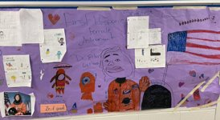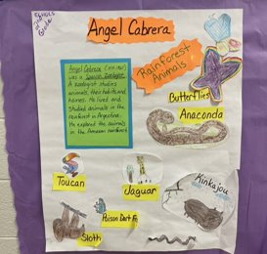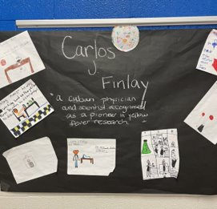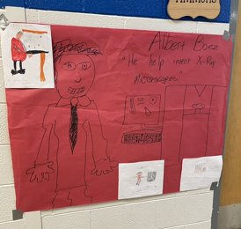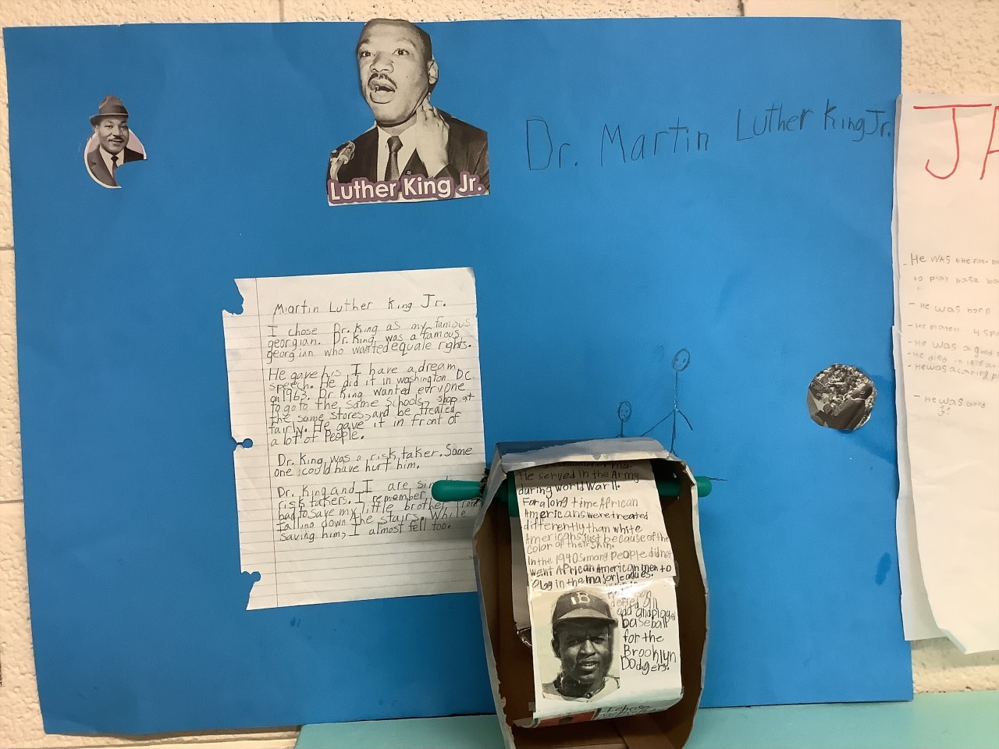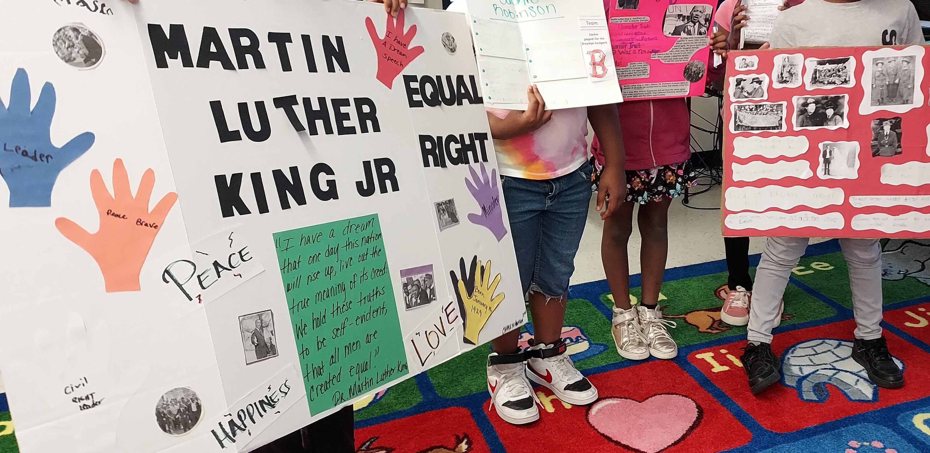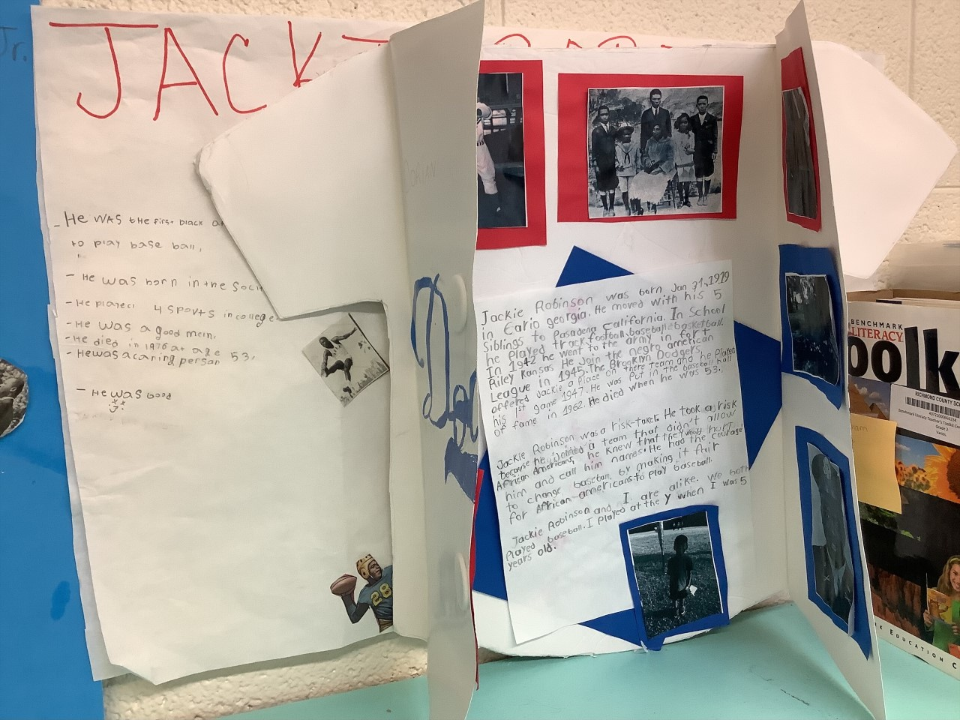
**Scroll Down for Unit Standards**

Unit Standards:

ELA: ELAGSE2RI1: Ask and answer such questions as who, what, where, when, why, and how to demonstrate understanding of key details in a text.
ELAGSE2SL2: Recount or describe key ideas or details from written texts read aloud or information presented orally or through other media
ELAGSE2W3: Write narratives in which they recount a well-elaborated event or short sequence of events, include details to describe actions, thoughts, and feelings, use temporal words to signal event order, and provide a sense of closure.

Math: NBT.1: Understand that the three digits of a three-digit number represent amounts of hundreds, tens, and ones; e.g., 706 equals 7 hundreds, 0 tens, and 6 ones. a. 100 can be thought of as a bundle of ten tens — called a ―hundred. b. The numbers 100, 200, 300, 400, 500, 600, 700, 800, 900 refer to one, two, three, four, five, six, seven, eight, or nine hundred (and 0 tens and 0 ones).
NBT.2: Count within 1000; skip-count by 5s, 10s, and 100s.
NBT.3: Read and write numbers to 1000 using base-ten numerals, number names, and expanded form.
NBT.4: Compare two three-digit numbers based on meanings of the hundreds, tens, and ones digits, using >, =, and < symbols to record the results of comparisons.

Science: N/A

Social Studies: SS2H1 Describe the lives and contributions of historical figures in GA History (Robinson, King, Gordon, Carter)
SS2CG3 How did the historical figures demonstrate positive citizenship traits?

