Standards
9.P.EICC.2.c Explain and learn concepts and processes by interpreting and constructing texts.
9.P.EICC.3.f Make, track, and support inferences about different levels of meaning within the text.
9.P.EICC.2.a Share real or imagined experiences by interpreting and constructing texts that tell or include stories.
9.P.EICC.2.d Interpret and construct texts to aid the analysis and evaluation of texts and ideas.
9.T.RA.1.a Generate questions to guide research, make connections between complex topics, explore creative solutions, narrow focus, and/or refine text creation.
9.P.ST.1.a Use prior knowledge, formal or informal research, and discussions with others to identify the key components of context that are most relevant.
9.P.AC.1.a Identify, apply, and analyze the literary, expository, and opinion (grades K-5) or rhetorical (grades 6-12) elements in texts, explaining or evaluating how specific elements affect the target audience and support the text’s purpose.
9.T.SS.2.a Analyze how the use of figurative, connotative, and/or rhetorical language contributes to the development of meaning, tone, or mood in a wide variety of texts.
9.P.AC.1.b Identify, apply, and analyze important, interesting, or effective uses of language, explaining or evaluating how specific word choices affect the target audience and support the text’s purpose.
9.T.C.2.d Synthesize information from a variety of credible sources used to research the answers to questions on academic and individual topics of interest.
9.P.EICC.4.d Link ideas and information to the organization plan, highlighting ideas and information that are most relevant, useful, and impactful.
9.P.AC.2.a Integrate literary, expository, and opinion (grades K-5) or rhetorical (grades 6-12) elements to appeal to target audiences and achieve specific purposes.
9.T.SS.1.d Apply knowledge of text structure and organization to create coherent and cohesive texts with an introduction that guides the focus and captures the audience; purposefully organized and developed supporting facts, reasons, explanations, details, descriptions, and/or events; and a memorable conclusion.
9.T.T.1.e Effectively apply a variety of narrative techniques to develop complex character(s) who change, use setting to create mood, develop an idea or theme across the text, achieve specific purposes, engage audiences, and enhance writing.
9.T.T.4.a Read, discuss, evaluate, and critique a variety of texts, considering poetic techniques used to present and design content and their associated implications on meaning and/or theme.
9.T.T.4.b Apply knowledge of various poetic techniques and conventions to create poetic text for an intended purpose.

9.T.RA.1.c Integrate paraphrased, summarized, and quoted material into original texts in various ways for intended purposes that strengthen the writing, citing appropriately.
9.T.T.1.b Analyze how plot structures, conflict, narrative devices, word choice, and other craft techniques impact an author’s purpose.
9.L.V.3.c Analyze the nuances in connotative meaning of words that share a similar denotation.
9.P.AC.3.d Consume and produce multimodal texts, integrating a variety of genres, text features, and craft techniques to influence target audiences and achieve specific purposes.
9.P.CP.2.b Integrate modes and genres most appropriate to purpose and audience.
9.P.CP.2.a Communicate clearly to present ideas, information, and texts.
9.T.RA.1.a Generate questions to guide research, make connections between complex topics, explore creative solutions, narrow focus, and/or refine text creation.
9.P.CP.1.d Work with others to discuss topics, investigate questions, solve problems, and explore and create texts.
9.T.SS.1.a Analyze the effectiveness of a text’s organizational structure to meet the needs and expectations of the target audience.
9.T.RA.2.b Analyze information from a variety of sources by identifying misconceptions; conflicting information or perspectives; and/or author bias and verifying the validity, relevancy, and accuracy of the information being considered.
9.T.C.1.c Construct and self-evaluate multimodal texts and/or presentations that serve more than one purpose and target a specific audience using multiple, clearly identifiable features of incorporated modes.
9.P.ST.1.a Use prior knowledge, formal or informal research, and discussions with others to identify the key components of context that are most relevant.
9.L.V.3.b Analyze relationships between words to determine connotative and denotative meanings for words and/or phrases across a variety of contexts.
9.T.SS.2.a Analyze how the use of figurative, connotative, and/or rhetorical language contributes to the development of meaning, tone, or mood in a wide variety of texts.
9.T.RA.1.b Use analytical findings to support a research question or thesis, citing the sources of quoted, paraphrased, and summarized ideas in Modern Language Association (MLA) format.
9.P.AC.1.b Identify, apply, and analyze important, interesting, or effective uses of language, explaining or evaluating how specific word choices affect the target audience and support the text’s purpose.
9.T.C.2.d Synthesize information from a variety of credible sources used to research the answers to questions on academic and individual topics of interest.
9.P.EICC.1.e Participate in a community of readers and writers by developing group norms, discussing texts, sharing individual writing, listening as others share their writing, and offering and responding to feedback.
9.T.RA.2.c Follow Modern Language Association (MLA) guidelines when responding to inferential questions about texts or when integrating and citing textual evidence, ensuring each source is accompanied by a basic entry on a works cited page.
9.T.T.3.a Read, discuss, evaluate, and critique a variety of texts, considering the argumentative techniques used to present and design content and their associated implications on meaning or central idea.
9.T.T.4.a Read, discuss, evaluate, and critique a variety of texts, considering poetic techniques used to present and design content and their associated implications on meaning and/or theme.
9.T.T.4.b Apply knowledge of various poetic techniques and conventions to create poetic text for an intended purpose.
9.T.RA.2.a Navigate and use a variety of credible print and digital sources, including academic databases, to locate relevant information about a central argument, topic, or question.

 | Pre-Teaching    Learning Target    Success Criteria 1  Success Criteria 2 | Activation of Learning  (5 min) | Focused Instruction  (10 min)  *I DO | Guided Instruction  (10 min)  *WE DO | Collaborative  Learning  (10 min)  *Y’ALL DO | Independent Learning  (10 min)  *YOU DO | Closing  (5 min)
 |  | - Do Now  - Quick Write*  - Think/Pair/Share  - Polls  - Notice/Wonder  - Number Talks  - Engaging Video  - Open-Ended Question | - Think Aloud  - Visuals  - Demonstration  - Analogies*  - Worked Examples  - Nearpod Activity  - Mnemonic Devices* | - Socratic Seminar *  - Call/Response  - Probing Questions  - Graphic Organizer  - Nearpod Activity  - Digital Whiteboard | - Jigsaw*  - Discussions*  - Expert Groups  - Labs  - Stations  - Think/Pair/Share  - Create Visuals  - Gallery Walk | - Written Response*  - Digital Portfolio  - Presentation  - Canvas Assignment  - Choice Board  - Independent Project  - Portfolio | - Group Discussion  - Exit Ticket  - 3-2-1  - Parking Lot  - Journaling*  - Nearpod
Monday | I am learning how to do research.  I can find information on prison reform programs.  I can write a summary of my findings.  I can cite my sources. | You have the power to make positive choices about your own behavior and social interactions. Look back at lines 55-56 of the poem “Gift-Wrapped Fathers”.  -What does the father do to “not be the bad guy”?  -How do you make responsible decisions in your life? (How do you evaluate the consequences of your choices? How do you evaluate the ways your decisions may affect your own well-being? How do you evaluate the ways your decisions may affect the well-being of others?) | How do you do research?  https://www.youtube.com/watch?v=eSL4FGsa6Ng |  |  | Do research on the prison reform movement in the United States and around the world. Choose one innovation-for example, programs that pair inmates with animals, or that teach barista skills for post-prison work in coffee shops. Summarize your findings in a multimedia presentation to share with the prison’s board of directors (or your classmates).  *describe the program and where it has been tested.  *report results: In what ways has the program been a success? Are changes planned?  *Present charts and statistics if you have them, along with photos of inmate participants.  *Like a good researcher, cite your sources. | What program have you decided to research?
Tuesday | I am learning how to do research.  I can find information on prison reform programs.  I can write a summary of my findings.  I can cite my sources. | Imagine you are the imprisoned father writing a letter to your son, who is now a teenager. What do you want and need to say to him?  Use figurative language: simile, metaphor, personification, etc.  Possible topics: the challenges and disappointments of fatherhood behind bars, lessons learned in prison, hopes for the future, expectations for your son  Think about the tone you want your letter to convey, and its overall message. | How to cite sources  https://www.youtube.com/watch?v=jzlexLa5ZHQ  https://www.citationmachine.net/  https://www.mybib.com |  |  | Do research on the prison reform movement in the United States and around the world. Choose one innovation-for example, programs that pair inmates with animals, or that teach barista skills for post-prison work in coffee shops. Summarize your findings in a multimedia presentation to share with the prison’s board of directors (or your classmates).  *describe the program and where it has been tested.  *report results: In what ways has the program been a success? Are changes planned?  *Present charts and statistics if you have them, along with photos of inmate participants.  *Like a good researcher, cite your sources. | Use one of the following vocabulary words to write a simile, metaphor, or personification.  Vocab words: capacity, confer, emerge, generate, trace
Wednesday | I am learning how to analyze word choice (diction) and style in a poem.  I can explain the author’s word choice.  I can explain the author’s style choices. | 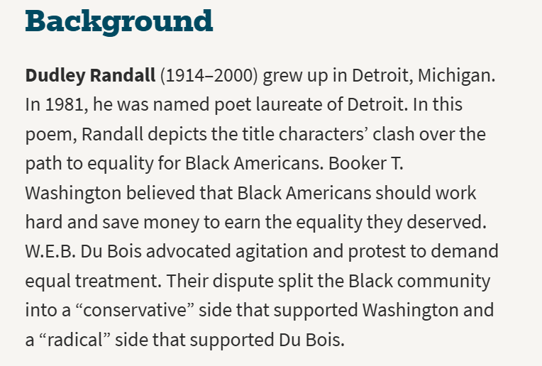  Booker T. Washington and W.E.B. Du Bois became adults after the Civil War had ended. At this time in U.S. history, all Black Americans were now free, but their rights were often severely limited; many were victims of discrimination and violence.  Is freedom from oppression more likely to come from education and hard work, or through agitation and protest? |  | Show How It’s Done:  Highlight “Mister Charlie” (line 4), “Miss Ann” (line 6), and “Charles and Miss” (line 11).  How do these forms of address offer clues to the speaker’s tone, or attitude? | Read: Booker T. and W.E.B. (pages 497-498)  Look at the following words that Booker T. uses in this poem to describe the attitudes and actions of people who share W.E.B.’s beliefs:  “shout” (line 19), “vain” (line 20), “sleepless (line 20), and “uproar” (line 21) | What does Booker T. think about the civil rights protestors?  What does Booker T. think is the best way to a better future?  In your own words, explain what lines 31-32 mean. | Style refers to how a writer expresses ideas, such as by word choice, line length, and punctuation.  In lines 33-35, point out the dash and change in line lengths. What tone, or attitude, do these style elements create?
Thursday | I am learning how to write a paragraph using textual evidence.  I can find relevant evidence to support my opinion.  I can explain my opinion in complete sentences. | Look at lines 17-30.  How can freedom mean different things to different people? Why do you think Booker T. might see owning a house as a kind of freedom? Why does W.E.B. see it as another example of oppression? |  |  |  | In a C.E.R. paragraph answer the following question. Use evidence from the “Booker T. and W.E.B.” poem.  Do you side with Booker T. or W.E.B.? | Complete the Assessment Practice Questions on page 499.
Friday | I am learning how to use different styles in poetry writing.  I can write figurative language.  I can write a poem inspired by the poem “Booker T. and W.E.B.” style. | Reread the poem’s last two lines. How do they humorously sum up the two narrators’ clashing perspectives? |  |  |  | Write a Dialogue Poem: Write a poem mimicking the style of “Booker T. and W.E.B.”, in which two or more speakers express opposing views about an important subject or issue.  *Develop specific diction (word choice) for each speaker and experiment with syntax (how words are arranged in sentences).  *Use at least one piece of figurative language. Needs to be underlined/highlighted and a key provided for what type of figurative language it is. | Reread and paraphrase line 2, focusing on the word cheek. What does Booker T.’s choice of that word suggest to you about his opinion of W.E.B.?
*key literacy strategies

