Georgia Virtual School Course Sign Up

Go to: <https://www.gavirtualschool.org/Students/Student-Account-Creation>

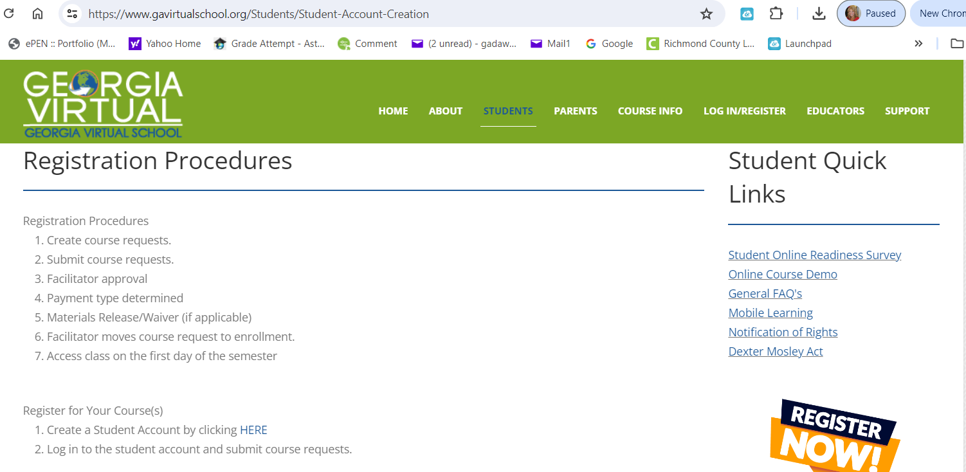

Create a Student Account by clicking [HERE](https://gavs.geniussis.com/).

Complete the information for your account. Please select the following:

**Student Type: Public**

**District: Richmond County**

**School: Choose your zoned home school**

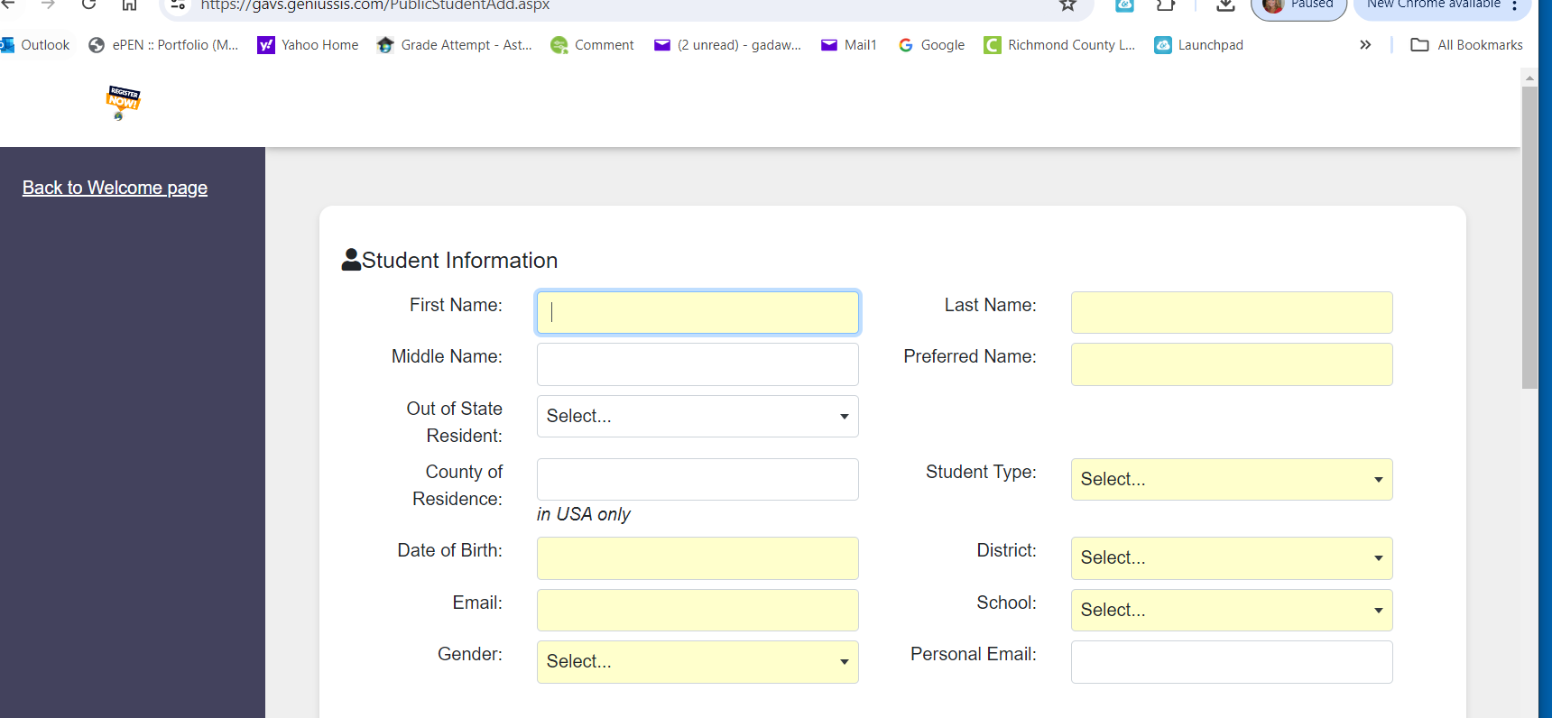

**SAVE YOUR LOGIN INFORMATION!!!**

Request the course that you will be taking with Georgia Virtual School.

If you do not know which course you are supposed to sign up for, **please contact Dr Ward at 706.339.4455**

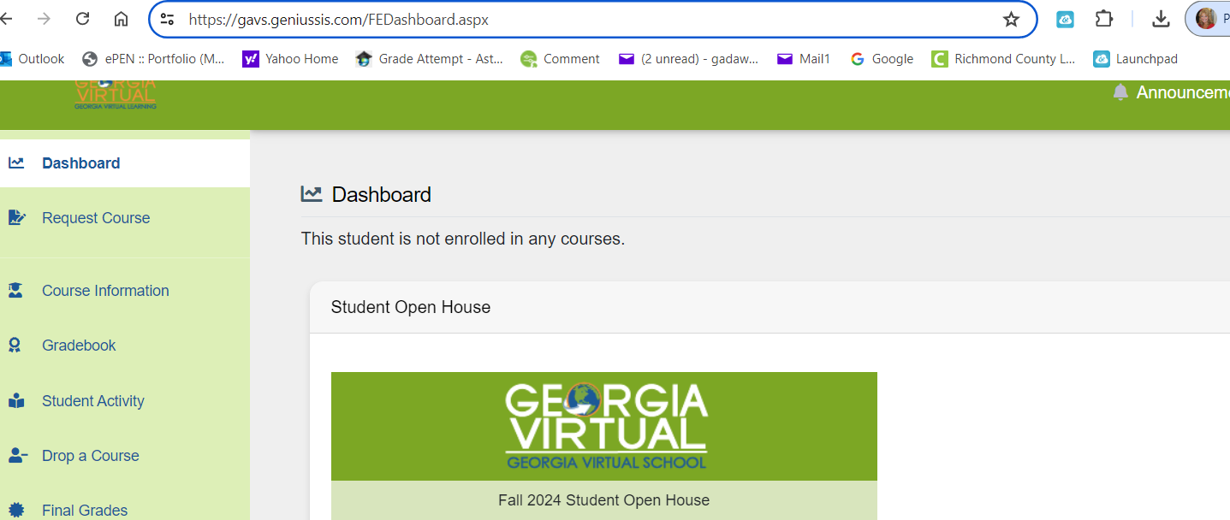

Make sure you choose REQUEST GAVS COURSE.

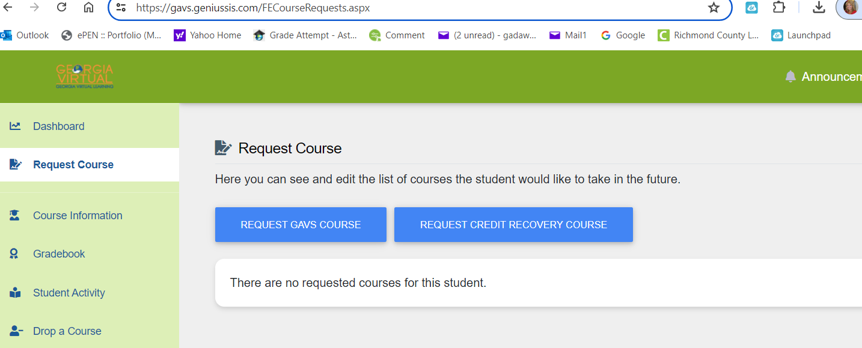

Make sure that you sign up for an A course for first semester and a B course for second semester. **DO NOT SIGN UP for an AB course.**

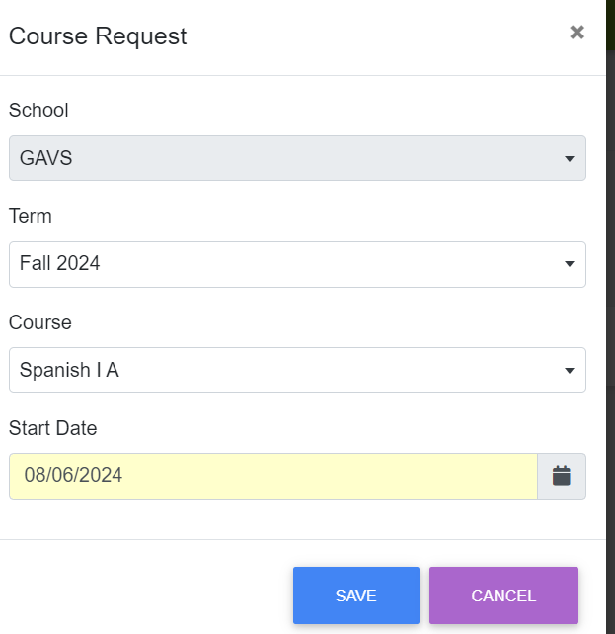

That is all you need to do for now. Your home school counselor will approve your class and you will be ready to start.

Call Dr. Ward if you have any questions or need help at 706.836.1802.