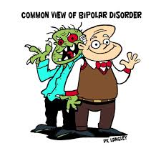

BELL RINGER: Analyze the political cartoon and write a brief statement that explains why some people view bipolar disorder this way.

______________________________________________________________________________________________________________________________________________________________________________________________________________________________________________________________________________________________________________________________________________________________________________________________________________________________________________________________________________________________________________________________

ANGEL’S AWAKENING: NOT BROKEN

HER STRUGGLE WITH BIPOLAR DISORDER

A local author of young adult science fiction reflects on her life experiences with bipolar disorder and how they have influenced her writing.

This video segment is part of *Not Broken*, a candid and hopeful documentary about seven young people fighting to live their dreams despite their mental health challenges, produced by Arizona Public Media.

<https://gpb.pbslearningmedia.org/resource/not-broken-part-17/angels-awakening-not-broken/>

After watching the video complete the following activity:

Students will write their thoughts regarding the video on a sheet of paper in a creative and colorful manner. The responses, comments, sketches, quotes and connections are not organized. The major focus is on recording initial responses during or immediately after watching a video. Next, we will discuss and share their graffiti renditions. The graffiti can then lead to webbing or charting to organize the connections.

