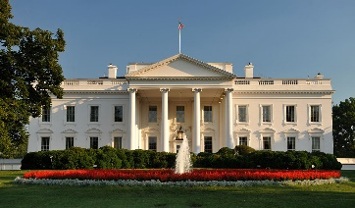

U.S. HISTORY SMALL GROUP EOC REVIEW QUESTIONS

SET #1 (Truman-Kennedy)

Directions: Use the *A Nation Conceived in Liberty* textbook (Chapters 16 and 17) to answer the questions in the chart on a separate sheet of paper.

|  |  |  |
| --- | --- | --- |
| HARRY S. TRUMAN | DWIGHT D. EISENHOWER | JOHN F. KENNEDY |
| Explain how President Truman’s policy of containment applied to the spread of communism.  Analyze and describe the key points of the Truman Doctrine.  Describe the significance of the Marshall Plan. | Explain how the United States under the Eisenhower Administration responded to the Soviet Union’s launching of Sputnik in 1957.  Explain the significance of the Eisenhower Doctrine and also state how it was viewed as an extension of the Truman Doctrine.  Define “McCarthyism” and also explain why Senator McCarthy’s theories were later discredited. | Explain how the failure of the Bay of Pigs Invasion impacted the relationship between Cuba and the Soviet Union.  Explain the agreement made between President Kennedy and Soviet leader Khrushchev that essentially kept the world away from nuclear war.  Describe the primary ideas outlined in Dr. King’s famous letter from Birmingham Jail. |