Rubicon- Adding Lesson Plans to Individual Map

- Go to www.rcboe.rubiconatlas.org.  - Log in. | 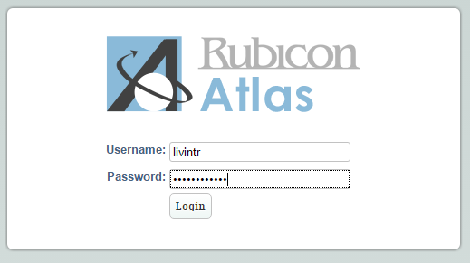
- Hover over ‘Develop’ and select the appropriate Individual Map. | 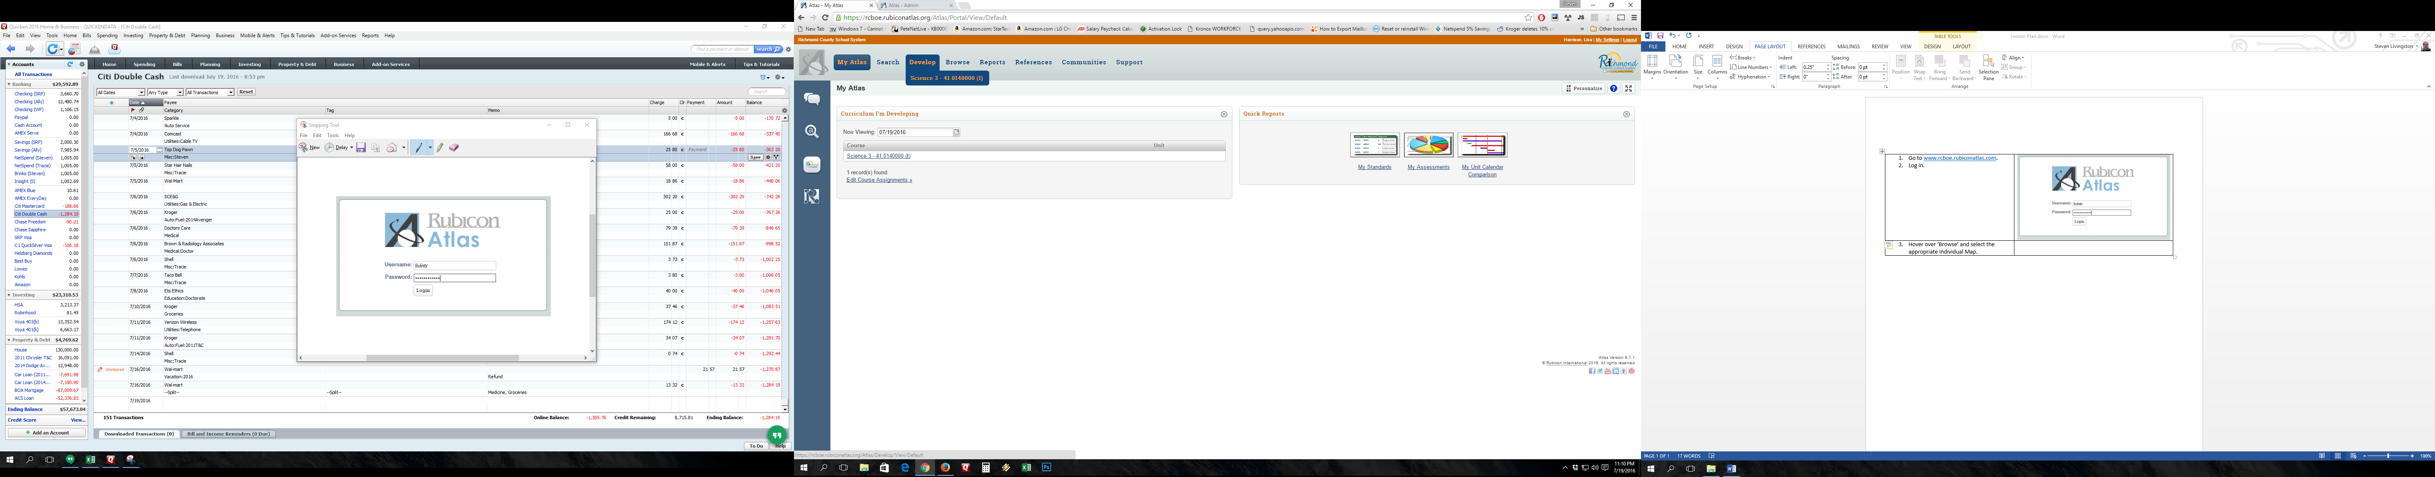
- Click on the Unit to which you want to add your lesson plan. | 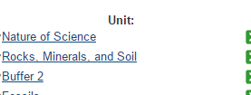
- Scroll to Stage 3. (Remember, you can use the arrows on the left to collapse the stages/sections for easier navigation).

- In the Lesson Plans & Tasks section under Stage 3, click ‘Add New Plan’. | 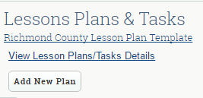
- The ‘Add Plan’ window will appear. | 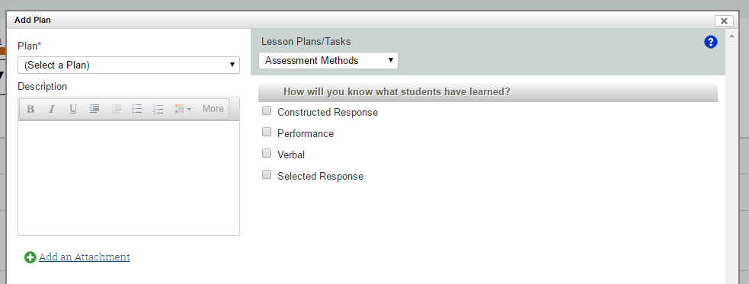
- Choose daily or weekly plan. | 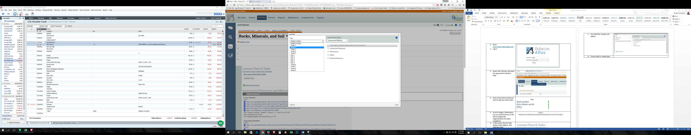
- Type a description (optional). | 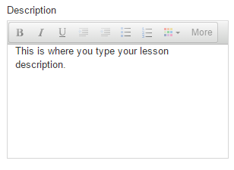
- Select the Assessment Methods, Instructional Strategies, RCK12 Literacy Instruction, Engagement Techniques, and Differentiation Techniques used in your lesson. | 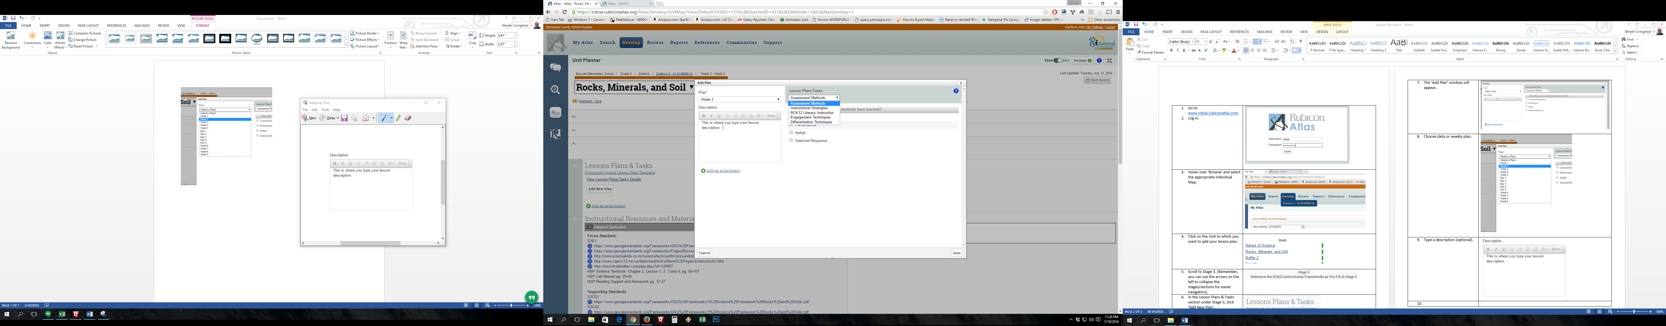
- Click ‘Add an Attachment’. | 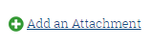
- Click ‘Lesson Plan’ (the hand icon). | 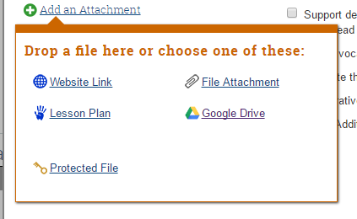
- Browse to your lesson plan. | 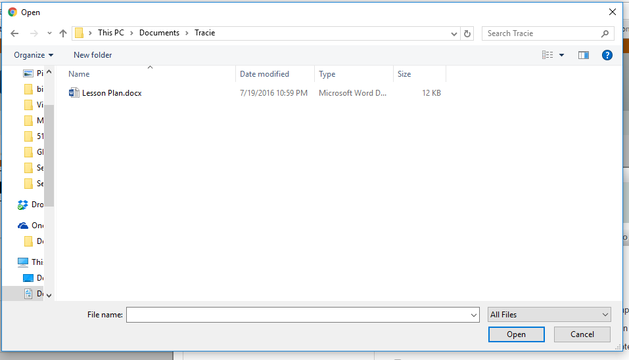
- Click ‘Save’. | 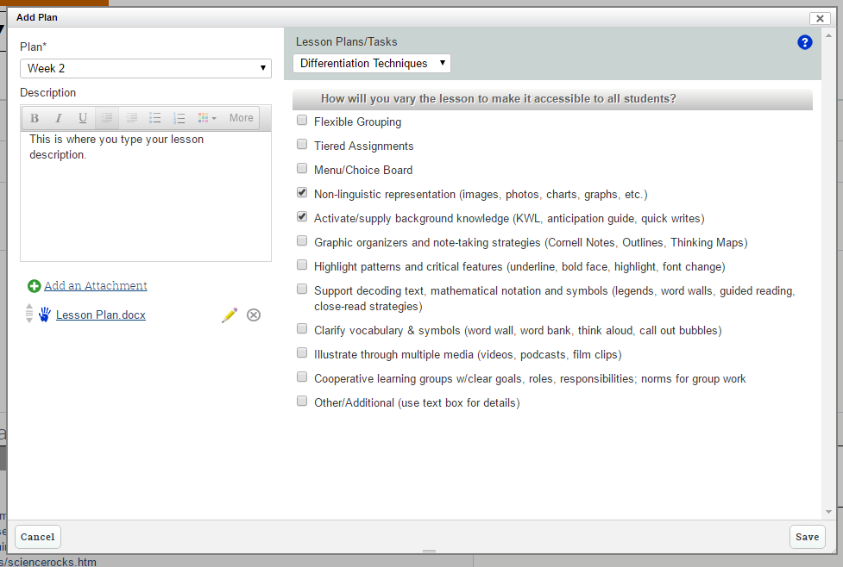
- Your lesson plan will now appear in the Lessons Plans & Tasks section of Stage 3 on your Individual Map. (Hand icon). | 