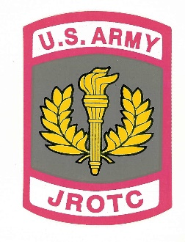

**LANEY JROTC DEPARTMENT**

Memorandum of Information

Subject: JROTC Performance Cord of Excellence (JPCE)

The LCL JROTC Program have established guidelines and expectations to meet in order to be considered for the JROTC Performance Cord of Excellence. Cadets are required to be in the JROTC program their Junior and Senior year of High School. The JPCE is based on performance and excellence, Cadets must have an 80% or above class average, Overall GPA of 2.5. Cadets must consistently participate on a JROTC team and support JROTC events and activities their Junior and Senior year in the program. All LET 3-4 cadets must complete a Leadership position application and conduct a Leadership position briefing to the Instructor. Cadets must be productive and in good standing within the JROTC program. Cadets will meet all established standards and structured criteria of the JROTC Policies , Procedures, and Protocols. Cadets will adhere to the JROTC syllabus, LCL Student Handbook and School Policies. These are the minimum requirements to be considered for the JSPE. (There are case by case circumstances for transfer cadets or first year enrolled seniors).

CW3 Flournoy, Ken

JROTC, Senior Army Instructor

Lucy Laney HS

Wildcat BN





