Rubicon- Adding a Course (Individual Map)
- Go to www.rcboe.rubiconatlas.org.  - Log in. | 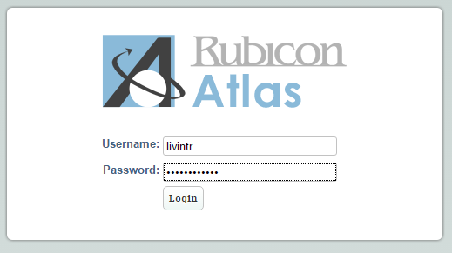
- Hover over the ‘Search’ tab and choose ‘Lesson Plans/Tasks’. |   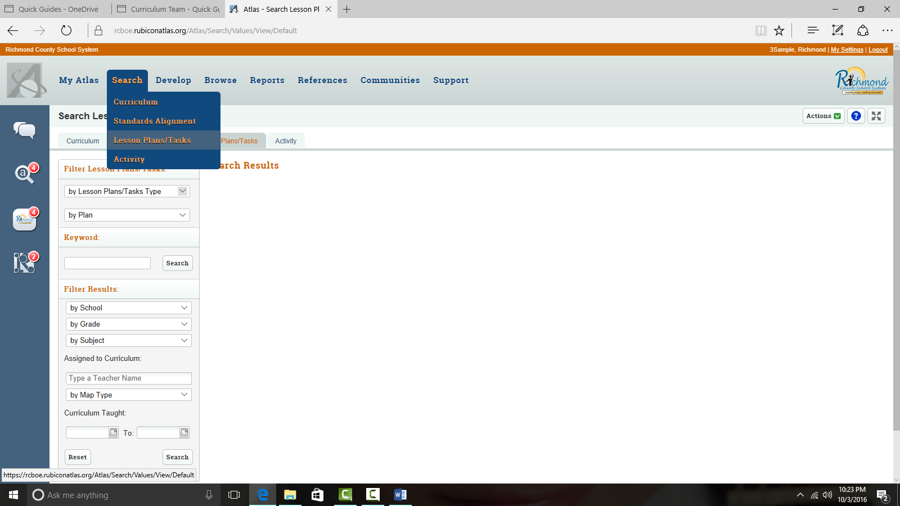
- Click the down arrow by ‘Lesson Plan/Task Type’ and select the appropriate lesson plan task. | 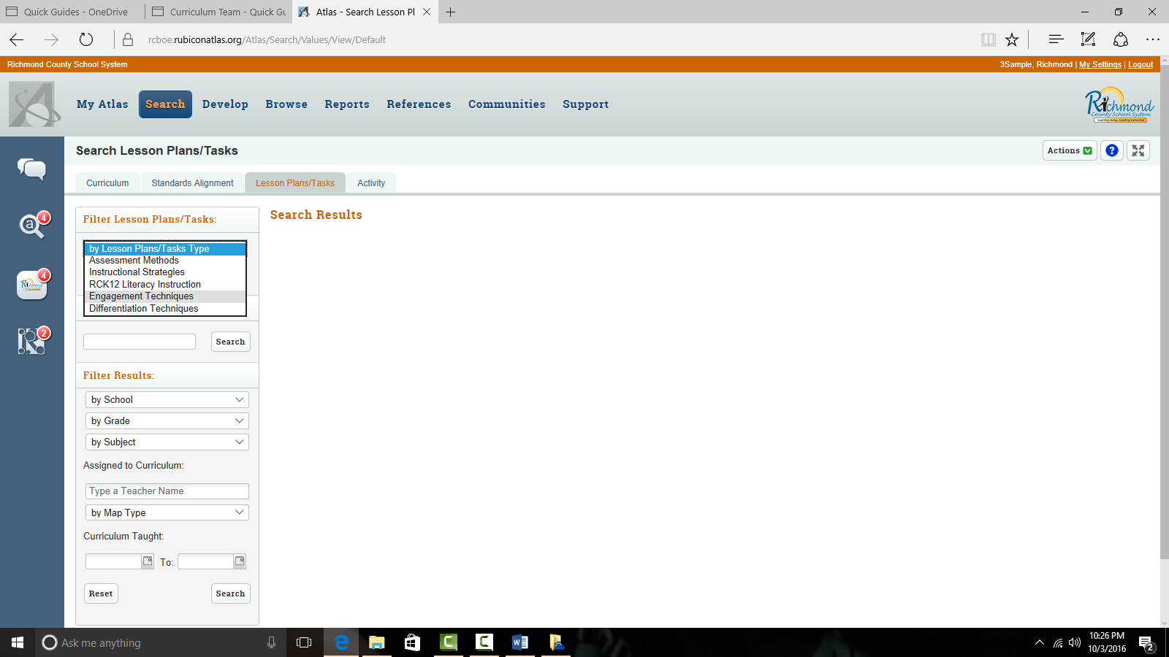
- Type your name in the ‘Assigned to Curriculum’ field and select your name from the resulting list.  - Click ‘Search’. | 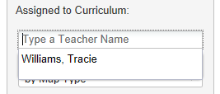  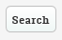
A list of all your lesson plans with the task type you chose will appear. | 