**RICHMOND COUNTY SCHOOL SYSTEM PARENT AND FAMILY ENGAGEMENT PLAN**

**Revised June 30, 2020 2020-2021**

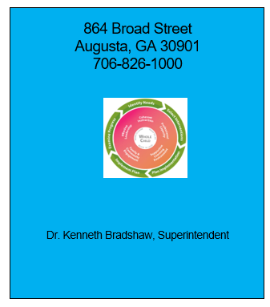

###### Mission:

*Build a globally*

*competitive school system teaching, learning collaboration and innovation.*

###### Vision:

*Provide an equitable education for all students to prepare them for life beyond the classroom.*

###### Learning Today…

***Leading Tomorrow***

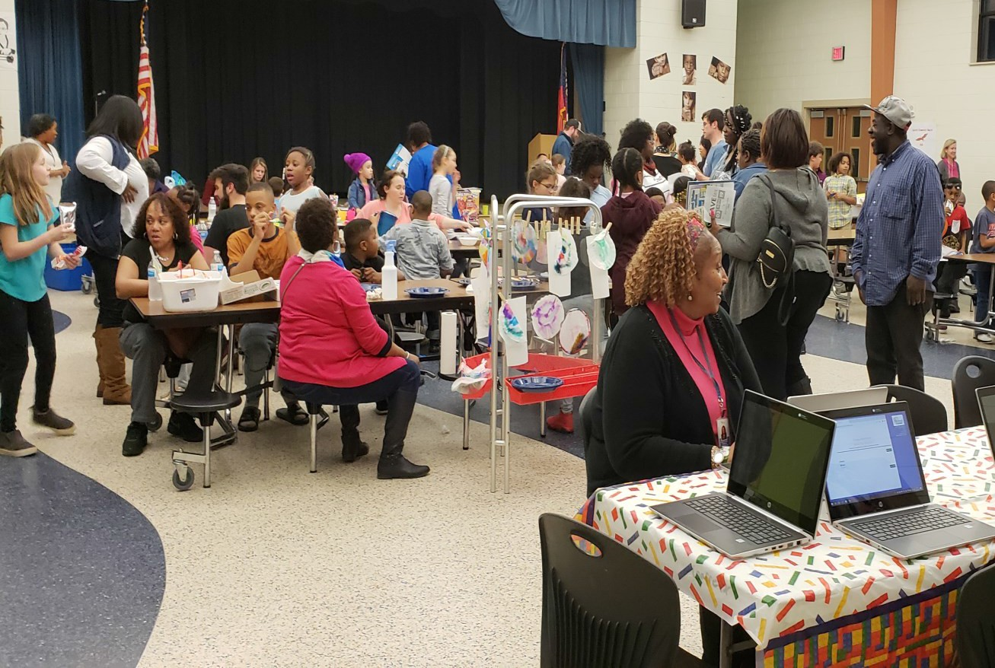

# What is Family Engagement?

#### Family Engagement means the participation of parents and family members in regular, two-way, and meaningful communication involving student academic learning and other school activities, including ensuring:

1. ) That parents play an integral role in assisting their child’s learning.
2. ) That parents are encouraged to be actively involved in their child’s education.
3. That parents are full partners in their child’s education and are included, as appropriate, in decision-making and on advisory committees to assist in the education of their child.

(D) The carrying out of other activities, such as those described in

Section 1116 of the ESSA.

**About the Parent and Family Engagement**

**Plan**

In support of strengthening student academic achievement, the Richmond County School System (RCSS) has developed this parent and family engagement plan that establishes the district’s expectations and objectives for meaningful family engagement and guides the strategies and resources that strengthen school and parent partnerships in the district’s Title I schools. This plan will describe RCSS’s commitment to engage families in the education of their children and to build the capacity in its Title I schools to implement family engagement strategies and activities designed to achieve the district and student academic achievement goals.

When schools, families, and communities work together to support learning, children tend to do better in school, stay in school longer and enjoy school more. Title I, Part A provides for substantive family engagement at every level of the program, such as in the development and implementation of the district and school plan, and in carrying out the district and school improvement provisions. Section 1116 of the Every Student Succeeds Act (ESSA) contains the primary Title I, Part A requirements for schools and school systems to involve parents and family members in their children’s education. Consistent with Section 1116, the RCSS committed to coordinating and integrating parent and family engagement strategies under Title 1 Part A with other federal, state, and local laws and programs by:

* Committing to utilize each school’s budget to provide self-help resources, parenting magazines, resources for the home (such as “Study Buddy,” and summer bridge reading and math materials), and improvement guides to assist with each student’s academic growth.
* Communicating effectively with parents utilizing parent workshops on various topics suggested by parents.
* Considering and addressing parents’ needs by committing to obtain documented suggestions, ideas, and comments at each scheduled parent event.
* Building relationships with internal and external departments and organizations within the community. Internally we will commit to scheduling monthly brainstorming sessions with our Partnership Office to assist with engagement strategies. Externally, we will align with local community partners as they plan community events and be in attendance with resources to distribute.

# Jointly

**Developed**

Throughout second semester of the 2019-2020 school year, parents were given the opportunity to provide input to improve the RCSS Parent and Family Engagement Plan for the 2020-2021 school year.

Parents were invited to give feedback on the district plan at school parent meetings across the district and to complete a survey located on the district website from which their feedback was collected. District plan and feedback forms were distributed to parents at district and school sessions and at the Title I end-of-year meetings held at the schools. The information was gathered and included in the 2020-21 RCSS Parent and Family Engagement Plan.

Upon final revision, the district parent and family engagement plan was incorporated into the Comprehensive LEA Improvement Plan (CLIP) which was submitted to the state. Parents are welcome to submit comments and feedback regarding the plan at any time on the school district website. All feedback received by June was included within the plan for this school year.

The district parent and family engagement plan is posted on district and school websites, distributed during the annual Title I district and school meetings, and made available to parents in school parent centers or guidance offices in a format and language they can under- stand.

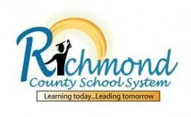

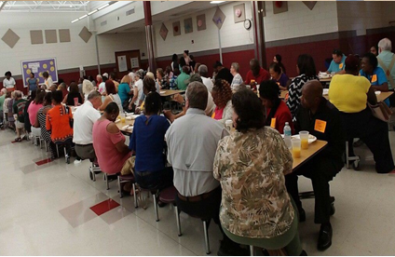

**Strengthening Our Schools**



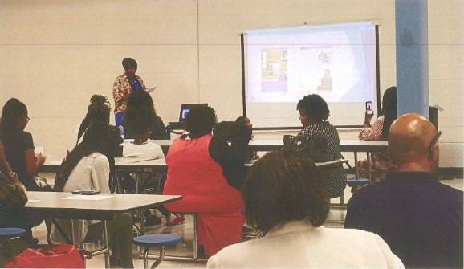

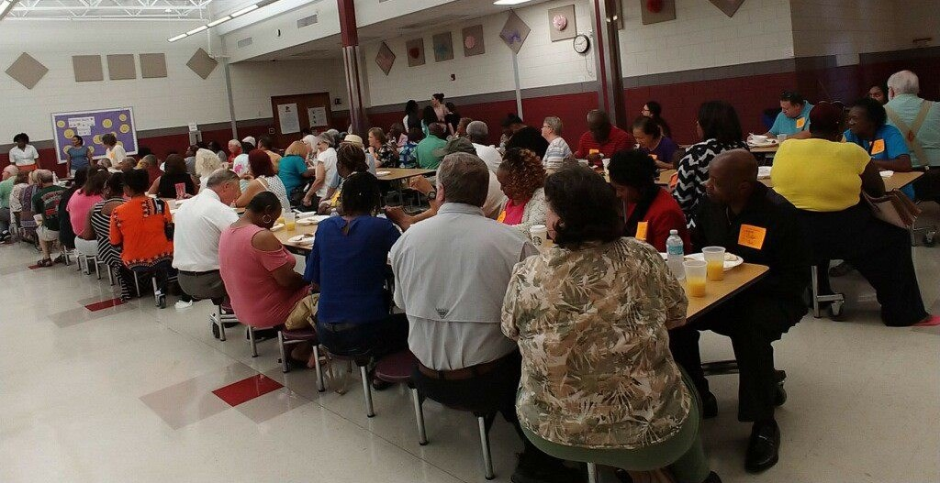

This year, the district Title I program specialists will provide assistance and support to all Title I schools to ensure family engagement requirements are being satisfied and that family engagement strategies and activities are being implemented.

In addition to frequent communication and school visits, Title I schools will receive notifications, resources, and training from the district to help them improve and strengthen parent and family engagement.

Additionally, the Federal Programs department will provide training to principals so principals will understand parent and family engagement requirements and plan opportunities for family engagement activities and meetings for the remainder of the school year.

**Parents receiving valuable information at a school’s parent night**

## Parent and Family Engagement Evaluation

The RCSS will conduct an annual evaluation of the content and effective- ness of this plan in improving the academic quality of our schools. Parents and family members will be invited to complete a survey at various meetings during February 2020 Surveys were sent to stakeholders, available on the district and schools’ web- sites, as well as paper/pencil at various parent meetings. During the Comprehensive Needs Assessment meetings, held in February 2020, parents and family members were asked to brainstorm strategies that can be used to make parent and family engagement more effective. Information gained from the surveys and meetings will be used to enhance family engagement and to revise the parent and family engagement plan for the upcoming school year.

## Reservation of Funds

The RCSS will reserve 1 percent from the total amount of Title I funds it receives in FY20 to carry out the parent and family engagement requirements listed in this plan and as described in Section 1116 of the ESSA. Furthermore, the RCSS will distribute 90 percent of the amount reserved to Title I schools to support their local-level family engagement programs and activities. The district will provide clear guidance and communication to assist each Title I school in developing an adequate family engagement budget that addresses their needs assessment and parent recommendations.

Each Title I school will host an input meeting for parents to provide suggestions as to how these family engagement funds will be used in the up- coming year at the district and school-level. In addition, parents can complete district surveys on the district website or at various parent and family engagement events such as cluster meetings. Surveys, input forms, and minutes from these meetings will be reviewed by the district to determine areas of need for the upcoming school year and consider changes to the family engagement budget.

**OppOortunities for Meaningful Parent Consultation**



All parents of students eligible to receive Title I services are invited and encouraged to share their input and suggestions throughout the year on the District Parent and Family Engagement Plan, the CLIP and Schoolwide Improvement/Title I Schoolwide Plan/Title I Targeted Assistance Plan in the following ways:

* During February 2020, all stakeholders in Title I schools were invited to give input and feedback on the District Family engagement Plan and the Comprehensive Needs Assessment/District Improvement Plan. Open community input meetings were held, and online feedback forms were available to gather input for the district’s needs assessment. Parent, student, and staff surveys are given annually and used in the needs assessment and planning process.
* Feedback forms will be available at the school, online and in the community
* Schools will be encouraged to host multiple person-to-person input opportunities throughout the year as requested through parent input.
* To the extent feasible, schools and the district will use virtual options to host meetings and collect parent input
* School parent input meetings will be held, and parents will be encouraged to contact their parent facilitator, family service facilitator, or other parent engagement representative
* The annual district survey is available on the district’s Federal Programs webpage
* District-wide parent input meetings will be held at multiple times and in multiple locations in the spring
* The Federal Programs Department can be contacted at 706-826-1000

Parents will be notified via school and district website, ShoutPoint, notifications at the school, announcements at parent events and in the community about these opportunities as they are scheduled. Feedback forms are provided online as well as in the schools and in the community giving parents the opportunity to share their input and suggestions on the use of Title I funds, their school’s Title I parent and family engagement program, their school’s school-family compact, their school’s parent and family engagement plan and the district parent and family engagement plan.



**Building Parent and School/Staff Capacity**

The RCSS will build parent and school/staff capacity to strengthen parent and family engagement throughout

the district.

**Parent Capacity**

* Schools will educate parents in understanding the State academic standards, school curriculum, student progress monitoring, and standardized assessments such as Georgia Milestones and End-of-Course tests.
* School staffs will teach parents through parent workshops throughout the FY21 school year at various sites. Topics may include improved discipline and communication, attendance, how brain development affects children’s behavior and decision-making, parenting a special needs child, seven smart strategies parents can use for immediate school success, and preventing use of tobacco, alcohol, and drugs.
* School staffs will offer parent workshops on topics suggested by parents such as at-home reading strategies, homework tips, and utilizing community resources. Programs will be held for parents who have children transitioning from pre-k to kindergarten, middle school to high school, and high school to post- secondary education in order to help parents prepare those students for their next steps in education.
* The RCSS will coordinate pages on the district and school websites that will contain resources and materials, including parent guides, study guides, and practice assessments to help parents work with their children at home. Copies of these materials will be made available at all Title I schools in the parent center or guidance office for those families who may have limited internet access. Resources will be available in Spanish when needed.

**Staff Capacity**

* School staffs will be trained to educate parents in understanding the State academic standards, school curriculum, student progress monitoring, and standardized assessments such as Georgia Milestones and End- of-Course tests. Other topics may include improved discipline and communication, attendance, how brain development affects children’s behavior and decision-making, parenting a special needs child, seven smart strategies parents can use for immediate school success, and preventing use of tobacco, alcohol, and drugs.
* Federal programs staff will work with staffs to ensure parents receive information in multiple ways such as website, distribution of flyers, Shoutpoint, texts, phone calls, and marquee posts, and that information is in a language and format parents can understand.
* Principals and their leadership teams will receive training to learn strategies to increase parent and family engagement, (to include training on the importance of the six “Shalls,”), to plan activities for parents and families throughout the 2020-2021 school year, and to discuss ways to improve communication between the school and families/community.

**Accessibility**

In carrying out the parent and family engagement requirements established by Section 1116 of the ESSA, the Title I director will communicate and collaborate with student services, Title III, special education, and curriculum offices to ensure full opportunities for participation of parents with limited English proficiency, parents with disabilities, and parents of migratory children including providing of information and school reports in a language parents can understand.

**Adoption**

This districtwide parent and family engagement plan has been developed jointly and agreed upon with parents and family members of children participating in Title I, Part A programs as evidenced by the collaboration of parents, school, and district personnel through parent meetings and survey.

This plan was adopted by the Richmond County School System on June 30, 2020 and will be in effect for the 2020-2021 academic school year. The school district will distribute this plan in multiple ways to all parents of participating Title I, Part A children on or before October 31, 2020.



























|  |  |  |  |
| --- | --- | --- | --- |
| **Event** | **Date** | **Time** | **Location** |
| Elementary School Open House | July 31, 2020 | 12:00p.m.-6:00 p.m. | Elementary, K-8 Schools |
| Middle School Open House | July 31, 2020 | 12:00p.m.-6:00 p.m. | Middle Schools |
| High School Open House | July 31, 2020 | 12:00p.m.-6:00 p.m. | High Schools |
| First Day of School | August 3, 2020 | See School’s Website | Elementary, K-8, Middle, High |
| District Annual Title I Meeting | September 17, 2020 | 9:00 a.m.-11:00 a.m. | Success Center |
| Elementary Parent Conferences | October 8, 2020 | By appointment | Elementary Schools |
| Elementary Parent Conferences | March 11, 2021 | By appointment | Elementary Schools |

**Thank you, Richmond County School System parents, families, and school community, for your valuable input which helped to jointly develop this Parent and Family Engagement Plan. Staying engaged in your child’s education and the decision-making process for schools and the district is vital to our success. If at any time during the year you have additional comments or feedback regarding this plan or other matters relating to your school and district parent and family engagement programs, feel free to contact the Federal Programs Department via phone, email or by mailing the form below. We look forward to meeting you at our next stakeholder input meeting in the spring.**

**Stakeholder Input Comments**

**Please contact me regarding my concern/comment.**

**Phone Email**

**Name (*Please print.*)**

**I am a parent  family member  school staff member  community member.**

**My child attends ES MS HS (*circle)***

**Date**

**Federal Programs Department 864 Broad Street., Augusta, GA 30901 706-826-1000**