**Student Orientation**

The student orientation will be the Digital Citizenship information provided by their teachers. In each PowerUP Teacher course, there is a module at the end of the course (LAND Module) on Digital Citizenship with the grade bands of the school listed. The teacher should review the grade band in which they have the greatest amount of students.

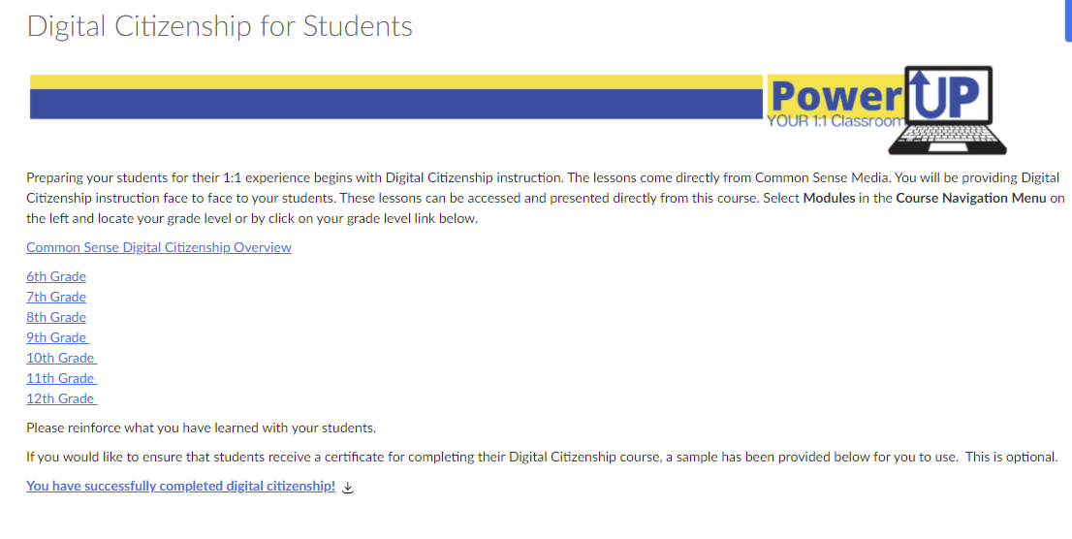

The school will determine who delivers the training. For example, one school may choose to have homeroom teachers deliver the information to their homeroom students. Another school may choose to have the English teachers deliver the information to their English classes – or Math teachers to the Math classes.

The script for the Digital Citizenship lesson plans allows for teachers to customize the lessons based on the time frame allotted. The point is that students hear the information from an adult who can share the resources about Digital Citizenship with them. The lessons are completely scripted so if the teacher reviews them, they should know exactly what to teach and what to shorten or to embellish upon. Finally, these Digital Citizenship lessons should be completed BEFORE your students receive their devices.

Use the schedule to determine the timeframe for your school to complete the student orientations.