Rubicon- Vocabulary Report
- Go to www.rcboe.rubiconatlas.com.  - Log in. | 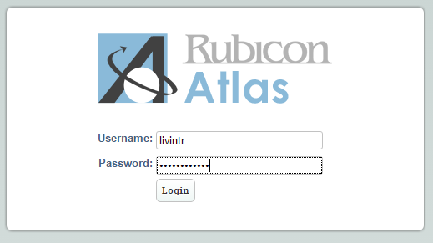
- Hover over the ‘Reports’ tab.  Click ‘Multiple Category Scope and Sequence.’ | 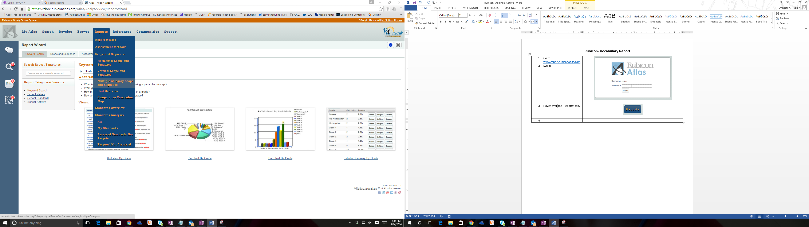
- Fill in the following fields:  School Type: Choose the appropriate type (Elementary, Middle, High, etc).  School: Choose RCSS Elementary, RCSS Middle, or RCSS High  Grade: Choose the appropriate grade level.  Subject: Choose the appropriate subject.  Map Type: Choose ‘District’.  Year: Choose ‘Current Year’.  Click ‘Browse’.  Note: You can select multiple grades and subjects if necessary. | 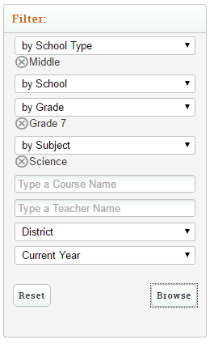
- Click the box next to the appropriate course.  Note: The course will appear in the “background” on the left of the ‘Choose Courses’ filter box.  - Click ‘Close’. | 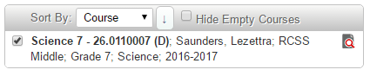  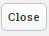
- Choose ‘Key Vocabulary’ in the ‘Mapping Category’ drop down menu.  Click ‘View Report’. | 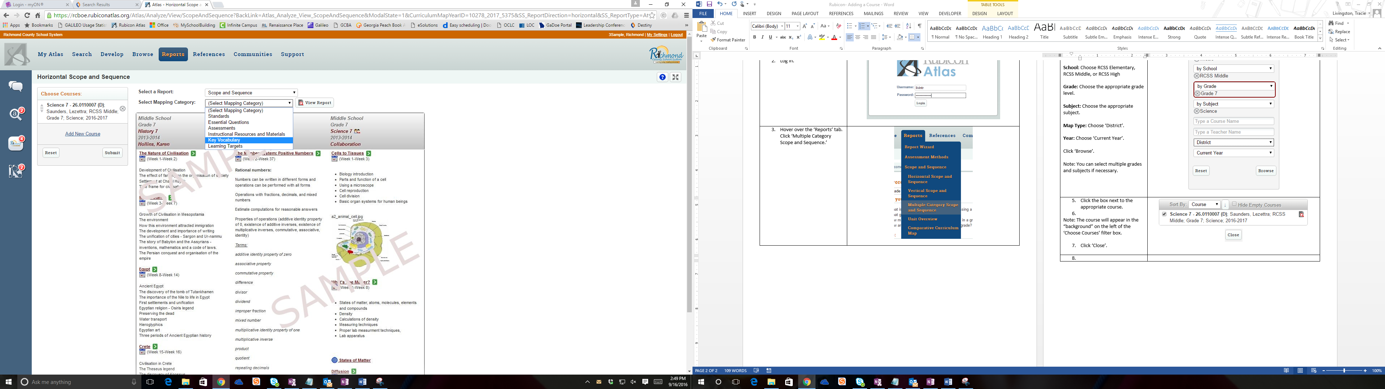  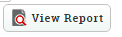
- Vocabulary will be listed by Unit. | 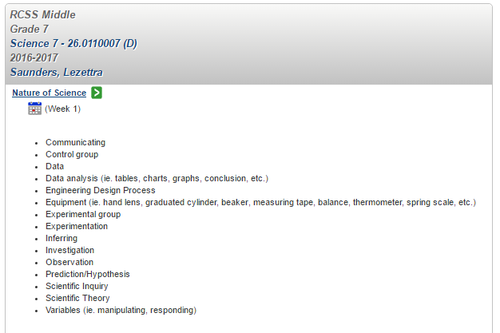
10. Optional: Pin the report to your dashboard.  Hover over Actions. Select Pin to My Atlas.  Optional: Save the report for later use.  Hover over ‘Actions’. Select ‘Save’. To view saved reports, hover over ‘Actions’ and select ‘Open Saved Reports’. | 