Grade Level: Dates:Aug 23-Sept 30
School Information  School: Copeland Elementary  School Code: 060043  Teachers:Hanley ,Godbee  Buffer: Buffer Sept 30 – Oct 12 | Transdisciplinary Theme: Who We Are  Segment of Theme: human relationships including families, friends, communities  Over Arching Concept: Individualism
Section 1: Overview
- Central Idea: Awareness of Ourselves and others helps us gain a sense of belonging
- Key Concepts: Function, Connection
- Guiding Related Concepts: | - Lines of Inquiry: | - Teacher Questions (Guided Questions):
Visual Art  Rules  Traditions | - Families come in all shapes and sizes.  - Following the rules will help me be successful.  - Treat people the way you want to be treated. | DOK Level 3 & 4  What can happen if you do not follow the rules?  Why are families different?  How does it make you feel when someone won’t share?  How is your family different from mine?  What could happen if we run in the classroom?
- Prior Content Knowledge: | - Assessing the Lines of Inquiry:
My Family, My likes and dislikes, rules at home | How will you assess student’s understanding of the lines of inquiry?  Students will draw a picture of their family and share with the class.  Students will create Essential Agreements and explain why each agreement is important.  Observations of students sharing and being kind to one another during play.
Section 2: What Are Our Target Goals?
- Concept Based Summative Assessment: | - Targeted Approaches to Learning (highlight 3): | - Targeted Learner Profile Attributes (highlight 2):
Create a Essential Agreements poster together as a class.  Students will create self-portraits using paint materials | Social Skills, Research Skills, Communication Skills. Thinking Skills, Self-Management Skills | well-balanced, caring, principled, open-minded, risk taker, knowledgeable, communicator, reflective, thinker, inquirer
Section 3: What Assessments will be provided in this unit of inquiry?
- Pre-Assessments:  What assessment will be given at the beginning of the unit to inform current understanding | - Formative Content Based Assessments:  What assessments will be given to monitor student learning of content? | - Summative Content Based Assessments:  What assessments will be given for students to show mastery of unit content?
Draw a family, label their drawing  KWL chart - Family structure | Daily read alouds on Family / Discussion  - A family is a family is a family read aloud / book discussion  Classroom observations of students during centers  Students who follow rules and ask others to do the same. | Drawing pictures of ourselves and our family.  Naming the people in our family.  Knowing essential agreements and why they are important.  Students pretend play as a family in the dramatic play center.
Section 4: How will we Facilitate Learning?
- Provocation:  How will interest into this unit be sparked? | - Learning Experiences:  What activities/experiences will help facilitate the learning? | - Evidence of Differentiation:  How will the learning experiences be adjusted to different learning styles/abilities?
Show and tell family photos - The teacher will bring in their own family photos to share with students.  Students will bring in their family photos and share about their family structure.  Provocation: Teachers model the importance of sharing and how to play in centers. | Week 1:  Provocation – The teacher will share their own family photos with the class and describe their family.  Students will have the opportunity to share their personal family photos.  Students will draw a picture of their family. The teacher will label the picture of the student’s family based on the student’s description.  Students discussed rules and why we have rules in school. Students learned the layout of the classroom and school. Students also discussed the purpose of school. Students create Essential Agreements as a class and discussed why each agreement was important.  Read alouds twice a day connected to the unit – Families  Week 2:  Provocation: Teachers model the importance of sharing and how to play in centers.  Students practiced the rules of sharing and how to use centers.  Students engaged in organized play in centers related to family  Read alouds twice per day connected to Families/Sharing/Kindness  Week 3:  Virtual Field Trip – Family Dinner – Students explored family dinners around the world:  “Food Trip Around the World” - Junytony  Read alouds related to culture – A Family is Family, All are Welcome, We are All Different, We are All Alike  Week 4:  Students learned about self-portraits. Students were able to use paint to create their own self-portraits. Students used a circle template to trace their face and were able to paint their facial features.  Students learned the terms for mom and dad in various languages and practiced saying the terms. (Spanish, German)  Discussion on pets being a part of the family. Students were able to share about their pets. Mrs. Hanley brought in her pet goats to share with the students. Students were able to interact and play with the goat.  Students have a class pet – Guinea Pig | Small groups, individual assistance  Para assistance for small group / individual students  Teacher station – focus on foundational skills  Modified self-portrait assignment / assisting students with paint supplies as needed.
- Learning Experiences in Specials:  How are Specials Courses able to connect to this unit? | - Local/National/Global Connections:  How can we connect the content to local/national/global issues? | - Student Action:  What learning experiences support potential student-initiated action?
Students receive Visual Arts instruction from their teacher in the classroom.  Students painted self-portraits during their Art time  Visual Art teacher shares are ideas with the teachers | Culture, Acceptance | Classroom expectations being monitored by the students  Students following essential agreements without being reminded.  Students sharing and helping others without being reminded.  Students will clean up after themselves after snack and breakfast
- Student Agency and Play:  What learning experiences provide students with voice, choice and ownership? What play opportunities will be provided by Kindergarten/Pre-K? hands on/STEAM for K-5? |  | - Resources:  Which resources will you and the students use? This may include people, places, technologies, learning spaces and physical materials.
Art- self portraits  Stations:  Dress up- Mirror, babies of different shapes and colors  Block Station – Bin of people with different types of people such as families and community helpers. Students can create communities made up of families and community helpers  Doll House – Students can play with dolls simulate families  Art Station – Culturally sensitive paper dolls to create themselves and their families  Kitchen Station – Students can play with multicultural foods and learn to set the table, students can simulate family situations  Reading Station – Books related to families, sharing, culture |  | Paint, Youtube videos on family, culture, sharing, family photos  Books:  I Love You All Day Long  Mommy’s Little Star  We Are All Different  Daddy’s Calls Me Man  Too Many Tamales  Feast5 For Ten  A Splendid Friend, Indeed  Mama Zooms  Peter’s Chair  My Friends  A Tiny Family  I Love You, Grandpa  YouTube Videos:  https://www.youtube.com/watch?v=II1b79NsQZg  https://www.youtube.com/watch?v=U2y4irBV96E  https://www.youtube.com/watch?v=49iP5YBSYt0
Section 5: Reflection (Write the year, change font color for each year)
- Reflect on learning experiences:
Hanley- Students enjoyed learning about their selves and each other. They can state the different types of people, families, careers and attributes of the people around them.
Godbee- The students completed a KWL chart about what is a family and drew pictures of themselves on how they are different from one another. Following the rules in the classroom and completing a matrix to see if they did follow the rules of the classroom with ease.

- How were the tasks differentiated to meet different learning styles? |  | - How did the learning experiences and strategies we used throughout the unit help to develop and show students understanding of the central idea?
By providing visual learning opportunities for students to learn how to set the table in our housekeeping center and by watching a YouTube video that demonstrate on how to set a table. We also provided canvas with a circle drawn on it to represent a face for the students to draw a self portrait of their selves because some of our students do not have the fine motors skills to draw a circle. We also went over class expectations in small groups to help students learn what we expect out of them int he classroom. |  | The learning experiences such as setting a table in housekeeping center help the students learn how to set a table and how families around the word eat at a dinner table together. Also showing pictures of our families help students understand that families come in all shapes, sizes, and colors.
- What learning experiences best supported students’ development and demonstration of the attributes of the learner profile and approaches to learning? |  | - How effective were the summative assessments in measuring student learning? What, if any, changes need to be made to the assessments?
Hanley- After bringing in photos of our families we were able to voice our curiosity about the families we saw in the photos.  - Each student reflected on their own morning routine and how others could be different.  - Students learned to be more caring and empathetic of their peers and their differences.  Godbee - The children came up with questions about families and we did some research on the questions. · Connecting our families to each other to understand how are families are alike and different. · Using social skills to communicate how to make friends, talking about our families and what makes us unique from everyone else. |  | Our summative assessments were effective for our students understanding. The students were ask to draw a picture of their family and tell the class who is in their family. The students describe their parents, siblings, aunts, uncles, grandparents, and cousins. The students also had to demonstrate our essential agreements such showing how we walk inside the building and discussing why it is important to walk in the build and run. Also, setting up the housekeeping area for pretend play as a family was very helpful for our students see how their classmates interact with their family at home.
- What student-initiated inquiries (questions) arose from this unit of inquiry? |  | - What student action arose from this unit of inquiry?
Hanley- “What’s it like having no siblings?”  “Do you always to grandmas for dinner on Sundays too?”  Godbee - What does a family mean? We looked up the definition and found out that a family is a group of one or more parents and their children living together as a unit. · Does everyone have a family. · Can a family be other people we around? We gave examples on how our class is a family and our school is a family |  | Students are able to identify the class expectations and perform the expectations set by the class.  Students can identify family members and explain who is their families. The students also can recognize how families are the same and how they are different.  Students understand how family dinner time works and how to set a table.
- Any additional notes or changes that need to be considered next year?
Section 6: Picture Evidence
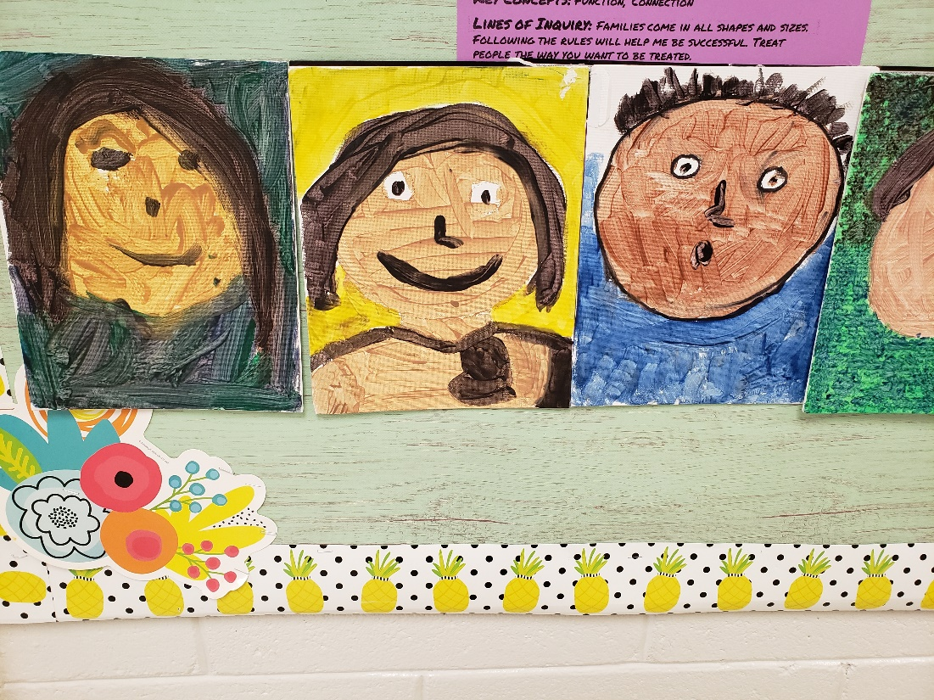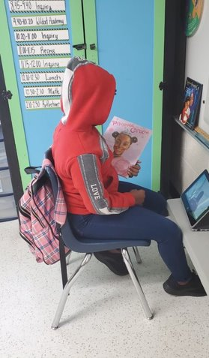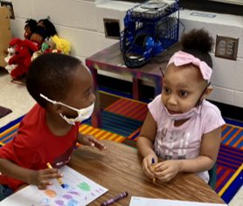
**Scroll Down for Unit Standards**

Unit Standards:

ELA:

Math:

Science:

Social Studies: SS1.4a
SS1.4b
SS3.4b

