Rubicon- Adding a Course (Individual Map)
- Go to www.rcboe.rubiconatlas.org.  - Log in. | 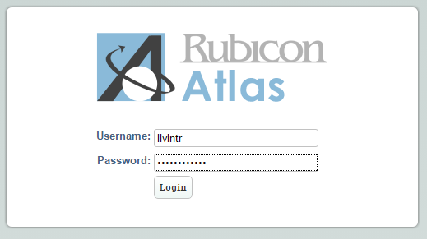
- Click the ‘Develop’ tab. | 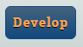
- Click ‘Edit Course Assignments’.  Note: You will see all the courses you are currently developing on this page. | 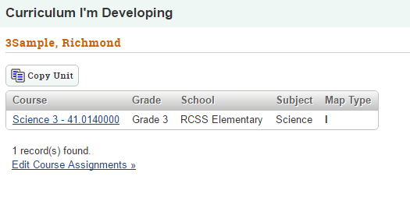
- Fill in the following fields:  Select a School: Choose RCSS Elementary, RCSS Middle, or RCSS High  Select a Subject/Grade: Choose your content area and grade level.  Select a Course Title:  If you do not know the course number you can leave the ‘Course Title’ field blank.  Choose Individual for the ‘Map Type’ field.  Edit Course Assignments: Click the ‘New’ button next to the course you want to develop. | 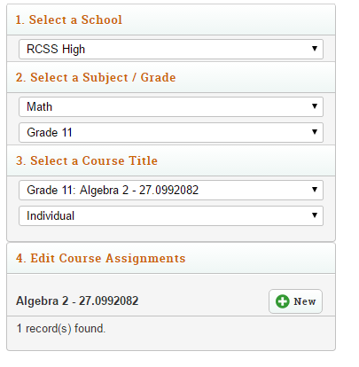
- The course you selected will be added to the ‘My Course Assignments’ section on the right.  Click ‘All Done’. | 