***What is a  
 School-Parent Compact?***

It is a written agreement describing how all members of a school community (parents, teachers, principals, and students) agree to share responsibility for student learning. This compact helps build a bridge between the school and home to encourage learning, communication, and achievement for all students.

***Jointly Developed***

The parents, students, and staff worked together and shared ideas to develop the school-parent compact. Teachers discussed with their grade team and designed practical strategies for parents to use at home. Parents provided valuable feedback on their needs to help their students. Meetings are held each year to review and revise the compact based on the school’s academic achievement goals and students’ needs. Parents are welcome to provide feedback on the compact at any time during the school year. All feedback will be collected and reviewed during the annual revision meeting with parents. Please call 706-592-4561 or visit our website, <https://www.rcboe.org/Domain/22> for more information on the school-parent compact.

***Activities to Build*** ***Partnerships***

Join us for our Family Engagement Activities for the 2025-2026 school year. Our Calendar will be uploaded on the school’s website and Class Dojo. A few of the activities that we will be hosting are: Monthly Volunteer Training, Infinite Campus student of the month ceremony, Training, Family Fun (Curriculum Nights), Movie Nights, Thanksgiving Dinner, Grandparent’s Day, Georgia Milestone Trainings, Donuts for Dad and Muffins for Moms.

***Communication about Student Learning***

Hephzibah Elementary School is committed to frequent two-way communication with families about children’s learning. Some of the ways you can expect us to reach you are:

* Canvas
* Weekly homework folders
* Class Dojo
* School Website
* Parent Teacher Conferences
* Phone Calls/Infinite Campus
* Open Door Policy

Do you have questions about your child’s progress? Contact your child’s school at phone (706) 592-4561 or through Class Dojo messaging system.

***Title I School-Parent Compact for***

***Achievement***

***2025-2026***

***K-5th Grade Focus for***

***Student Success***



**Josh Workman, Principal**

**Stephanie Spencer, Assistant Principal**

***Revised August 14, 2025***

***Cover***

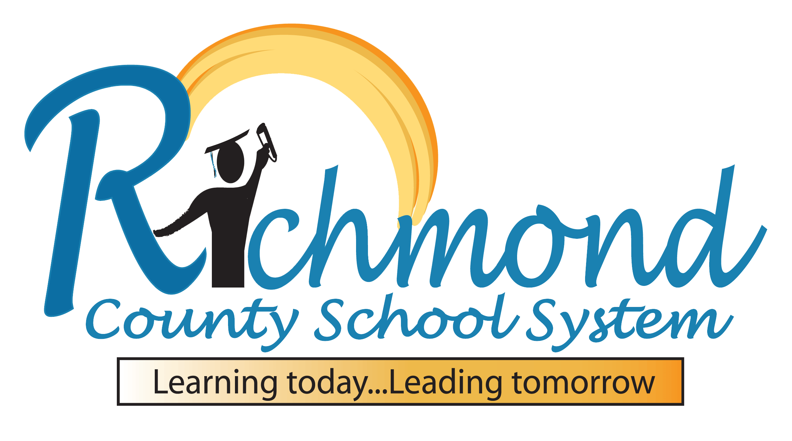

***District goal***

* During the 25-26 school year, we will increase student content mastery in tested subject areas on the Georgia Milestones by 6%.
* During the 25-26 school year, we will increase post-high school readiness by increasing our graduation rate by 2%.

***School Goals***

* Within the 25–26 SY, we will increase stakeholder engagement by 15% through participation in events, communication and volunteer opportunities.
* Within the 25-26 SY, we will increase % of students who reach typical growth or proficient by 7% on the EOY Reading iReady Diag/GMAS vs 24-25.
* Within the 25-26 SY, we will increase % of students who reach typical growth or proficient by 7% on the EOY Reading iReady Diag/GMAS vs 24-25.

***Focus Areas***

• Vocabulary development, read for fluency and comprehension

• Number sense, fact fluency, multi-step problem solving

***As a student, I will….***

* Play the games and activities on the suggested websites.
* Review Math facts for at least 20 minutes.
* Read books and complete a reading log on my Lexile level nightly.



***As a parent, I will …***

* Visit the suggested websites and encourage my child to practice building vocabulary and math skills.
* Ensure students complete and pass 2 reading and math lessons on i-Ready.
* Drill math facts at least 3 times a week.
* Ensure adequate time for reading with my child each night.

***As a school, we will….***

* Provide students with the opportunity to build fluency skill in reading using MyOn, Fundations, and i-Ready.
* Provide students with the opportunity to build math skill by using First In Math, ST Math, and i-Ready.
* Send home books on your child’s Lexile level with weekly reading tasks and a reading log.

***Teachers, Parents, and Students—Together for Success***