**Freedom Park K-8 School**

**Mrs. Carla Nobles’ 6th Grade Math Class**

**Course Syllabus 2023 - 2024**

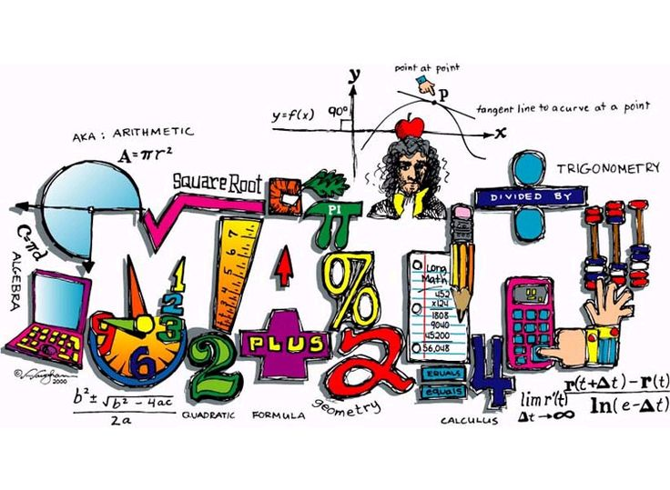

**Contact Information**

**Email:** [nobleca@boe.richmond.k12.ga.us](mailto:nobleca@boe.richmond.k12.ga.us)

**Phone: 706-796-8428**

**ClassDojo**

**Tutoring: Dates will be coming**

**Apps We Will Use:**

Flocabulary Delta Math I-Ready IXL BrainPOP Desmos

**Textbook:** HMH Into Math Grade 6 Consumable **Launchpad:** (ED) Georgia Science

**Assignments and Absences**

Students will receive a variety of assignments designed to enhance their learning. If a student is absent, the student is responsible for the missing assignments.

**Grading Policy:**

Tests: 40% Quizzes/Classwork/Homework: 60%

**Make-up work**: Students need to come pick up their make-up work before school on the first day back from an absence. At this time, students need to be prepared to turn in any work that was due the day they missed.

**Retest Policy** Students may take a retest to bring up a test grade of a 69 or lower. Occasionally, I will have students make corrections instead of take a whole new test. This is always up to teacher decision. The deadline for each retest/correction is always given to the student and it is the student’s responsibility to come in by the deadline.

**Classroom Procedures & Expectations**

1. Everyone can & will LEARN!
2. Do your BEST – EVERYDAY! Your effort determines your SUCCESS!
3. Have the “I can do it” attitude! Stick to it! Push Through! Choose to LEARN and EXCEL!
4. Be prepared to LEARN --- EVERYDAY!

“I am looking forward to a great year.”

Mrs. Nobles