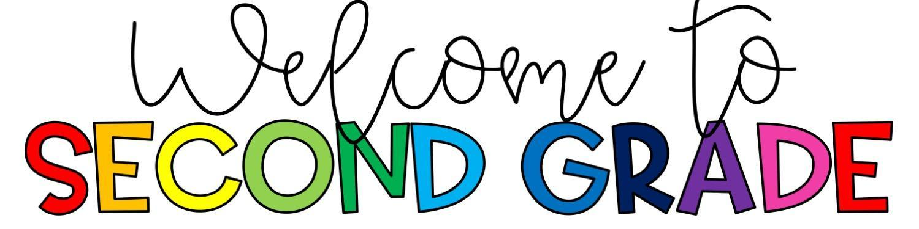

Dear McBean Parents/Guardians,

Hello! My name is Altricia “Trish” Jordan. I am a 2nd grade teacher at McBean Elementary School. One of the greatest singers—Whitney Houston—said it best: “I believe the children are our future. Teach them well and let them lead the way….” I believe that all children deserve a safe, positive learning environment that is conducive to learning. I will work very hard to create a classroom climate in which all children feel free to take risks and to be themselves. I also realize that all children are unique and learn in different ways. Therefore, I will employ various teaching methods, techniques, and strategies to ensure that I am meeting the different learning styles of all students. Furthermore, I hope to instill in every student the value of learning as a life-long process. I have an exciting year planned for your child, and I am looking forward to everything that’s in store. I'd like to share some things with you that will help make this an awesome school year...

**Morning Drop-Off**: Breakfast starts at 7:45AM. School starts at 8:20AM. Parents will only be allowed to walk their child to their classroom on the first day of school. After that, a school staff member will be at each hallway to help your child get to the correct classroom.

**Afternoon Pick-Up**: School ends at 3:05PM. If you choose to pick your child up from school, you must remain in your car in the car rider line. School staff will be outside to bring car riders to their vehicles. If your child is a bus rider or going to Prime Time, these students will remain with their teachers until they are dismissed.

**Transportation Changes:** Please send a note if your child will go home a different way. If your child needs to leave school with someone other than a person listed on the release card, send a note to school with your child (a note will not be accepted from the person requesting to pick up the child). Also, we will not be able to take a verbal message from a child- written notes are required to make any changes to transportation.

**Homework:**According to the Richmond County Student Handbook, students will receive one homework grade each grading period. Your child will have homework Monday-Thursday. Homework packets will be assigned each week and will be due on Friday of that week. Please remember to study sight words and math facts daily.

**Folders:** Folders will be sent home daily with homework assignments and important forms that may need to be signed. Conduct will be sent home daily and graded papers will be sent home bi-weekly. Please sign any forms in the folder and return the following day.

**Personal Belongings:** Please be sure to put your child’s name on all personal belongings to avoid losing them (this includes school supplies).

**Money:** When sending money, it would be very helpful if you put the money in an envelope or sandwich bag and label it with your child’s name, teacher’s name, amount enclosed, the purpose of the money.

**Attendance:**We need all children in school daily unless they are sick. Students who are absent from school are encouraged to bring a written excuse for their absence on the first day back at school (parent note or doctor note). The school will accept and count 5 days of absent notes from a parent but the others should come from your child’s doctor. All excessive absences and tardies will be reported to DFCS.

**Birthdays:** According to the Richmond County Student Handbook, students are only allowed to bring healthy food items to school for any type of celebration. If you have any questions about what qualifies as a healthy snack, please feel free to contact me.

**Snacks:** We do not eat lunch until 12:15PM, so we have snack time daily at 11:00AM. Please send in a snack for your child if you would like for them to participate. According to the Richmond County Student Handbook, students are only allowed to bring healthy food items. If you have any questions about what qualifies as a healthy snack, please feel free to contact me.

* I will create a monthly snack list. So that you’re only responsible for supplying a healthy snack once a month. 😊

**Grading Scale:**

 The standards-based report card for grades K-3 will include a grading scale of 1-4.

* 1-Beginning Learner (I am starting to learn this. I can’t do it by myself yet.)
  + 2-Developing Learner (I am starting to understand. Sometimes I may need help or an example.)
  + 3-Proficient Learner (I can do it by myself. I can show how I understand. I make little to no mistakes.)
  + 4-Distinguished Learner (I am working on a higher level. I can explain how to do this. I can teach others.)
  + If an indicator is not measured during the grading period, the student will NOT receive a mark on the report card.

I feel that a three-way partnership between the student, the parent, and the teacher is the key to a successful school year. Please feel free to call or email me with any questions or concerns that you may have, and I will get back to you at my earliest convenience. We are going to have a great school year!

Sincerely your child’s 2nd grade teacher,

Miss Jordan

JordaAl@BOE.Richmond.K12.GA.US