**Georgia Studies Course Syllabus**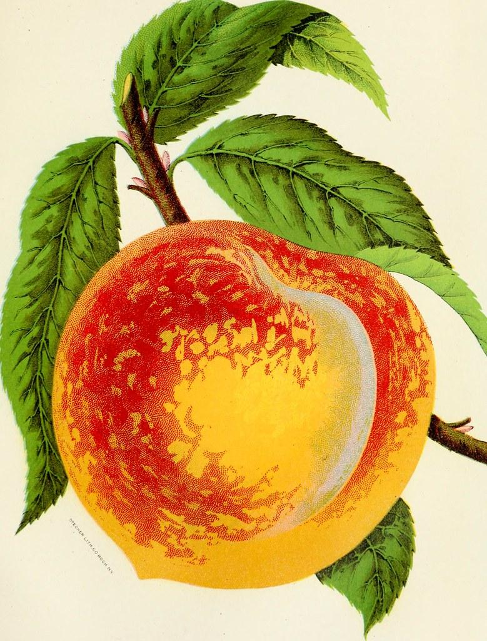

**Eighth Grade 2023-2024**

**Ms. Kiandra Burns**

**Hephzibah Middle School**

**Email**: **burnski@boe.richmond.k12.ga.us**

**Phone Number: 706-592-4534**

**Remind: @2023hms8b**

**Course Description**

In eighth grade, students study Georgia geography, history, government, and economics. While the four strands are interwoven, ample opportunity is also provided for in-depth study of the geography of Georgia and the government of Georgia. U.S. historical events are included, as appropriate, to ensure students understand Georgia’s role in the history of the United States.

**Course Outline**

|  |
| --- |
| Unit 1: Geography & American Indians |
| Unit 2: Exploration and Colonization |
| Unit 3: Revolution, Statehood, and Westward Expansion |
| Unit 4: The Civil War, Reconstruction, & The New South |
| Unit 5: World War I to Post-World War II |
| Unit 6: Civil Rights to Modern Georgia |
| Unit 7: Government and Personal Finance |

**HMS Grading Policy**

# Grading Procedure

Students will receive two categories of grades:

* Summative Assessments – 40%

Examples include unit tests, essays, research papers, project-based assignments, and other culminating assessments to measure mastery of standards that comprise a unit of study

* Formative Assessments – 60%

Examples include quizzes, labs, and other graded assignments to assess certain standards in a unit of study

**Academic Grade Reporting**

Middle school student performance will be recorded and reported in all courses by numerical grades, based on a 100-point scale.

**Calculation of Final Grades**

Final grades will be determined by the cumulative semester average using the following criteria:

**Make-Up Work**

Students are expected to make-up assignments and assessments missed due to absence from school. It is the student’s responsibility to ask teachers for the make-up work upon returning to class. Make-Up work must be completed within 5 days of returning to school.

**Late Work**

Students are expected to complete and turn in assignments by the assigned due date. If you are absent on the day the assignment is due, please turn in your assignment the day you return.

**Content Mastery Assessments**

These assessments will be given quarterly in all core content areas.

**Academic Grading Scale**

The District grading scale as applied to points earned by the end of a grading period are as follows:

**A**=100-90, **B**=89-80**, C**=79-75, **D**=74-70, **F**=69/below

**Communication**

Email and Remind will be used to inform students and parents/guardians of upcoming classroom activities, assignments and assessments, but please remember that everything will be posted in Canvas. Communication from home is also highly encouraged. Parent Portal and Canvas will be updated regularly and is also another excellent tool to keep updated with student progress.

ACKNOWLEDGEMENT of the Georgia Studies Syllabus

**Class Period: _________________**

**Student and parent/guardian are requested to complete and return this page only to verify receipt of the Syllabus for this school year. Homework credit will be given to the student when this completed form is turned in to me.**

Print Student Name above Student Signature above Date

Parent Signature above Date

Contact Information Phone: Email address: