**Jump In Movie questions**

Standards:

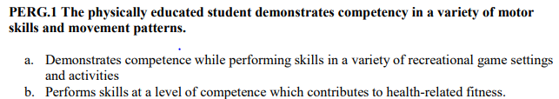

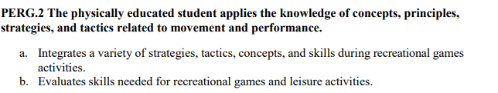

1. Copy: Learning Targets:

I can list the skills needed in order to participate in double dutch.

I can come up with strategies to help improve my jumping skills for double dutch

1. Copy: Success Criteria:
   1. I can show improvement from day one of double dutch using the skills and techniques from coach, video, movie, and peer assistance
   2. I can explain the purpose of us participating in double dutch in this class
2. Who is Izzy in the movie? 
3. Why did Rodney become a bully?
4. List two ways Izzy and Rodney are similar.
5. List three reasons why Izzy boxed
6. List two reasons Izzy was skeptical with participating in double dutch
7. List two “messages/lessons” you believe one should takeaway from watching this movie.
8. Do you think you can double dutch if you use the strategies and techniques and continue to work at it?
9. What is the ultimate goal of Recreational Games class (based on what I constantly tell you all when we start a new activity)?