Belair Elementary School

Art Choice board

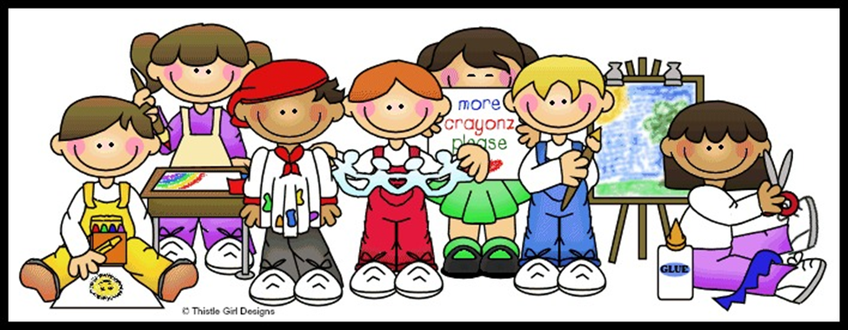

Choose an ART project that you would like to complete.

|  |  |
| --- | --- |
| Lines  Use different types of lines to create a drawing of a room in your home. You can draw yourself in the room doing something cool! | Shapes  Draw at least 3 objects in your home that are geometric and 3 objects that you would consider organic. Have fun! |
| Color  Ask your parent if you can go outside to draw a scene from nature. Make sure you color everything you draw. | Form  Pick an object from your home. (example: remote control or tissue box) Draw that object in 3-dimensional form. (Make it look “real”) |
| Texture  Draw something that looks wet, rough, and fuzzy. You should have 3 drawings when you are done. | Value  Pick only one color and draw and color a picture showing the values of that color. (The value of a color will include how light or dark that color is.) |