Setting up the Text Option for

Multi-Factor Authentication

The first two (2) images are the normal login screens when logging into the Office 365 web portal.

1. Using your computer, type or copy and paste the link into a browser: [http://portal.office.com](http://portal.office.com/)

# Enter your login address in the field next to the red arrow and click <Next>.

# Note: login address format is [**smithee@richmond.k12.ga.us**](mailto:smithee@richmond.k12.ga.us%20)

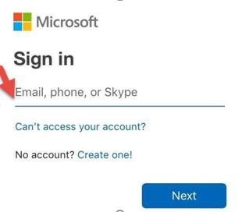

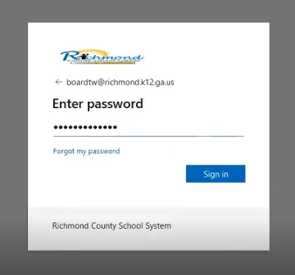3. Enter the password used to log into your workstation and click <Sign In>.

4. The below screen “More information required” window will appear. Click <Next>.

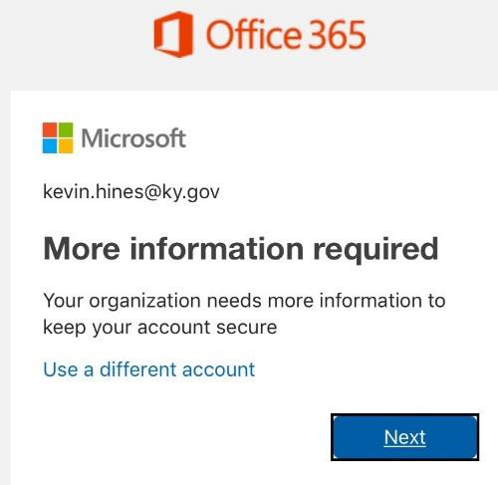

5. Select the authentication method

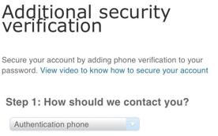

Do the following to setup the text message option for your mobile device as your verification method:

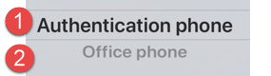

* Select Authentication Phone
* Enter your contact telephone number including area code. Note: you can change the mobile number by backspacing over the telephone number and typing in a new telephone number.
* Click on the radio button to select text message **Methods:**

Method: Send a code by text message – by clicking on the radio button, this option allows the user to receive a 6- digit code via SMS (mobile phone) to be keyed into a verification screen.

(Note: data rates will apply.)

# 6. After setting up the method, the image below is displayed to save a password to be used for additional

# security. Save this password and then click <Done>.

# 

# 7. You have completed setting up MFA. The image below is displayed “Stay signed in”. if select <Yes>.

# MFA allows you to be logged in 30 days.

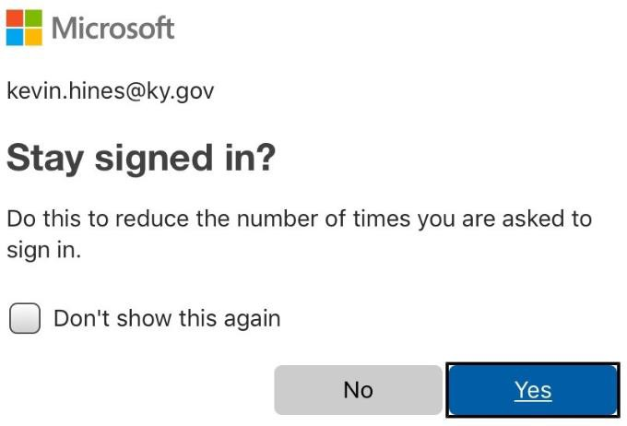

8. The End.