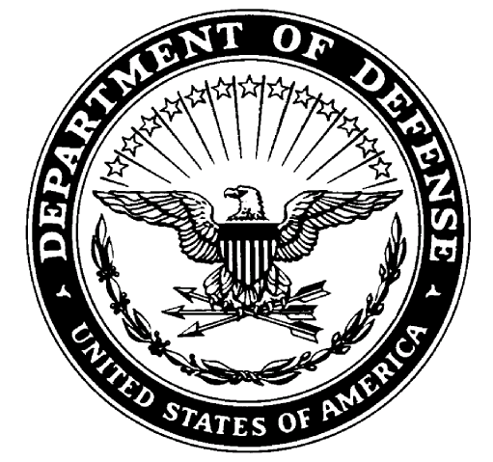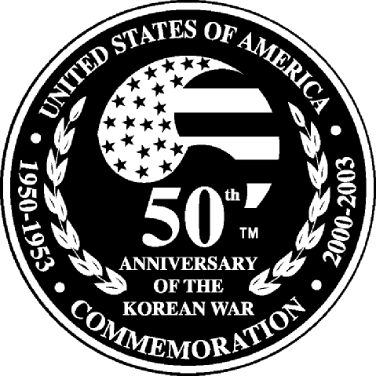**ACADEMY OF RICHMOND COUNTY HIGH SCHOOL**

U.S. ARMY JROTC *“MUSKETEER BATTALION”*

*JROTC CURRICULUM, SACS APPROVED, MAY 2005*

*TRAINING LEADERS FOR THE TWENTY-FIRST CENTURY AND BEYOUND*

**MEMORANDUM FOR RECORD**

**SUBJECT: JROTC CADET DRESS AND APPEARANCE CONTRACT 2024-2025**

**CCR 670-1 2-4. Hair, Cosmetic, Fingernail, Hygiene/Grooming, and Tattoo Policies**

**A. Hair.**

(1) General. The requirement for hair grooming standards is necessary to maintain uniformity within a military population. Many hairstyles are acceptable, as long as they are neat and conservative. It is not possible to address every acceptable hairstyle, or what constitutes eccentric or conservative grooming. Therefore, it is the responsibility of leaders at all levels to exercise good judgment in the enforcement of Army policy. All Cadets will comply with the hair, fingernail, and grooming policies while in any military uniform or while in civilian clothes on duty.

(a) Leaders will judge the appropriateness of a particular hairstyle by the appearance of headgear when worn. Headgear will fit snugly and comfortably, without distortion or excessive gaps. Hairstyles that do not allow soldiers to wear the headgear properly, or that interfere with the proper wear of the protective mask or other protective equipment, are prohibited.

(b) Extreme, eccentric, or trendy haircuts or hairstyles are not authorized. If Cadets use dyes, tints, or bleaches, they must choose those that result in natural hair colors. Colors that detract from a professional military appearance are prohibited. Therefore, Cadets should avoid using colors that result in an extreme appearance. **Applied hair colors that are prohibited include, but are not limited to, purple, blue, pink, green, orange, bright (fire-engine) red, and fluorescent or neon colors**.

(c) Cadets who have a texture of hair that does not part naturally may cut a part into the hair. The part will be one straight line, not slanted or curved, and will fall in the area where the Cadet would normally part the hair. Cadets will not cut designs into their hair or scalp.

**(2) Male haircuts will conform to the following standards.**

(a) The hair on top of the head must be neatly groomed. The length and bulk of the hair may not be excessive or present a ragged, unkempt, or extreme appearance. The hair must present a tapered appearance. A tapered appearance is one where the outline of the Cadet’s hair conforms to the shape of the head, curving inward to the natural termination point at the base of the neck. When hair is combed, it will not fall over the ears or eyebrows. It will not touch the collar, except for the closely cut hair at the back of the neck. The block-cut fullness in the back is permitted to a moderate degree, as long as the tapered look is maintained. In all cases, the bulk or length of hair may not interfere with the normal wear of headgear or protective masks or equipment. ***[Males are authorized to wear braids, cornrows, or dreadlocks but hair must not be unkempt while in uniform. Hair that is clipped closely or shaved to the scalp is authorized.]***

(b) Males will keep sideburns neatly trimmed. Sideburns may not be flared; the base of the sideburn will be a clean shaven, horizontal line. Sideburns will not extend below the lowest part of the exterior ear opening.

(c) Males will keep their face clean-shaven when in uniform. Mustaches are permitted; if worn, males will keep mustaches neatly trimmed, tapered, and tidy. Mustaches will not present a chopped off or bushy appearance, and no portion of the mustache will cover the upper lip line or extend sideways beyond a vertical line drawn upward from the corners of the mouth. Handlebar mustaches, goatees, and beards are not authorized. **If an appropriate medical authority prescribes beard growth, the length required for medical treatment must be specified.** For example, “The length of the beard will not exceed 1⁄4 inch.” (See TB MED 287) Cadets 8 will keep the growth trimmed to the level specified by appropriate medical authority, but they are not authorized to shape the growth into a goatee, a “Fu Manchu,” or handlebar mustache.

(d) Males are prohibited from wearing wigs or hairpieces while in uniform or in civilian clothes on duty, except to cover natural baldness or physical disfiguration caused by an accident or medical procedure.

**(3) Female haircuts will conform to the following standards.**

Female hairstyles may not be eccentric or faddish and will present a conservative, professional appearance. For the purpose of these regulations, female hairstyles are organized into three basic categories: short length, medium length, and long length hair.

(a) Short length. Short hair is defined as hair length that extends no more than 1 inch from the scalp (excluding bangs). Hair may be no shorter than 1/4 inch from the scalp (unless due to medical condition or injury), but may be evenly tapered to the scalp within 2 inches of the hair line edges. Bangs, if worn, may not fall below the eyebrows, may not interfere with the wear of all headgear, must lie neatly against the head, and not be visible underneath the front of the headgear. The width of the bangs may extend to the hairline at the temple.

(b) Medium length. Medium hair is defined as hair length that does not extend beyond the lower edge of the collar (in all uniforms), and extends more than 1 inch from the scalp. Medium hair may fall naturally in uniform, and is not required to be secured. When worn loose, graduated hair styles are acceptable, but the length, as measured from the end of the total hair length to the base of the collar, may not exceed 1 inch difference in length, from the front to the back. Layered hairstyles are also authorized, so long as each hair’s length, as measured from the scalp to the hair’s end, is generally the same length giving a tapered appearance. No portion of the bulk of the hair, as measured from the scalp, will exceed 2 inches.

(c) Long length. Long hair is defined as hair length that extends beyond the lower edge of the collar. Long hair will be neatly and inconspicuously fastened or pinned above the lower edge of the collar, except that bangs may be worn. The regulations for the wear of bangs detailed in paragraph 3–2a(3)(a) apply. No portion of the bulk of the hair, as measured from the scalp as styled, will exceed 2 inches (except a bun, which is worn on the back of the head and may extend a maximum of 3 1/2 inches from the scalp and be no wider than the width of the head).

(d) Additional hairstyle guidelines. Faddish and exaggerated styles, to include shaved portions of the scalp other than the neckline, designs cut in the hair, unsecured ponytails (except during physical training), and unbalanced or lopsided hairstyles are prohibited. Hair will be styled so as not to interfere with the proper wear of all uniform headgear. All headgear will fit snugly and comfortably around the largest part of the head without bulging or distortion from the intended shape of the headgear and without excessive gaps. When headgear is worn, hair should not protrude at distinct angles from under the edges. Hairstyles that do not allow the headgear to be worn in this manner are prohibited. Examples of hairstyles considered to be faddish or exaggerated and thus not authorized for wear while in uniform or in civilian clothes on duty include, but are not limited to hair sculpting (eccentric texture or directional flow of any hairstyle to include spiking); buns with loose hair extending at the end; hair styles with severe angles or designs; and loose unsecured hair (not to include bangs) when medium and long hair are worn up.

(e) Devices. Hair holding devices are authorized only for the purpose of securing the hair. Soldiers will not place hair holding devices in the hair for decorative purposes. All hair holding devices must be plain and of a color as close to the Soldier’s hair as is possible or clear. Authorized devices include, but are not limited to, small plain scrunchies (elastic hair bands covered with material), barrettes, combs, pins, clips, rubber bands, and hair or head bands. Such devices should conform to the natural shape of the head. Devices that are conspicuous, excessive, or decorative are prohibited. Some examples of prohibited devices include, but are not limited to: large, lacy scrunchies; beads, bows, or claw or alligator clips; clips, pins, or barrettes with butterflies, flowers, sparkles, gems, or scalloped edges; and bows made from hairpieces. Foreign material (for example, beads and decorative items) will not be used in the hair.

(f) Braids, cornrows, twists, and locks. Medium and long hair may be styled with braids, cornrows, twists, or locks (see glossary for definitions). Each braid, cornrow, twist, or lock will be of uniform dimension, have a diameter no greater than a 1/2 inch, and present a neat, professional, and well-groomed appearance. Each must have the same approximate size of spacing between the braids, cornrows, twists, or locks. Each hairstyle may be worn against the scalp or loose (free-hanging). When worn loose, such hairstyles must be worn per medium hair length guidelines or secured to the head in the same manner as described for medium or long length hair styles. Ends must be secured

**B. Cosmetics.**

(1) General. As with hairstyles, the requirement for standards regarding cosmetics is necessary to maintain uniformity and to avoid an extreme or unmilitary appearance. Males are prohibited from wearing cosmetics, to include nail polish. **Females are authorized to wear cosmetics with all uniforms**, provided they are applied conservatively, are in good taste, and complement the uniform. Leaders at all levels must exercise good judgment in the enforcement of this policy.

(a) Females may wear cosmetics if they are conservative and complement the uniform and their complexion. Eccentric, exaggerated, or trendy cosmetic styles and colors, to include makeup designed to cover tattoos, are inappropriate with the uniform and are prohibited. Permanent makeup, such as eyebrow or eyeliner, is authorized as long as the makeup conforms to the standards outlined above.

(b) Females will not wear shades of lipstick and nail polish that distinctly contrast with their complexion, detract from the uniform, are extreme. Some examples of extreme colors include, but are not limited to, purple, gold, blue, black, white, bright (fire-engine) red, khaki, camouflage colors, and fluorescent colors. Cadets will not apply designs to nails or apply two-tone or multi-tone colors to nails.

(2) Females will comply with the cosmetics policy while in any military uniform or while in civilian clothes on duty.

c. Fingernails. All personnel will keep fingernails clean and neatly trimmed. Males will keep nails trimmed so as not to extend beyond the fingertip. Females’ fingernails will not exceed a nail length of 1⁄4 inch, as measured from the tip of the finger. Females will trim nails shorter if the commander determines that the longer length detracts from the military image, presents a safety concern, or interferes with the performance of duties.

d. Hygiene and body grooming. Soldiers will maintain good personal hygiene and grooming on a daily basis and wear the uniform so as not to detract from their overall military appearance. e. Tattoos. Tattoos or brands that are extremist, indecent, sexist, or racist are prohibited, regardless of location on the body, as they are prejudicial to good order and discipline within units.

**C. Wear of Jewelry.**

a. Cadets may wear a wristwatch, a wrist identification bracelet, and two rings (a wedding set is considered one ring) with Army uniforms, unless prohibited by the JROTC Cadre for safety or health reasons. Any jewelry Cadets wear must be conservative and in good taste. Identification bracelets are limited to medical alert bracelets and MIA/POW identification bracelets. Cadets may wear only one item on each wrist.

b. No jewelry, will appear exposed while wearing the uniform; this includes watch chains, or similar items, and pens and pencils. The only authorized exceptions are religious items, a conservative tie tack or tie clasp which male Cadets may wear with the black four-in-hand necktie, and a pen or pencil that may appear exposed on ACUs.

c. Body piercing. When on any Army installation or other place under Army control, Cadets may not attach, affix, or display objects, articles, jewelry, or ornamentation to or through the skin while they are in uniform **(this includes earrings for male soldiers)**.

d. Females are authorized to wear prescribed earrings with the service, dress, and mess uniforms.

(1) Earrings may be screw-on, clip-on, or post-type, in gold, silver, white pearl, or diamond. ***Earrings will not exceed 6 mm or 1⁄4 inch in diameter, and they must be unadorned and spherical***. When worn, the earrings will fit snugly against the ear. Females may wear earrings only as a matched pair, with only one earring per ear lobe.

2) Females are not authorized to wear earrings with any class C (utility) uniform (BDU/ACU, physical fitness, field, or organizational).

**D. Consent to correction**

As a JROTC cadet I will adhere to all the previously listed standards for uniform wear as a member of the Musketeer JROTC department, ARC School Policies and Richmond County Board of Education requirements. If at any time I break one of the rules associated with any of these three governing bodies I acknowledge I could be subject to removal of rank, position, demerits and various levels of corrective training to include push-ups, wall sits, and essays, based on the severity of the infraction.

**Cadet Acknowledgment statement**

I__________________________________________ acknowledge that I am in JROTC because I am willing to adhere to the requirements associated with being a JROTC cadet. These requirements include but are not limited ensuring my hair is within the proper standards associated with AR 670-1 and CCR 125-2, my uniform is kept in good repair wearing the JROTC uniform properly for each uniform wear day and I will respect the lawful orders of the cadre and cadets that are placed in authority over me. I am willing to deal with the consequences that may result from my non-compliance to this requirements which include removal from JROTC or failure of the course.

I ____________________________________________am willing to adhere to JROTC Standards.

Last First MI.

Cadet Signature:________________________________________________________________

**Parent Acknowledgment statement**

I _____________________________________________ will ensure my cadet adhere to the

Last First MI.

uniform standards associated in AR 670-1 and CCR 125-2. I will ensure my cadet’s uniform remains clean and is returned to the JROTC department dry cleaned before the end of the 2024-2025 school year.

Parent Signature:________________________________________________________________